L.V. Gromashevsky Institute of Epidemiology and Infectious Diseases National Academy of Medical Science of Ukraine

Scientific Influenza and ARI Center

Weekly Bulletin for Influenza Epidemic Situation in Ukraine by 4 Sentinel Centers
(Кyiv, Dnipro, Odesa, Khmelnytsky)
Week 11, 2017

Loaded on website www.ukrinfluenza.com.ua

Since 2008 the system of ILI and SARI sentinel surveillance has been functioning in Ukraine. The sentinel centers are located in different geographical areas of the country: in Kyiv, Dnipro, Odesa and Khmelnytsky, which include 18 sentinel stations: 10 hospitals and 8 polyclinics.
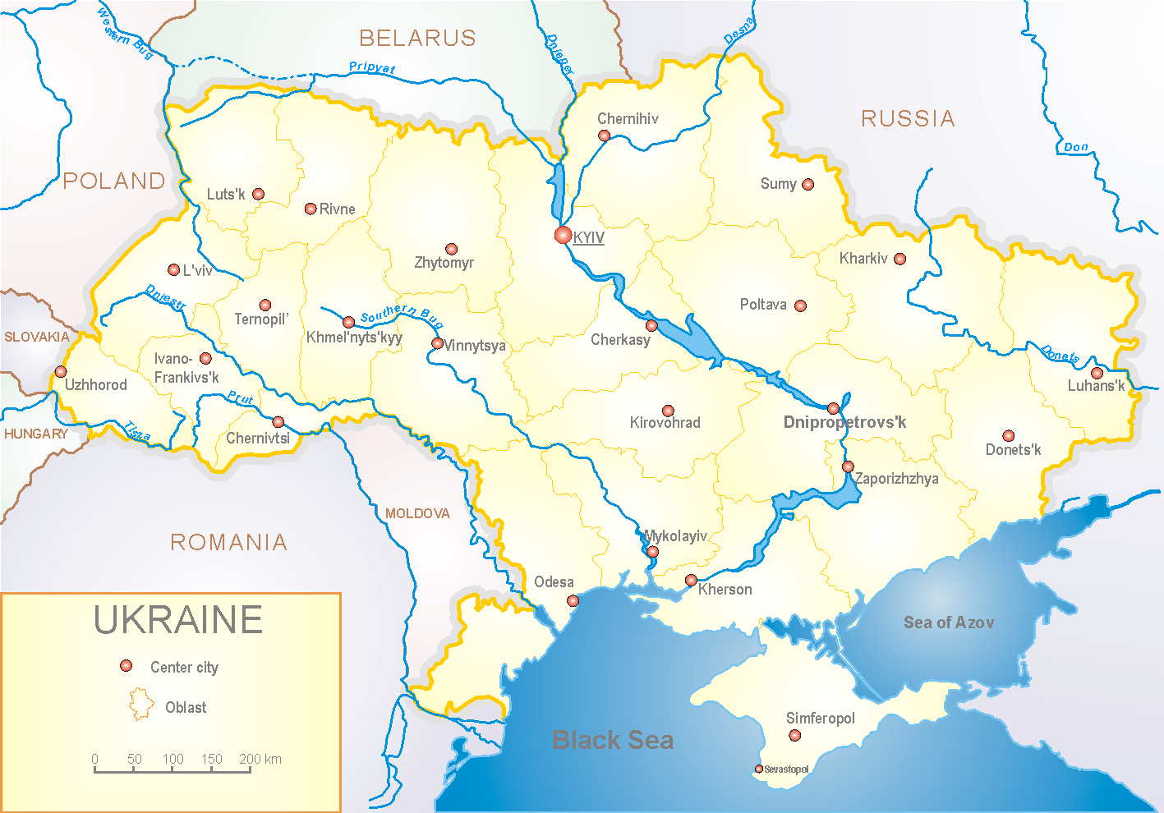

According to data of influenza sentinel surveillance system in Ukraine in 8 policlinics of 4 sentinel centers the quantity of outpatient, which meet the definition of ILI during the 11th week (13.03 – 19.03.17) was 52 cases (25.1 per 100 thousand corresponding population). In comparison with the previous week the decline of morbidity level was 5.5% and it was 2.4 times less than index of last year (index 25.1 versus 61.2 in 2016) (fig.1).

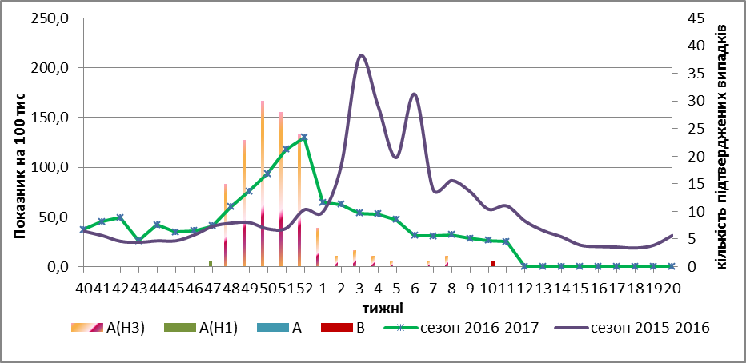

Fig.1. The dynamic of ILI cases and number of laboratory confirmed influenza cases in 4 sentinel centers of Ukraine in the 2016 – 2017 season.

During the 11th week in 10 hospitals of 4 sentinel centers there were hospitalized 1219 patients, this is 5.3% more than during the previous week. The quantity of SARI patients (patients which meet the definition SARI) was 44 cases (1.5 per 100 thousand); the increase of morbidity levels was 22.2% in comparison with the previous week and in 2.8 times less than index of last year (index 1.5 versus 4.3 in 2016) (fig. 2).

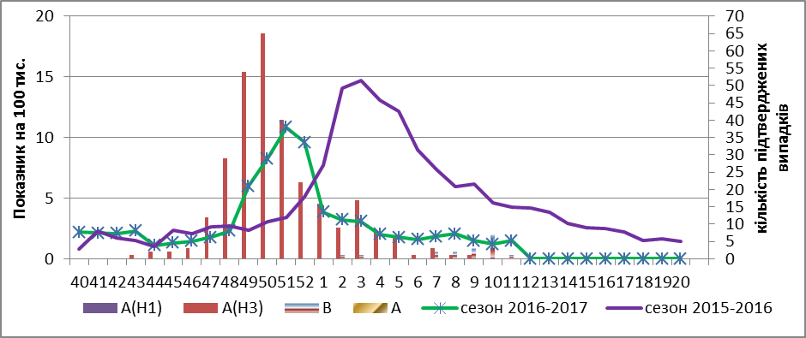

Fig.2 The dynamic of SARI cases and the number of laboratory confirmed influenza in season 2016 – 2017 in four sentinel centers of Ukraine.

During the 11th week the proportion of SARI cases was 3.6% (fig. 3).

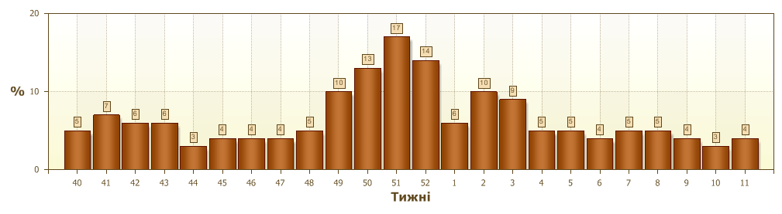
Fig.3. Proportion of SARI from the total number of hospitalizations in 10 hospitals of sentinel centers.

From 40th to 11th week 2016-2017 there were investigated 730 samples from ILI and SARI patients by PCR method. There were detected 460 positive influenza samples: 194 – influenza viruses A(unsubtyped), 1 – influenza virus A(H1), 247 – influenza viruses A(H3) and 18 – influenza virus B (fig.4). There were isolated 122 isolates of influenza viruses on MDCK/SIAT cell culture.

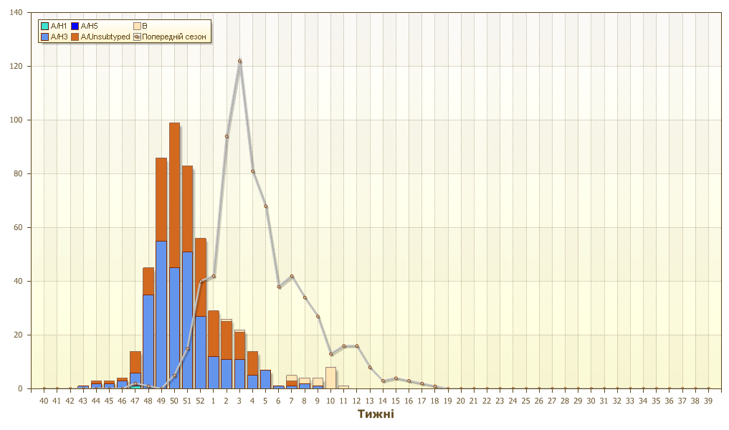

Fig.4. The number of laboratory confirmed influenza cases among ILI and SARI patients in season 2016 – 2017 in four sentinel centers of Ukraine.

During the 11th week levels of ILI and SARI morbidity don’t exceed the seasonal indexes. In Odesa and Khmelnytsky there are registered the sporadic cases of influenza B virus. The highest percentage of confirmed influenza cases is recorded among children 15 – 14 years old – 55.0%, 15 – 17 years old – 62.0%, in the age group 18 – 29 – 59.0% and 65 years old – 58.0%.

Performed by:
Alla Mironenko, MD, DSc
Olga Holubka, PhD

