L.V. Gromashevsky Institute of Epidemiology and Infectious Diseases National Academy of Medical Science of Ukraine
National Influenza Center

Weekly Bulletin for Influenza Epidemic Situation in Ukraine by 4 Sentinel Centers
(Кyiv, Dnipropetrovsk, Odesa, Khmelnitsky)
Week 12, 2015

According to data of sentinel surveillance system in 8 policlinics of 4 sentinel cities of Ukraine the quantity of outpatient, which meet the definition of ILI during the 12th week (03.16 – 03.22.15) was 134 cases (49.2 per 100 thousand) corresponding population. In comparison with previous week the decrease of morbidity level is 20.7% (fig. 1).
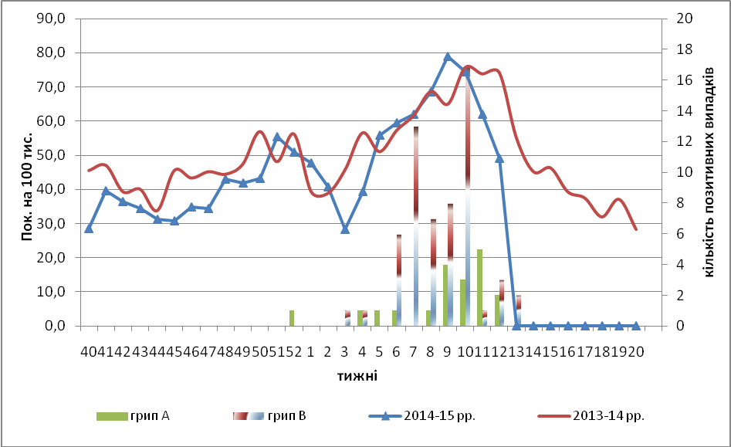

Fig.1. The dynamic of ILI cases and number of laboratory confirmed influenza cases in 4 sentinel cities of Ukraine in the 2014 – 2015 season.

There was some percentage increase of appeals to policlinics with ILI diagnosis during the 12th week among the age group 18 – 29 (fig. 2).
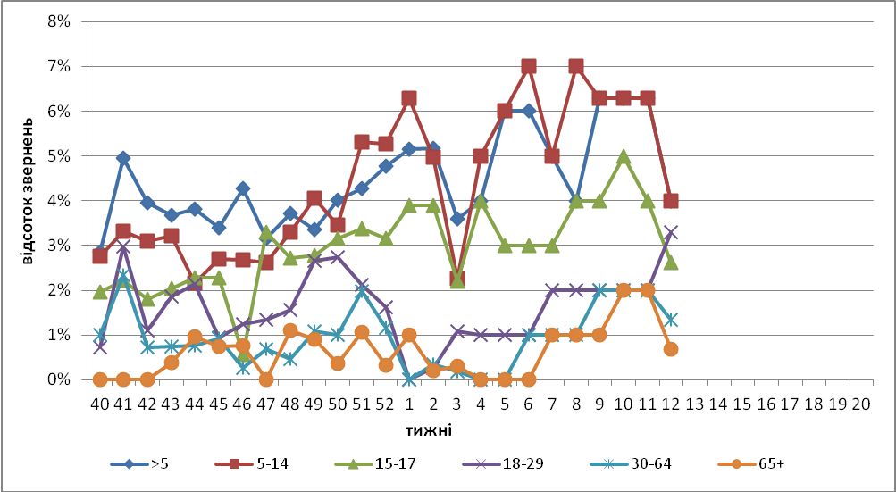
Fig. 2. The percentage of appeals to policlinics with ILI diagnosis among different age groups in season 2014 – 215 in four sentinel cities of Ukraine.

During the 12th week the quantity of SARI patients (patients which meet the definition SARI) was 146 cases in 10 hospitals (4.92 per 100 thousand) the increase of morbidity level was 14.1% in comparison with previous week, there was also the increase of hospitalization level by 16.7% (fig. 3).

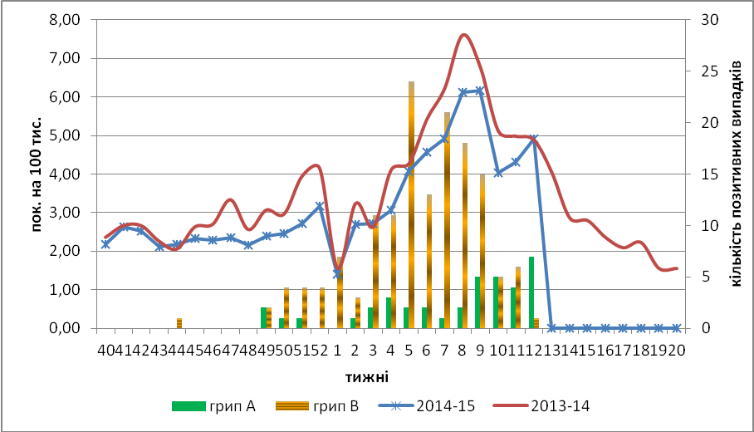

Fig.3 The dynamic of SARI cases and the number of laboratory confirmed influenza in season 2014 – 2015 in four sentinel cities of Ukraine.

From 40th to 12th week there were investigated 1048 samples from ILI and SARI patients by PCR method, laboratory confirmed 250 influenza viruses (23.8%): А(Н3) – 9 (3,6%), А(Н1)pdm – 15 (6,0%), influenza А – 35 (14,0%), influenza В – 181 (76,4%).

Using the HAI method there was confirmed that the influenza viruses type B, which circulate in Ukrainian territory, belong to B/Yamagata linage. The influenza virus B of the same genetic linage was included to vaccine composition for season 2014 – 2015 for the Northern hemisphere.
Virological sentinel influenza surveillance data which are presented weekly on WHO site http://www.who.int/influenza/gisrs_laboratory/flunet/en/ are shown in fig. 4.

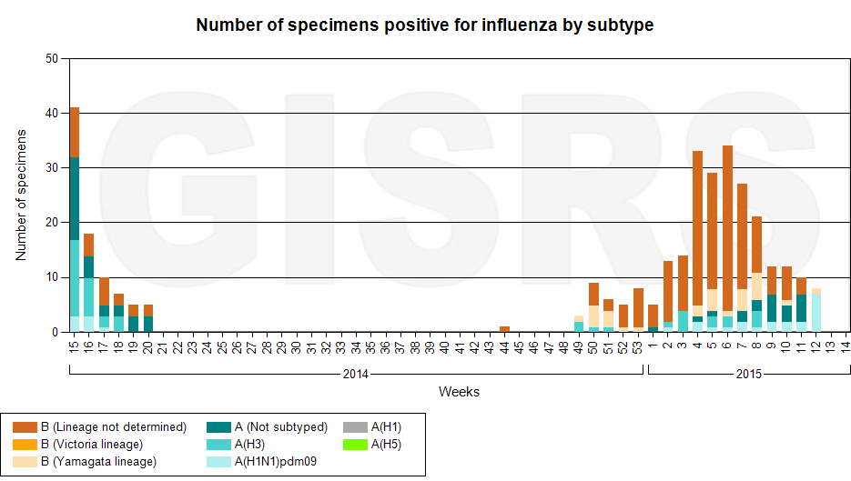

Fig. 4. The quantity of laboratory confirmed influenza cases among patients with ILI and SARI diagnosis in season 2014 – 2015 in the sentinel cities of Ukraine.

Performed by:
Alla Mironenko, MD, DSc
Olga Holubka, PhD

