L.V. Gromashevsky Institute of Epidemiology and Infectious Diseases National Academy of Medical Science of Ukraine
National Influenza Center

Weekly Bulletin for Influenza Epidemic Situation in Ukraine by 4 Sentinel Centers
(Кyiv, Dnipropetrovsk, Odesa, Khmelnitsky)
Week 15, 2015

According to data of sentinel surveillance system in 8 policlinics of 4 sentinel cities of Ukraine the quantity of outpatient, which meet the definition of ILI during the 15th week (04.06 - 04.12.15) was 105 cases (38.5 per 100 thousand) corresponding population. In comparison with previous week the increase of morbidity level is 2.9% (fig. 1).
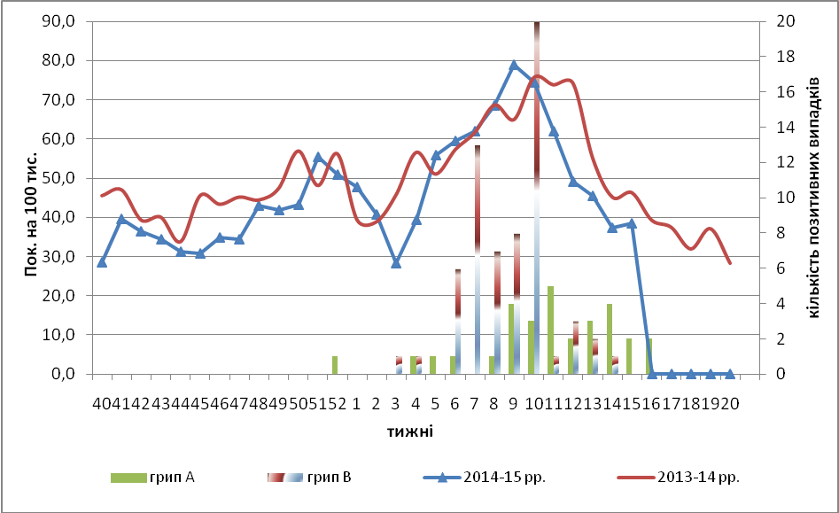
Fig.1. The dynamic of ILI cases and number of laboratory confirmed influenza cases in 4 sentinel cities of Ukraine in the 2014 – 2015 season.

There was some percentage increase of appeals to policlinics with ILI diagnosis during the 15th week among the child population in the age groups: 5 – 14 and 15 – 17 (fig.2).
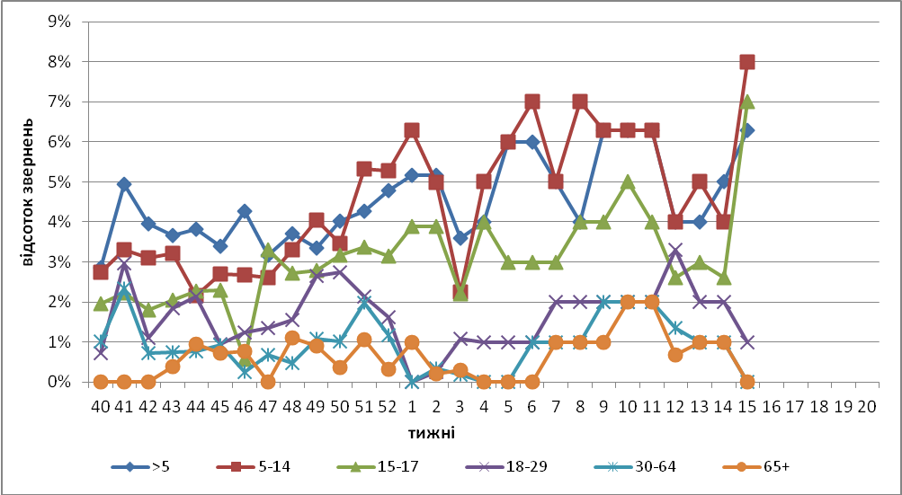
Fig. 2. The percentage of appeals to policlinics with ILI diagnosis among different age groups in season 2014 – 215 in four sentinel cities of Ukraine.
During the 15th week the quantity of SARI patients (patients which meet the definition SARI) was 114 cases in 10 hospitals (3.84 per 100 thousand) the increase of morbidity level was 5.6% in comparison with the previous week, there was also the decrease of hospitalization level by 9.3% (fig. 3).
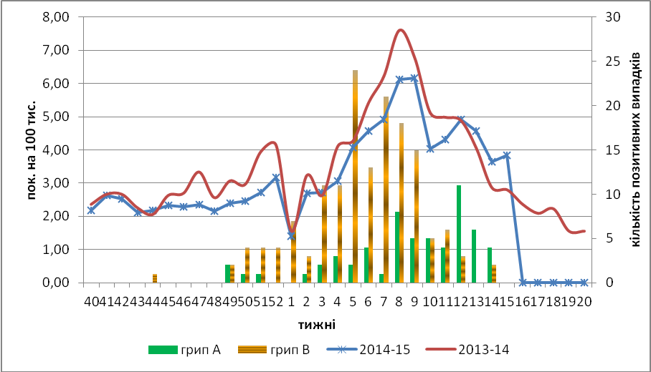
Fig.3 The dynamic of SARI cases and the number of laboratory confirmed influenza in season 2014 – 2015 in four sentinel cities of Ukraine.

From 40th to 15th week there were investigated 1167 samples from ILI and SARI patients by PCR method, laboratory confirmed 272 influenza viruses (23.3%): influenza А – 48 (17,6%), А(Н3) –10 (3,7%), А(Н1)pdm – 27 (9,9%), influenza В – 187 (68,7%).
Virological sentinel influenza surveillance data which are presented weekly on WHO site http://www.who.int/influenza/gisrs_laboratory/flunet/en/ are shown in fig. 4.

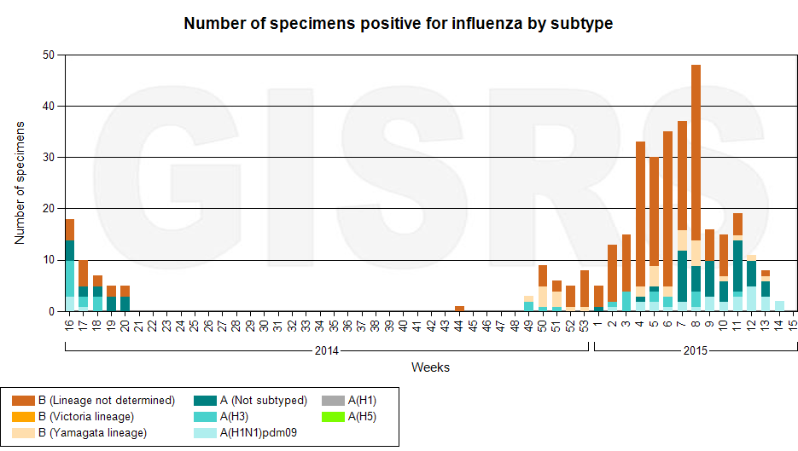

Fig. 4. The quantity of laboratory confirmed influenza cases among patients with ILI and SARI diagnosis in season 2014 – 2015 in the sentinel cities of Ukraine.

Performed by:
Alla Mironenko, MD, DSc
Olga Holubka, PhD

