L.V. Gromashevsky Institute of Epidemiology and Infectious Diseases National Academy of Medical Science of Ukraine
National Influenza Center

Weekly Bulletin for Influenza Epidemic Situation in Ukraine by 4 Sentinel Centers
(Кyiv, Dnipropetrovsk, Odesa, Khmelnitsky)
Week 17, 2015

According to data of sentinel surveillance system in 8 policlinics of 4 sentinel cities of Ukraine the quantity of outpatient, which meet the definition of ILI during the 17th week (04.20 - 04.26.15) was 91 cases (33.4 per 100 thousand) corresponding population. In comparison with previous week the decrease of morbidity level is 10.8% (fig. 1).

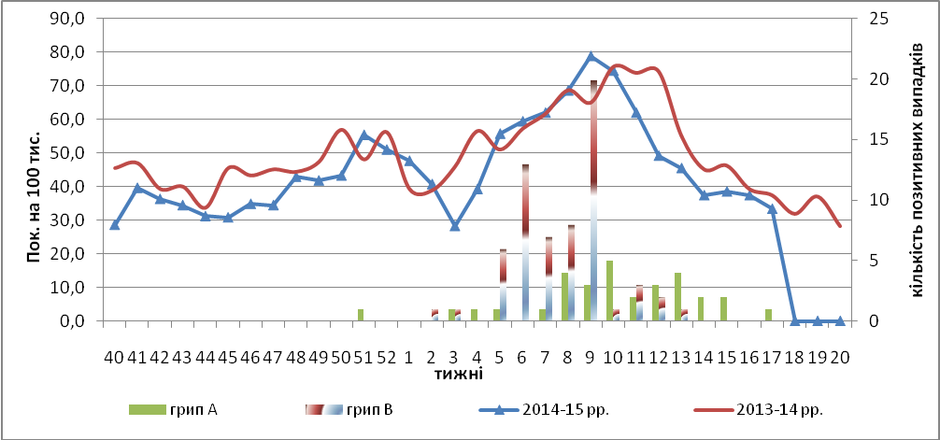
Fig.1. The dynamic of ILI cases and number of laboratory confirmed influenza cases in 4 sentinel cities of Ukraine in the 2014 – 2015 season.

There was some percentage decrease of appeals to policlinics with ILI diagnosis during the 17th week among the whole population except the age group 0 – 5 (fig.2).

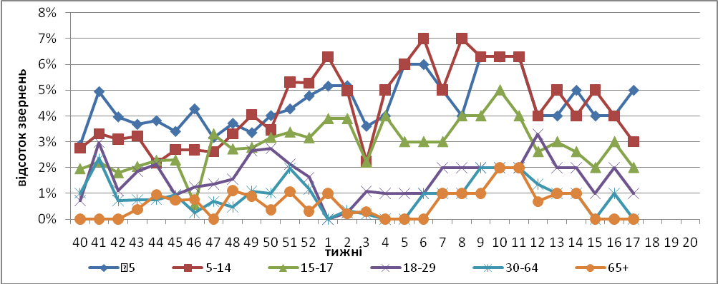
Fig. 2. The percentage of appeals to policlinics with ILI diagnosis among different age groups in season 2014 – 215 in four sentinel cities of Ukraine.
During the 17th week the quantity of SARI patients (patients which meet the definition SARI) was 69 cases in 10 hospitals (2.32 per 100 thousand) the decline of morbidity level was 18.8% in comparison with the previous week, there was also the decrease of hospitalization level by 34.8% (fig. 3).

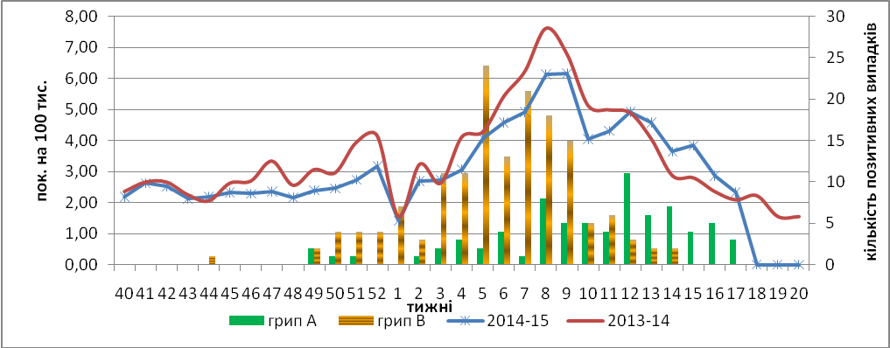
Fig.3 The dynamic of SARI cases and the number of laboratory confirmed influenza in season 2014 – 2015 in four sentinel cities of Ukraine.

From 40th to 17th week there were investigated 1215 samples from ILI and SARI patients by PCR method, laboratory confirmed 292 influenza viruses (24.03%): influenza А – 61 (21,0%), А(Н3) –11 (3,7%), А(Н1)pdm – 30 (10,3%), influenza В – 190 (65,1%). There were confirmed 15 influenza B viruses, which belong to B/Yamagata genetic lineage by HIA method.
Virological sentinel influenza surveillance data which are presented weekly on WHO site http://www.who.int/influenza/gisrs_laboratory/flunet/en/ are shown in fig. 4.

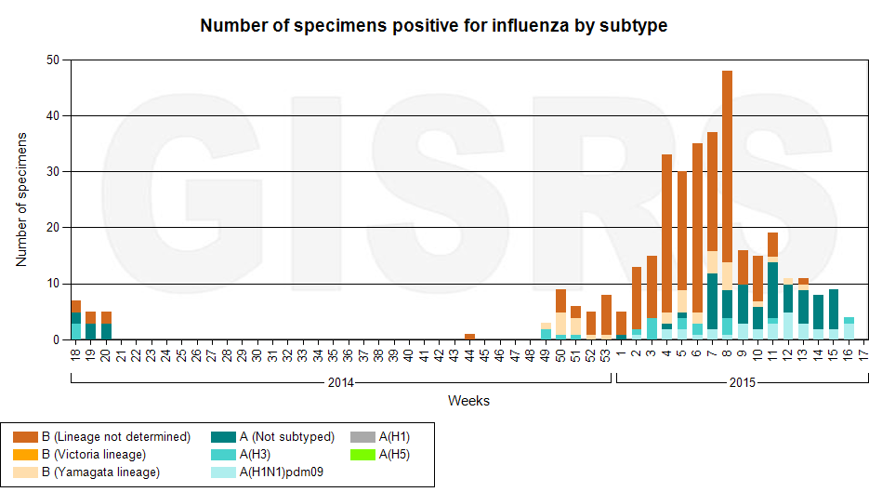

Fig. 4. The quantity of laboratory confirmed influenza cases among patients with ILI and SARI diagnosis in season 2014 – 2015 in the sentinel cities of Ukraine.

Performed by:
Alla Mironenko, MD, DSc
Olga Holubka, PhD

