L.V. Gromashevsky Institute of Epidemiology and Infectious Diseases National Academy of Medical Science of Ukraine
National Influenza Center

Weekly Bulletin for Influenza Epidemic Situation in Ukraine by 4 Sentinel Centers
(Кyiv, Dnipropetrovsk, Odesa, Khmelnitsky)
Week 20, 2015

According to data of sentinel surveillance system in 8 policlinics of 4 sentinel cities of Ukraine the quantity of outpatient, which meet the definition of ILI during the 20th week (05.11 - 05.17.15) was 63 cases (23.1 per 100 thousand) corresponding population. In comparison with previous week there was the decrease of morbidity level - 16.0% (fig. 1).
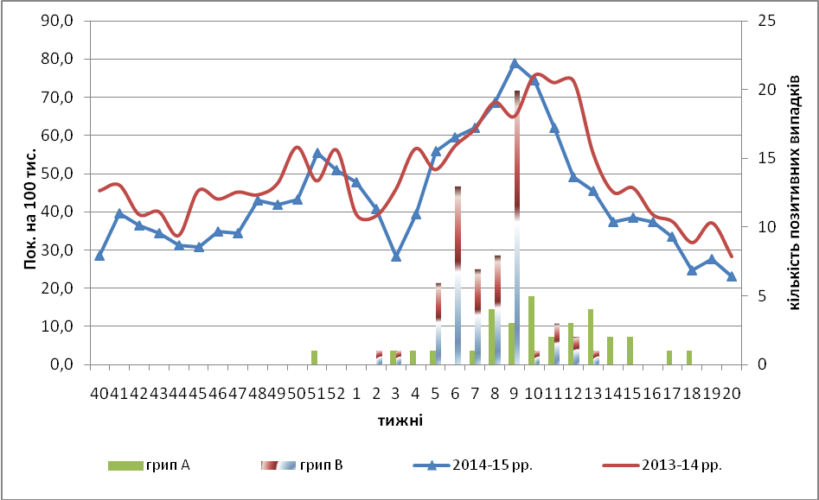

Fig.1. The dynamic of ILI cases and number of laboratory confirmed influenza cases in 4 sentinel cities of Ukraine in the 2014 – 2015 season.

The percentage of appeals to policlinics with ILI diagnosis remains constant among the population in all age groups during the 20th week (fig.2).
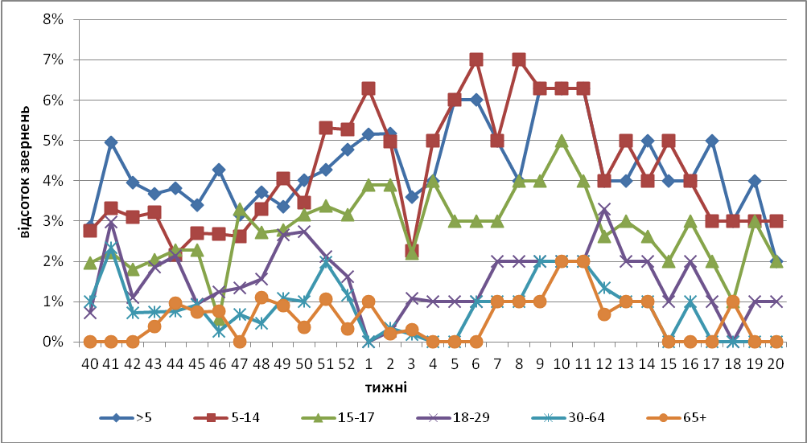

Fig. 2. The percentage of appeals to policlinics with ILI diagnosis among different age groups in season 2014 – 215 in four sentinel cities of Ukraine.

The 20th week considered the ending of epidemic influenza season. So, from 40th to 20th week there were done 134400 ambulatory visits by clinics of sentinel centers and were detected 3952 cases with ILI symptoms, this amounted 3%. Among examined 478 persons (12%) laboratory confirmed 107 cases (22%) of influenza viruses, there were detected 42 cases of influenza A viruses (39.2%) and 66 – influenza B viruses (61.7%).
During the 20th week the quantity of SARI patients (patients which meet the definition SARI) was 38 cases in 10 hospitals (1.28 per 100 thousand) the decline of morbidity level was 11.6% in comparison with the previous week, and there was the increase of hospitalization level by 17.2% (fig. 3).
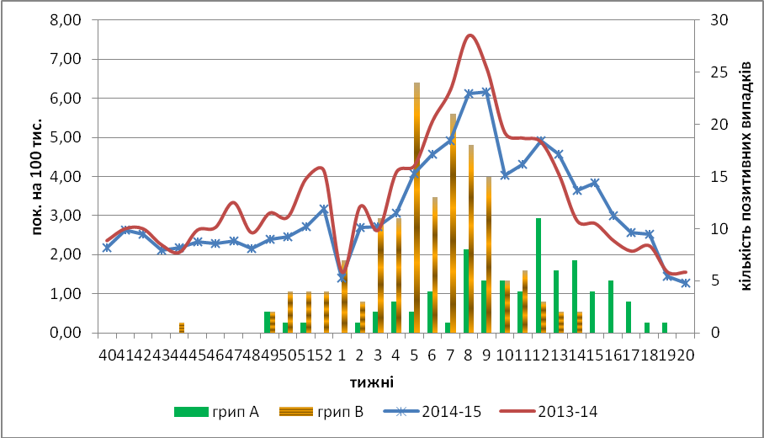

Fig.3 The dynamic of SARI cases and the number of laboratory confirmed influenza in season 2014 – 2015 in four sentinel cities of Ukraine.

During the season 2014 – 2015 there were hospitalized 34647 patients into hospitals of four sentinel cities, among them 3105 cases of patients with SARI symptoms, and this accounted 9%. There were laboratory examined 836 patients (27%), among them there were detected 225 cases (27%) of influenza viruses, detected influenza A viruses – 82 (36.4%) and 146 influenza B viruses (64.8%).
From 40th to 20th 2014 – 2015 week there were investigated 1314 samples from ILI and SARI patients by PCR method, laboratory confirmed 332 influenza viruses (25.3%): influenza А – 65 (19.6%), А(Н3) –15 (4.5%), А(Н1)pdm – 40 (12.0%), influenza В – 193 (58.1%). There were confirmed 19 influenza B viruses, which belong to B/Yamagata genetic lineage by HIA method.
Virologic sentinel influenza surveillance data which are presented weekly on WHO site http://www.who.int/influenza/gisrs_laboratory/flunet/en/ are shown in fig. 4.

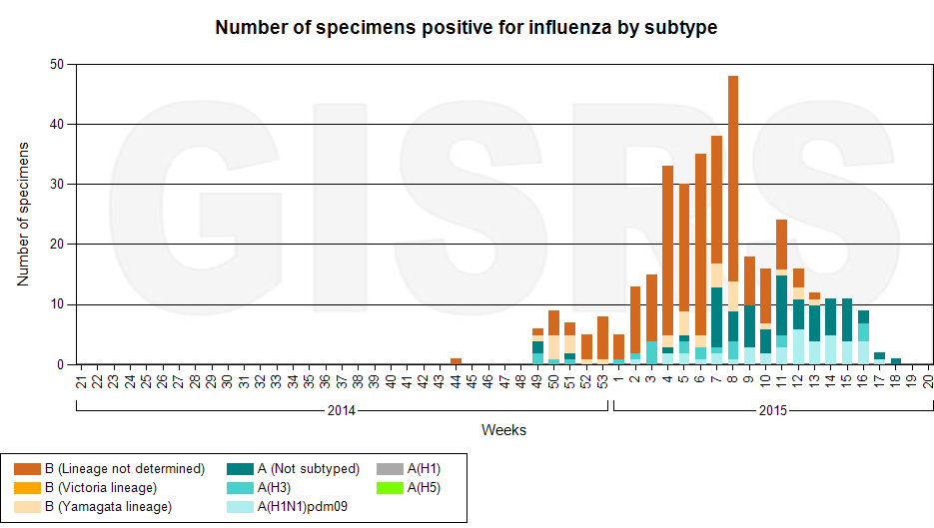

Fig. 4. The quantity of laboratory confirmed influenza cases among patients with ILI and SARI diagnosis in season 2014 – 2015 in the sentinel cities of Ukraine.

Performed by:
Alla Mironenko, MD, DSc
Olga Holubka, PhD

