L.V. Gromashevsky Institute of Epidemiology and Infectious Diseases National Academy of Medical Science of Ukraine
Scientific Influenza and ARI Center

Weekly Bulletin for Influenza Epidemic Situation in Ukraine by 4 Sentinel Centers
(Кyiv, Dnipro, Odessa, Khmelnitsky)
Week 20, 2017

Loaded on website www.ukrinfluenza.com.ua
Since 2008 the system of ILI and SARI sentinel surveillance has been functioning in Ukraine. The sentinel centers are located in different geographical areas of the country: in Kyiv, Dnipro, Odesa and Khmelnytsky, which include 18 sentinel stations: 10 hospitals and 8 polyclinics.
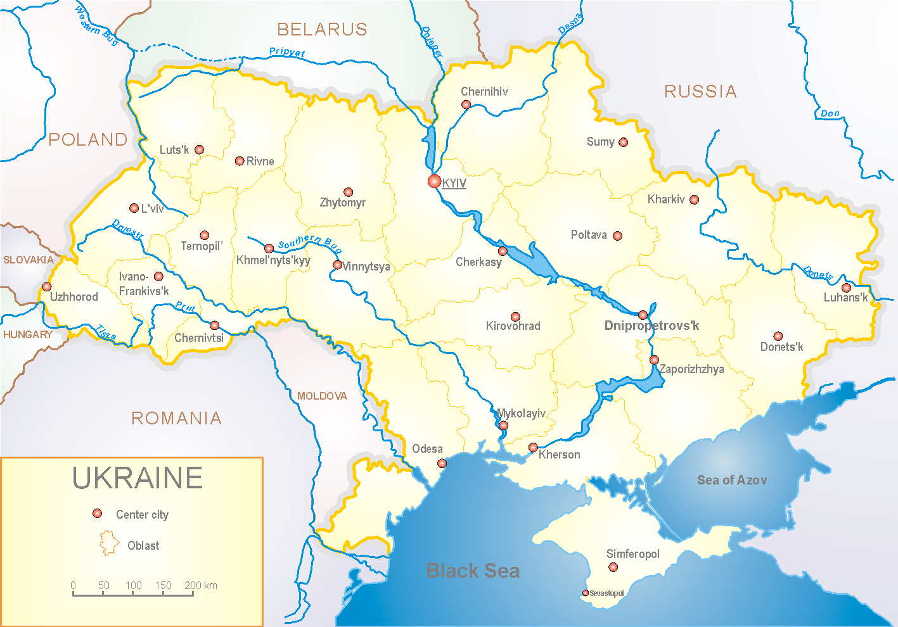

According to data of sentinel surveillance system the epidemic season 2016-2017 marked by early beginning - the 43rd week 2016 with active circulation of influenza virus A(H3) and was characterized by stable decline of morbidity levels (R_{aver.gr/dec} = - 1,2 %). The indicators of severe cases were 1.8 times less than the indicators of previous year (index 87.5 versus 158.1 in 2015 – 2016). From the 7th week 2017 and to the end of the season the influenza virus B dominated in circulation. The peak of morbidity and virological confirmations was on the 50th week and was 65.0%.
There were hospitalized to the hospitals of 4 sentinel cities 41412 patients among them 2489 (6.0%) were SARI patients. There were laboratory examined 885 patients (36.0%) among them there were confirmed 424 cases (it was 48.0%). There were detected: 110 – influenza viruses A, 213 – A(H3N2), 63 – influenza viruses B, among them - 23 related to B/Victoria lineage (fig. 1).
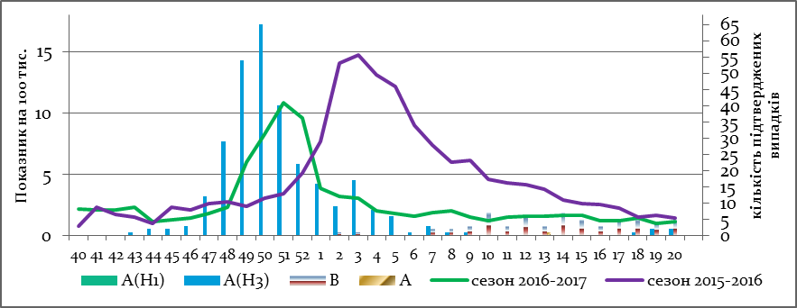

Fig.1. The dynamic of registered SARI cases and the number of laboratory confirmed influenza in season 2016 – 2017 in four sentinel cities of Ukraine.
The first case was confirmed as A(H1) on the 47th week 2016. From the 48th week the influenza virus A(H3) began to circulate actively and from the 10th week 2017 and up to the end of the season the circulation of influenza virus B dominated.
There were made 99034 outpatients visits and calls home by policlinic institutions of 4 sentinel centers, among them 2902 (3.0%) met the definition of ILI, 482 (17.0%) of cases were examined – 178 (37.0%) of them were influenza positive. There were detected: 92 – influenza viruses A, 1 – A(H1N1)pdm09, 68 – A(H3N2) and 9 – influenza viruses B (fig. 2).

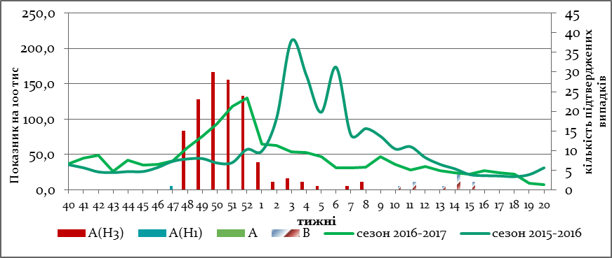

Fig.1. The dynamic of registered ILI cases and number of laboratory confirmed influenza cases in 4 sentinel centers of Ukraine in the 2016 – 2017 season.
From 40th to 20th week of 2016 – 2017 there were investigated 894 samples from ILI and SARI patients by PCR method. There were detected 556 (62.2%) positive influenza samples: 202 – influenza A (unsubtyped), 1 - influenza virus A(H1), 281 – A(H3), 72 – influenza B, among them 23 related to B/Victoria lineage (fig.3).
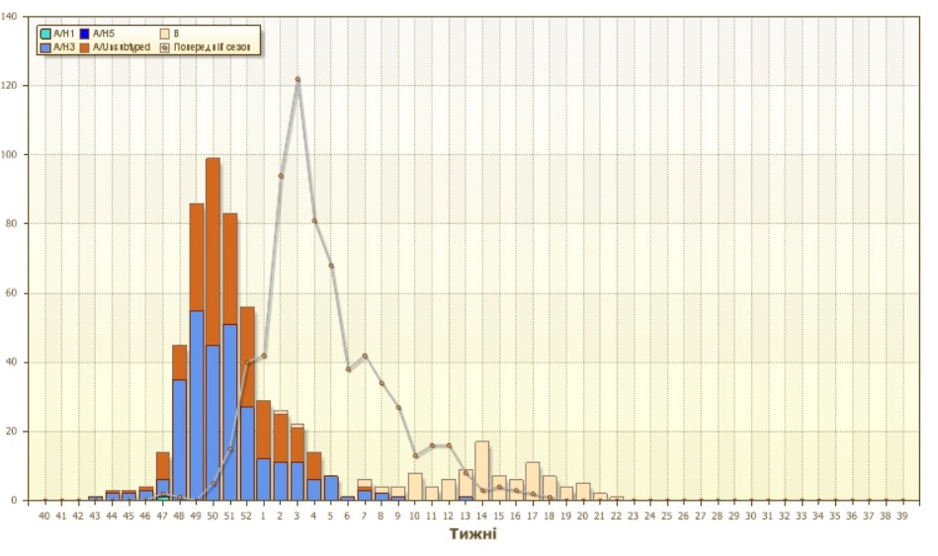
Fig.3. The number of laboratory confirmed influenza cases among ILI and SARI patients in season 2016 – 2017 in four sentinel centers of Ukraine.
There were isolated 168 isolates of influenza viruses on MDCK/SIAT cell culture among them 15 (8.9%) – influenza A, 109 (64.8%) – were subtyped as A(H3N2), 2 (1.2%) – A(H1N1)pdm and 42 (25.0%) – influenza virus B(fig.4)
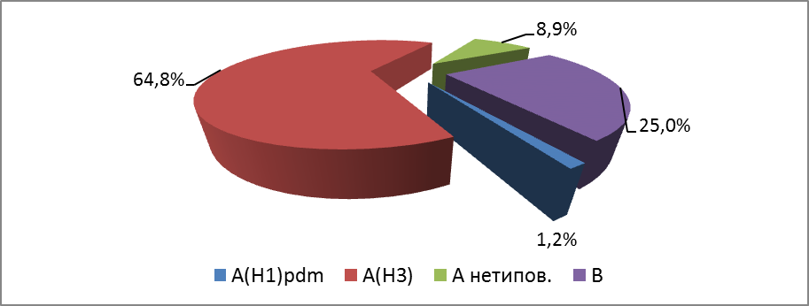

Fig. 4. The quantity of isolated isolates of influenza viruses in sentinel centers of Ukraine in 2016 – 2017.
The highest number of confirmed cases among SARI patients was in age groups 18 – 29 and 15 – 17 years old.
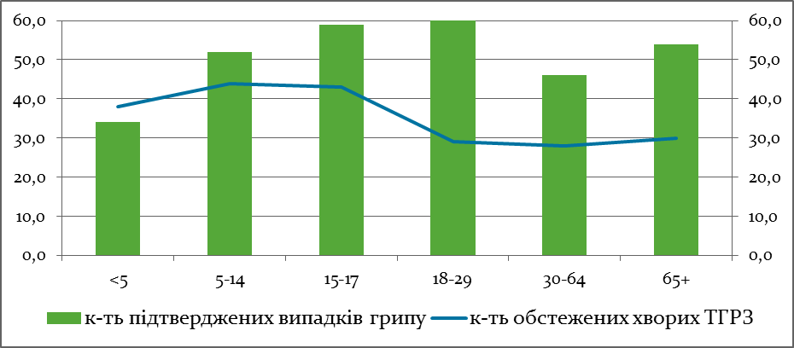

Performed by:
Alla Mironenko, MD, DSc
Olga Holubka, PhD

