L.V. Gromashevsky Institute of Epidemiology and Infectious Diseases National Academy of Medical Science of Ukraine

Scientific Influenza and ARI Center

Weekly Bulletin for Influenza and COVID-19 Epidemic Situation in Ukraine by 4 Sentinel Centers
(Кyiv, Dnipro, Odessa, Khmelnitsky)
Week 2, 2023

Loaded on website www.ukrinfluenza.com.ua
Since 2008 the system of ILI* and SARI* sentinel surveillance has been functioning in Ukraine. The sentinel centers are located in different geographical areas of the country: in Kyiv, Dnipro, Odessa and Khmelnytsky, which include 15 sentinel stations: 9 hospitals and 6 polyclinics.
* - ILI and SARI case definitions include cases of respiratory diseases caused by other respiratory viruses: influenza, adenovirus, parainfluenza virus, rhinovirus, RSV and SARS-CoV-2.
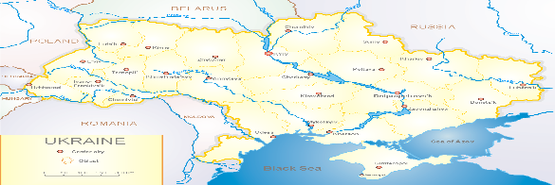
According to data of influenza sentinel surveillance system in Ukraine in 6 policlinics of 4 sentinel cities of Ukraine during the 2nd week 2023 (09.01 – 15.01.2023) the quantity of outpatient, which meet the definition of ILI was 77 cases (7.8 per 100 thousand). The increase of morbidity level was 63.8% in comparison with the previous week (fig.1).

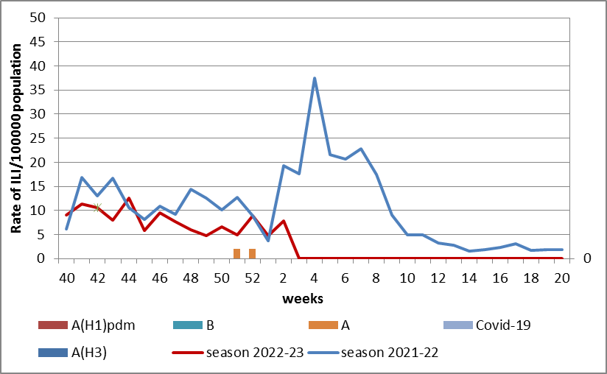

Fig.1. The dynamic of recorded ILI cases and number of laboratory confirmed influenza and SARS-CoV-2 cases in 4 sentinel centers of Ukraine in the 2022 – 2023 season.

During the 2nd week 2023 in 9 hospitals of 4 sentinel centers there were hospitalized 708 patients, among them 527 children (74.4%) with a suspicion of SARI; this is 3.7% less than during the previous week. The proportion of hospitalized patients is 11.2%. 79 SARI patients were detected (3.4 per 100 thousand), 77 of them (3.4 per 100 thousand) - children under 17 years old. The decrease of morbidity levels was 0.1% in comparison with the previous week. 12 influenza A viruses and 2 SARC-CoV-2 viruses were laboratory confirmed among children (fig. 2).

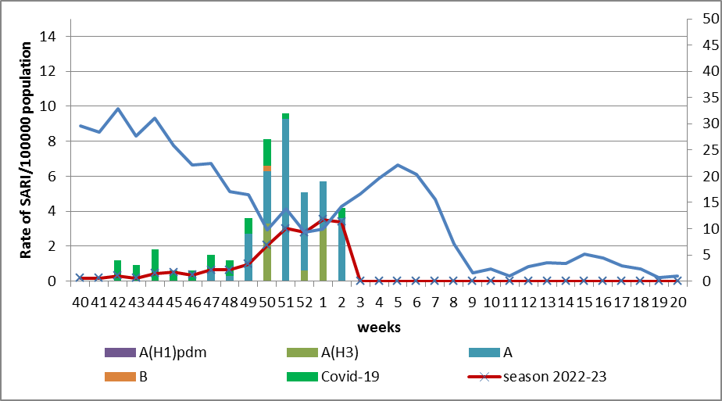

Fig.2 The dynamic of recorded SARI cases and the number of laboratory confirmed influenza and SARS-CoV-2 cases in season 2022 – 2023 in four sentinel centers of Ukraine.
From the 40th to the 2nd week 2023 there were investigated 221 samples from ILI and SARI patients by PCR method. There were laboratory confirmed 149 viruses (67.4%), among them – 34 (22.8%) SARS-CoV-2 viruses, 115 (77.2%) influenza A viruses and 1 influenza B virus.
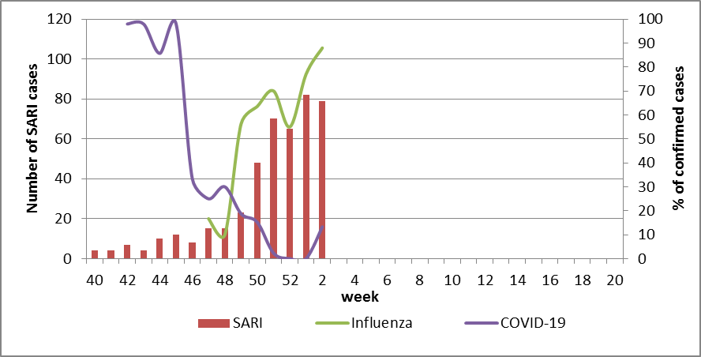
Fig. 3. Percentage of confirmed influenza and COVID-19 cases among hospitalized patients with SARI from the 40th week 2022 to the 20th week 2023.
The intensity of epidemic influenza process is still high. The highest percentage of laboratory confirmed influenza cases were on the 2nd week 2023 was 80.0%. Sporadic COVID-19 cases with low percentage of confirmation are registered due to activation of influenza virus, which can be seen on the fig. 3.
According to weekly ECDC-WHO (https://flunewseurope.org), on the 2nd week 2023 in the countries of European region the influenza epidemic continues, the intensity of epidemic influenza process is still high, but the growth rates of morbidity and the percentage of confirmed cases decreased during the reported week due to holidays.
33 countries reported about regional or widespread influenza activity, and epidemic intensity fluctuates from medium to very high. The exceeding of epidemic threshold more than by 40% is recorded in many counties.
The circulation of influenza viruses in the European region is mixed. The predominance of influenza A(H1)pdm09 viruses are recorded in the systems of sentinel and non-sentinel surveillance.
According to data of sentinel entities, which perform the SARI epidemiological surveillance on the hospital basis, reported that the highest percentage of positive influenza cases are in the following countries: Romania (59%), Ireland (33%), Kazakhstan (33%), Ukraine (31%), Kyrgyzstan (29%), Bosnia and Herzegovina (28%), russian federation (26%), Albania (23%), Slovakia (21%), Sebia (19%) and Malta (11%).
From the beginning of the season 2022-2023 there were detected by PCR method 143735 influenza cases (22.0%) among 1086071 investigated sentinel samples. Among them 93.0% - influenza A and 7.0% - influenza B. 54.0% belong to influenza A(H1)pdm and 46.0% - to A(H3). 625 influenza B viruses belong to B/Victoria lineage, 9343 – influenza B, lineage is not identified.
According to data of PHC of MOH of Ukraine during the 2nd week the part of confirmed COVID-19 cases decreased by 8.8% both among adults and children (-15.8%) in comparison with previous week. 58 fatal cases were registered among people 60+, this is 4.9% less than during the previous week.
So according to sentinel surveillance of Ukraine there is the simultaneous circulation of SARS-CoV-2 and influenza viruses. The intensity of epidemic influenza process is high; the highest part of confirmed cases is among children (80.0 %).

Performed by:
Alla Mironenko, MD, DSc, Professor
Olga Holubka, PhD

