L.V. Gromashevsky Institute of Epidemiology and Infectious Diseases National Academy of Medical Science of Ukraine

Scientific Influenza and ARI Center

Weekly Bulletin for Influenza Epidemic Situation in Ukraine by 4 Sentinel Centers
(Кyiv, Dnipro, Odessa, Khmelnitsky)
Weeks 40 - 41, 2017

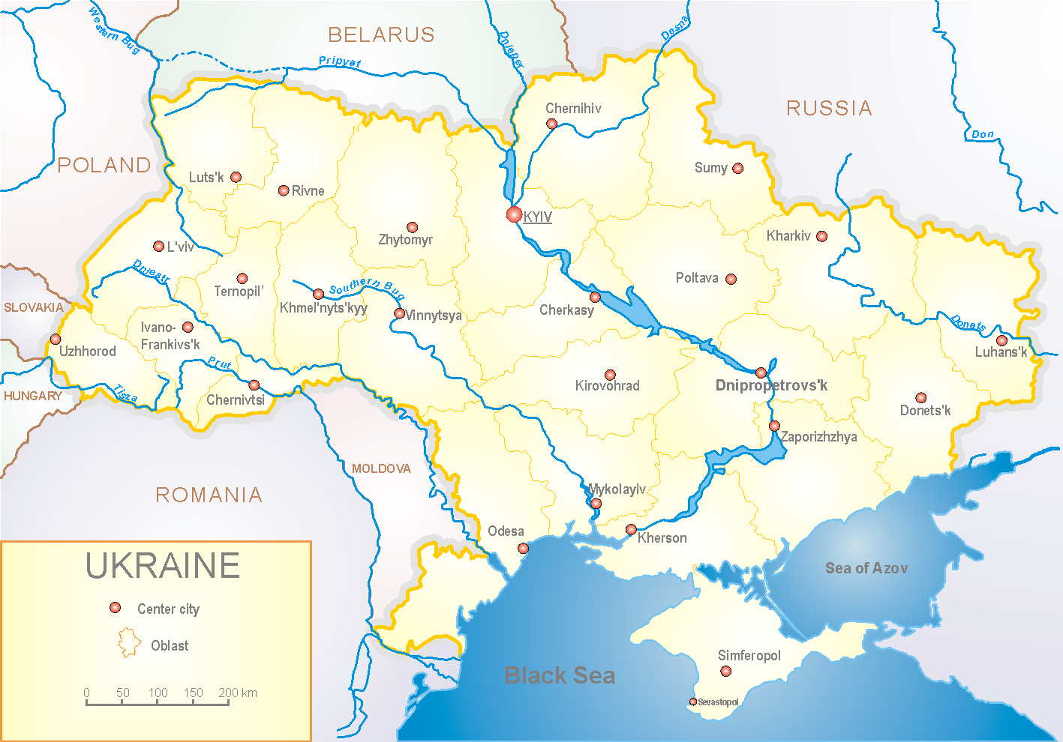
Since 2008 the system of ILI and SARI sentinel surveillance has been functioning in Ukraine. The sentinel centers are located in different geographical areas of the country: in Kyiv, Dnipro, Odessa and Khmelnytskyi, which include 18 sentinel stations: 10 hospitals and 8 polyclinics.

According to data of influenza sentinel surveillance system in Ukraine during the 40th – 41st weeks of season 2017 – 2018 there were reordered ILI and SARI cases among population which met the seasonal levels.
In 8 policlinics of 4 sentinel cities of Ukraine the quantity of outpatient, which meet the definition of ILI during the 41st week (09.10 – 15.10.17) was 2 cases (1.0 per 100 thousand) corresponding population. In comparison with the 40th week there was the decrease of morbidity level – 50.0% (fig. 1).

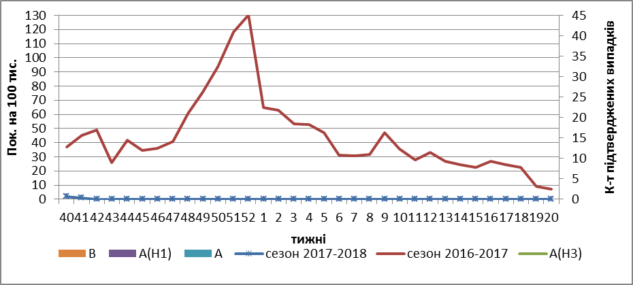
Fig.1. The dynamic of ILI cases and number of laboratory confirmed influenza cases in 4 sentinel centers of Ukraine in the 2017 – 2018 season.

During the 41st week in 10 hospitals of 4 sentinel centers there were hospitalized 1060 patients, this is 7.0% less than during the 40th week. The quantity of SARI patients (patients which meet the definition SARI) was 2 cases (0.07 per 100 thousand); the decline of morbidity levels was 23.3% in comparison with the previous week (fig. 2).

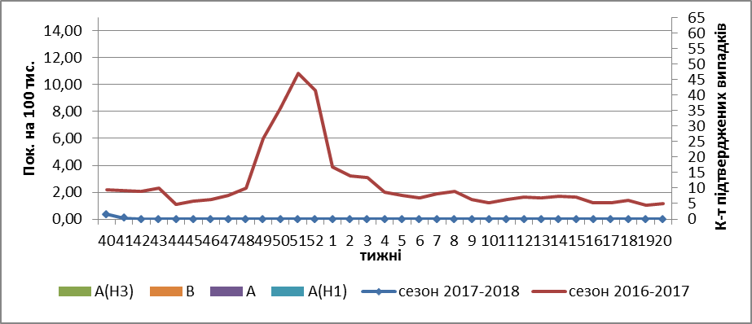

Fig.2 The dynamic of SARI cases and the number of laboratory confirmed influenza in season 2017 – 2018 in four sentinel centers of Ukraine.

From 40th to 41st week 2017-2018 there were investigated 10 samples from ILI and SARI patients by PCR method. There weren’t detected any positive influenza samples.

So the flu season is beginning in Ukraine.

Performed by:
Alla Mironenko, MD, DSc
Olga Holubka, PhD

