L.V. Gromashevsky Institute of Epidemiology and Infectious Diseases National Academy of Medical Science of Ukraine
National Influenza Center

Weekly Bulletin for Influenza Epidemic Situation in Ukraine by 4 Sentinel Centers
(Кyiv, Dnipropetrovsk, Odesa, Khmelnitsky)
Weeks 40 - 47, 2015

According to data of influenza sentinel surveillance system in Ukraine during the 40th – 47th weeks of season 2015 – 2016 there were registered the following levels of influenza morbidity among the population. Abovementioned data met seasonal levels.
In 8 policlinics of 4 sentinel cities of Ukraine the quantity of outpatient, which meet the definition of ILI during the 47th week (16.11 – 22.11.15) was 34 cases (16.4 per 100 thousand) corresponding population. In comparison with previous week the decline of morbidity level is 48.5% (fig. 1).

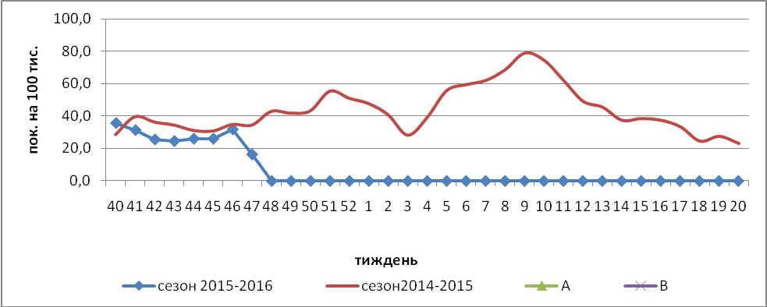

Fig.1. The dynamic of ILI cases and number of laboratory confirmed influenza cases in 4 sentinel cities of Ukraine in the 2015 – 2016 season.

The percentage of appeals to policlinics with ILI diagnosis during the 47th week increased among teens 15-17 and in the age groups: 5 – 14 and <5 (fig.2).
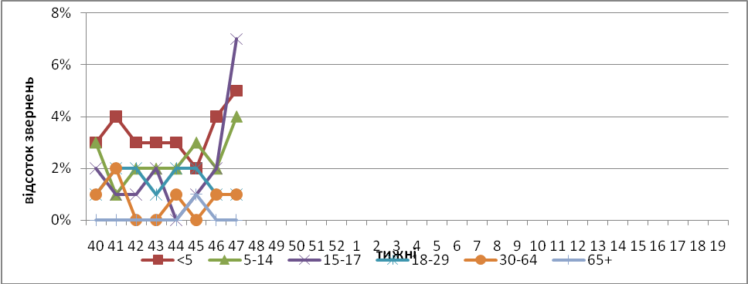

Fig. 2. The percentage of appeals to policlinics with ILI diagnosis among different age groups in season 2015 – 2016 in four sentinel cities of Ukraine.

During the 47th week in 10 hospitals there were hospitalized 1070 patients, in comparison with the previous week there was the increase of hospitalization level by 3.8%. The quantity of SARI patients (patients which meet the definition SARI) was 75 cases (2.53 per 100 thousand) the increase of morbidity level was 33.9% in comparison with the previous week (fig. 3).
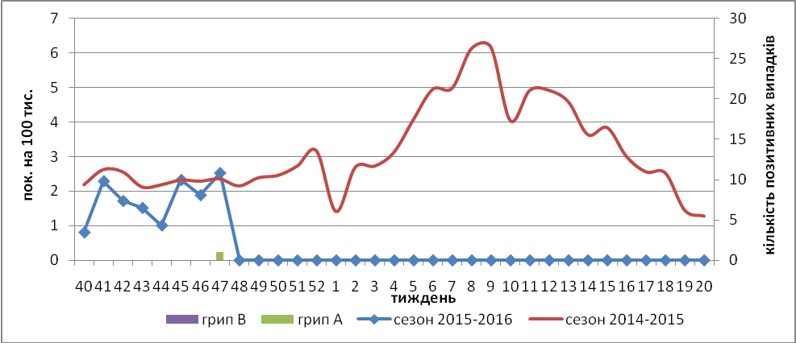
Fig.3 The dynamic of SARI cases and the number of laboratory confirmed influenza in season 2015 – 2016 in four sentinel cities of Ukraine.

From 40th to 47th week there were investigated 70 samples from ILI and SARI patients by PCR method.
During the 47th week there was detected 1 influenza virus A(H1)pdm from died patient (53 years old), who had an obesity and was in the intensive care unit of sentinel center in Kyiv.
Virological sentinel influenza surveillance data which are presented weekly on WHO site http://www.who.int/influenza/gisrs_laboratory/flunet/en/ are shown in fig. 4.
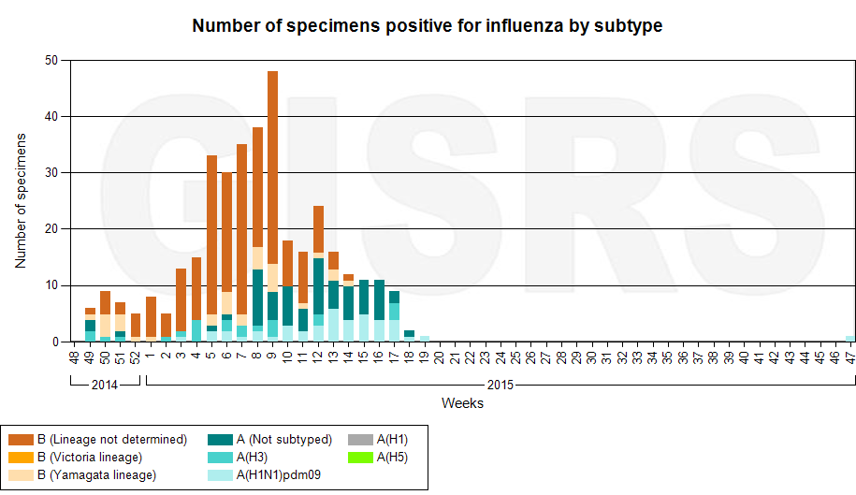
Fig. 4. The quantity of laboratory confirmed influenza cases among patients with ILI and SARI diagnosis in season 2015 – 2016 in the sentinel cities of Ukraine.

Therefore, the flu season is beginning in Ukraine.

Performed by:
Alla Mironenko, MD, DSc
Olga Holubka, PhD

