L.V. Gromashevsky Institute of Epidemiology and Infectious Diseases National Academy of Medical Science of Ukraine

Scientific Influenza and ARI Center

Weekly Bulletin for Influenza Epidemic Situation in Ukraine by 4 Sentinel Centers
(Кyiv, Dnipro, Odessa, Khmelnitsky)
Week 41, 2022

Loaded on website www.ukrinfluenza.com.ua
Since 2008 the system of ILI* and SARI* sentinel surveillance has been functioning in Ukraine. The sentinel centers are located in different geographical areas of the country: in Kyiv, Dnipro, Odessa and Khmelnytsky, which include 15 sentinel stations: 9 hospitals and 6 polyclinics.
* - ILI and SARI case definitions include cases of respiratory diseases caused by other respiratory viruses: influenza, adenovirus, parainfluenza virus, rhinovirus, RSV and SARS-CoV-2.
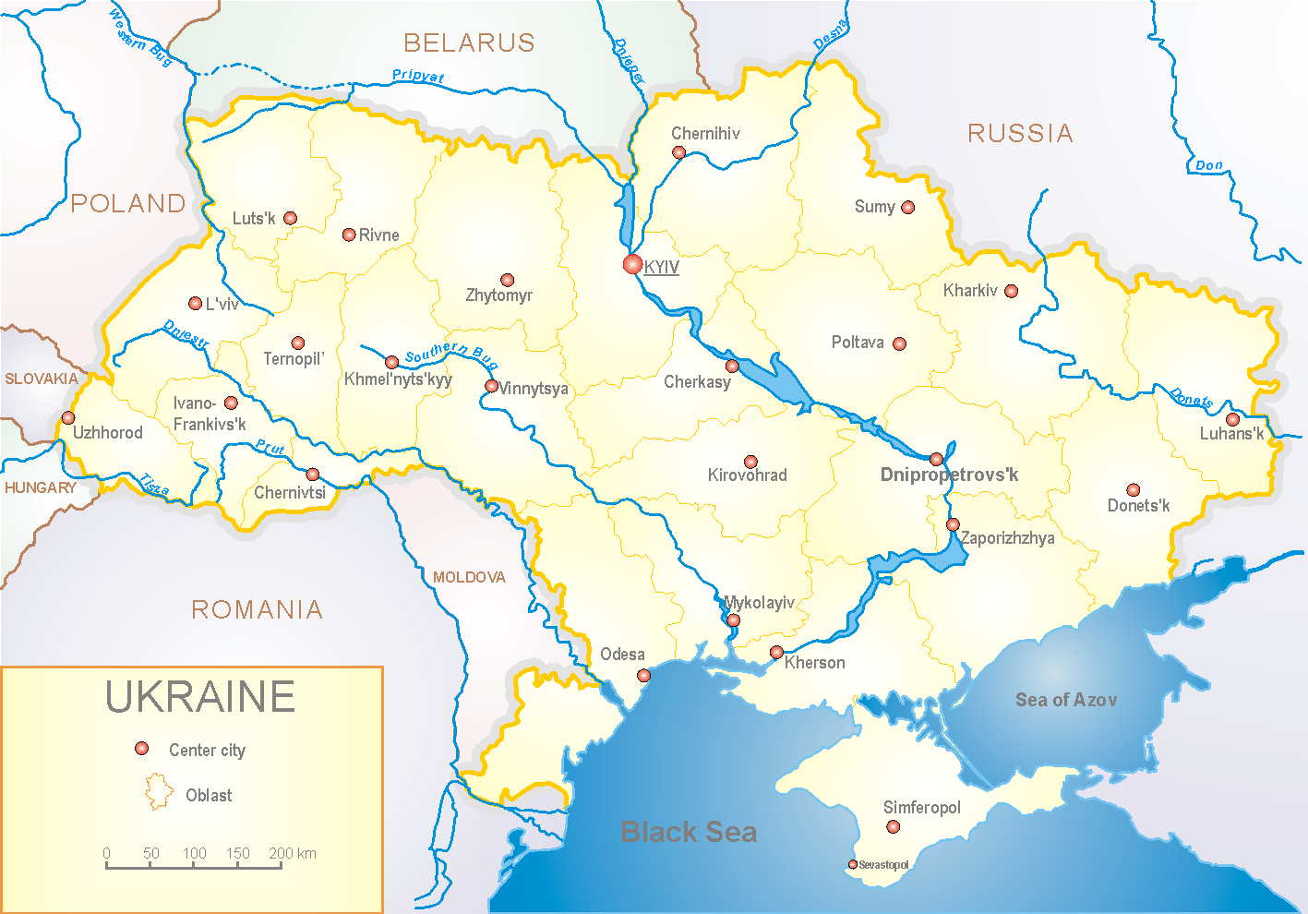
Influenza epidemic season begins on the background of pandemic of severe respiratory illness COVId-19, caused by SARS-CoV-2 virus, which continues 2.5 years. The Russian war against Ukraine also has a negative influence on statistical indicators and epidemic process of influenza and COVID-19.
According to data of influenza sentinel surveillance system in Ukraine in 6 policlinics of 4 sentinel cities of Ukraine during the 41st week (10.10 – 16.10.2022) the quantity of outpatient, which meet the definition of ILI was 112 cases (11.4 per 100 thousand). The increase of morbidity level was 25.8% in comparison with the previous week and was 48.2% less than the index of previous year (16.9 per 100 thousand population in 2021) (fig. 1).

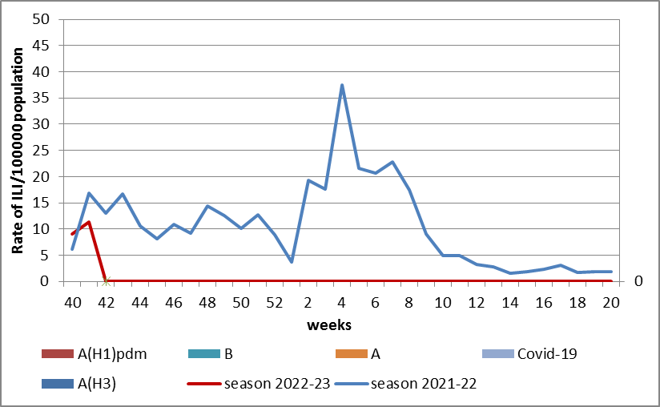

Fig.1. The dynamic of recorded ILI cases and number of laboratory confirmed influenza and SARS-CoV-2 cases in 4 sentinel centers of Ukraine in the 2022 – 2023 season.

During the 41st week in 9 hospitals of 4 sentinel centers there were hospitalized 508 patients, this is 18.3% less than during previous week. The proportion of hospitalized patients is 0.8% (fig. 2).

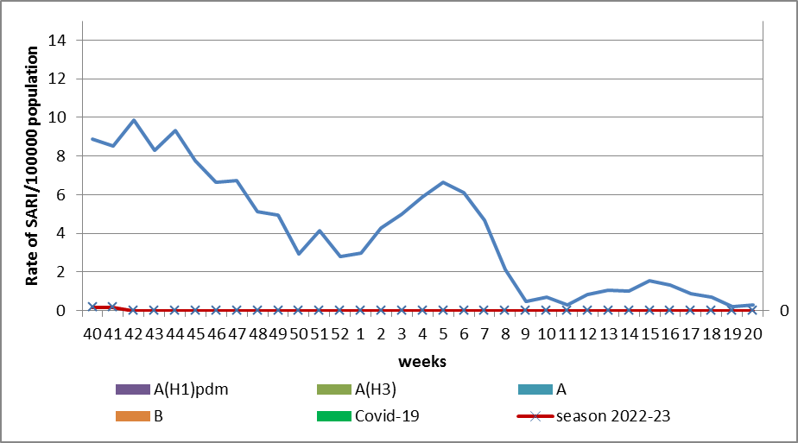

Fig.2 The dynamic of recorded SARI cases and the number of laboratory confirmed influenza and SARS-CoV-2 cases in season 2022 – 2023 in four sentinel centers of Ukraine.

According to weekly ECDC-WHO (https://flunewseurope.org), influenza activity is on off-season levels in European region increase. But Scotland and Germany informed about regional influenza activity, there were laboratory confirmed influenza A and B viruses with dominance of A(H3). Kazakhstan informed about wide spread and circulation of A(H3). From the beginning of the season there were detected 94.7% influenza A (A(H1)pdm – 24.6%, A(H3) – 75.4%) and 2.6% - influenza B in the sentinel clinics.

So according to data of influenza sentinel surveillance system the morbidity indexes are on off-season levels. No influenza cases were detected in Ukraine.

Performed by:
Alla Mironenko, MD, DSc, Professor
Olga Holubka, PhD

