L.V. Gromashevsky Institute of Epidemiology and Infectious Diseases National Academy of Medical Science of Ukraine

Scientific Influenza and ARI Center

Weekly Bulletin for Influenza Epidemic Situation in Ukraine by 4 Sentinel Centers
(Кyiv, Dnipro, Odessa, Khmelnitsky)
Week 42, 2022

Loaded on website www.ukrinfluenza.com.ua
Since 2008 the system of ILI* and SARI* sentinel surveillance has been functioning in Ukraine. The sentinel centers are located in different geographical areas of the country: in Kyiv, Dnipro, Odessa and Khmelnytsky, which include 15 sentinel stations: 9 hospitals and 6 polyclinics.
* - ILI and SARI case definitions include cases of respiratory diseases caused by other respiratory viruses: influenza, adenovirus, parainfluenza virus, rhinovirus, RSV and SARS-CoV-2.
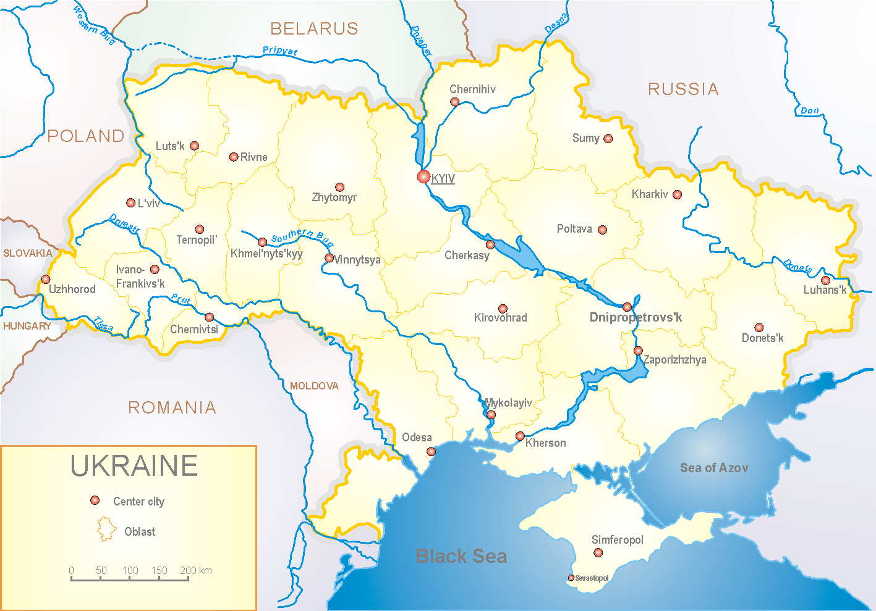
According to data of influenza sentinel surveillance system in Ukraine in 6 policlinics of 4 sentinel cities of Ukraine during the 42nd week (17.10 – 23.10.2022) the quantity of outpatient, which meet the definition of ILI was 104 cases (10.6 per 100 thousand). The decrease of morbidity level was 7.1% in comparison with the previous week and 23.1% less than the index of previous year (13.0 per 100 thousand population in 2021) (fig. 1).
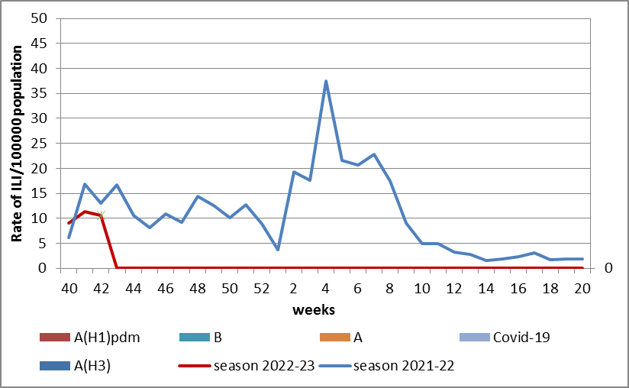

Fig.1. The dynamic of recorded ILI cases and number of laboratory confirmed influenza and SARS-CoV-2 cases in 4 sentinel centers of Ukraine in the 2022 – 2023 season.
During the 42nd week in 9 hospitals of 4 sentinel centers there were hospitalized 477 patients, this is 6.1% less than during previous week. The proportion of hospitalized patients is 1.5%. During the 42nd week there were 7 SARI patients (0.3 per 100 thousand). The increase of morbidity level was 75.0% in comparison with the previous week and was 3 times less than the index of previous year (9.9 per 100 thousand in 2021). There were detected 4 cases of SARS-CoV-2 among adults (fig. 2).

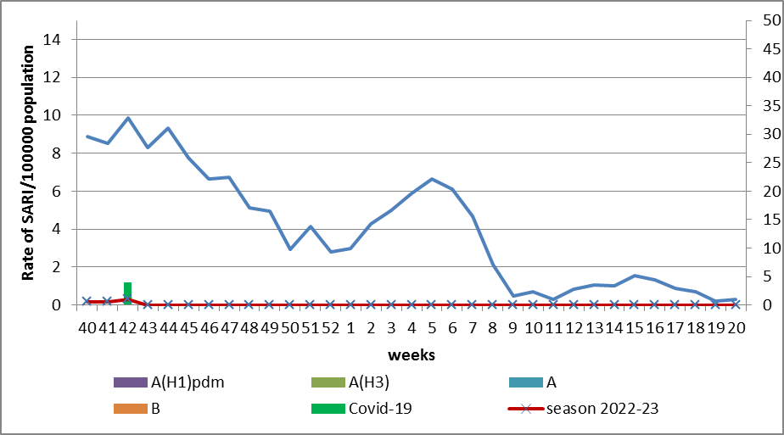

Fig.2 The dynamic of recorded SARI cases and the number of laboratory confirmed influenza and SARS-CoV-2 cases in season 2022 – 2023 in four sentinel centers of Ukraine.

According to weekly ECDC-WHO (https://flunewseurope.org), during the 41st week the influenza activity is on off-season levels in European region. Scotland and Germany informed about regional influenza activity, there were laboratory confirmed influenza A and B viruses with dominance of A(H3). The level of morbidity is above the epidemic threshold in Germany. Kazakhstan informed about wide spread of influenza. The highest number of confirmed influenza cases was observed among hospitalized patients with SARI during the 40 and 41st weeks of the current season.
So according to data of influenza sentinel surveillance system the morbidity indexes are on off-season levels. No influenza cases were detected in Ukraine.

Performed by:
Alla Mironenko, MD, DSc, Professor
Olga Holubka, PhD

