**L.V. Gromashevsky Institute of Epidemiology and Infectious Diseases National Academy of Medical Science of Ukraine**

**Scientific Influenza and ARI Center**

**Weekly Bulletin for Influenza Epidemic Situation in Ukraine by 4 Sentinel Centers**

**(Кyiv, Dnipro, Odessa, Khmelnitsky)**

**Week 42, 2017**

Since 2008 the system of ILI and SARI sentinel surveillance has been functioning in Ukraine. The sentinel centers are located in different geographical areas of the country: in Kyiv, Dnipro, Odessa and Khmelnytskyi, which include 18 sentinel stations: 10 hospitals and 8 polyclinics.

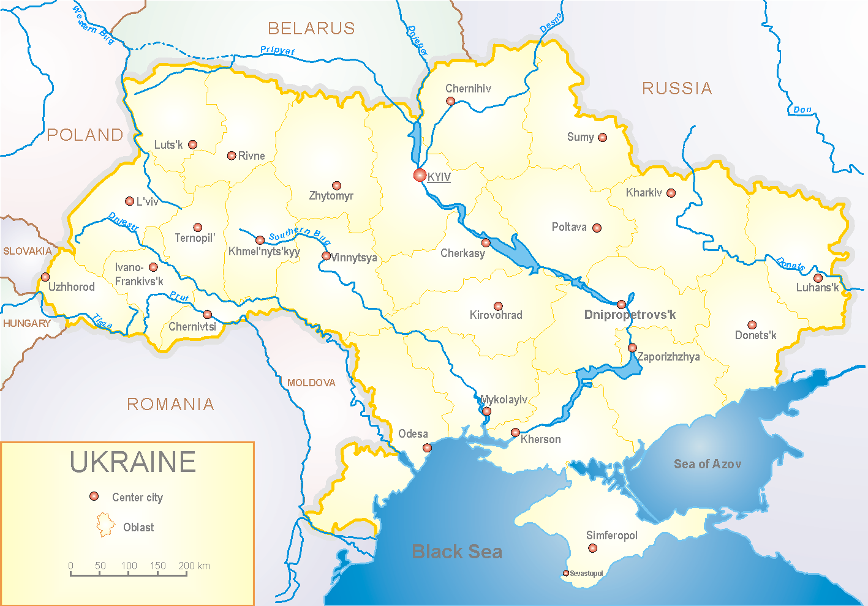

In 8 policlinics of 4 sentinel cities of Ukraine the quantity of outpatient, which meet the definition of ILI during the 42nd week (16.10 – 22.10.17) was 2 cases (1.0 per 100 thousand) corresponding population. In comparison with the previous week the morbidity levels have not changed (fig. 1).

Fig.1. The dynamic of ILI cases and number of laboratory confirmed influenza cases in 4 sentinel centers of Ukraine in the 2017 – 2018 season.

During the 42nd week in 10 hospitals of 4 sentinel centers there were hospitalized 1031 patients, this is 2.7% less than during the previous week. The quantity of SARI patients (patients which meet the definition SARI) was 4 cases (0.13 per 100 thousand); the growth rate of morbidity levels was 50.0% in comparison with the previous week (fig. 2).

Fig.2 The dynamic of SARI cases and the number of laboratory confirmed influenza in season 2017 – 2018 in four sentinel centers of Ukraine.

From 40th to 42nd week 2017-2018 there were investigated 12 samples from ILI and SARI patients by PCR method. There weren’t detected any positive influenza samples.

So the flu season is beginning in Ukraine.

Performed by:

Alla Mironenko, MD, DSc

Olga Holubka, PhD