L.V. Gromashevsky Institute of Epidemiology and Infectious Diseases National Academy of Medical Science of Ukraine

Scientific Influenza and ARI Center

Weekly Bulletin for Influenza Epidemic Situation in Ukraine by 4 Sentinel Centers
(Кyiv, Dnipro, Odessa, Khmelnitsky)
Week 43, 2022

Loaded on website www.ukrinfluenza.com.ua
Since 2008 the system of ILI* and SARI* sentinel surveillance has been functioning in Ukraine. The sentinel centers are located in different geographical areas of the country: in Kyiv, Dnipro, Odessa and Khmelnytsky, which include 15 sentinel stations: 9 hospitals and 6 polyclinics.
* - ILI and SARI case definitions include cases of respiratory diseases caused by other respiratory viruses: influenza, adenovirus, parainfluenza virus, rhinovirus, RSV and SARS-CoV-2.
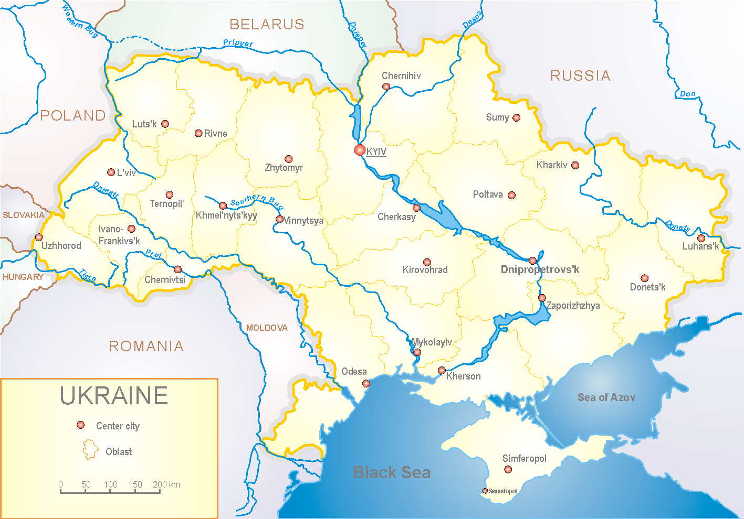
According to data of influenza sentinel surveillance system in Ukraine in 6 policlinics of 4 sentinel cities of Ukraine during the 43rd week (24.10 – 30.10.2022) the quantity of outpatient, which meet the definition of ILI was 78 cases (7.9 per 100 thousand). The decrease of morbidity level was 25.0% in comparison with the previous week and 2.1 times less than the index of previous year (16.7 per 100 thousand population in 2021) (fig. 1).

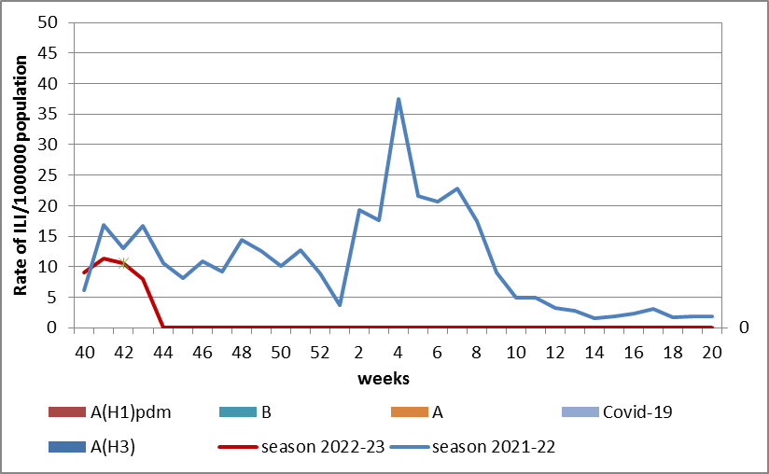

Fig.1. The dynamic of recorded ILI cases and number of laboratory confirmed influenza and SARS-CoV-2 cases in 4 sentinel centers of Ukraine in the 2022 – 2023 season.

During the 43rd week in 9 hospitals of 4 sentinel centers there were hospitalized 470 patients, this is 1.5% less than during previous week. The proportion of hospitalized patients is 0.9%. During the 43rd week there were 4 SARI patients (0.2 per 100 thousand). The decrease of morbidity level was 43.0% in comparison with the previous week and was 4 times less than the index of previous year (8.3 per 100 thousand in 2021). There were detected 2 cases of SARS-CoV-2 among adults (fig. 2).
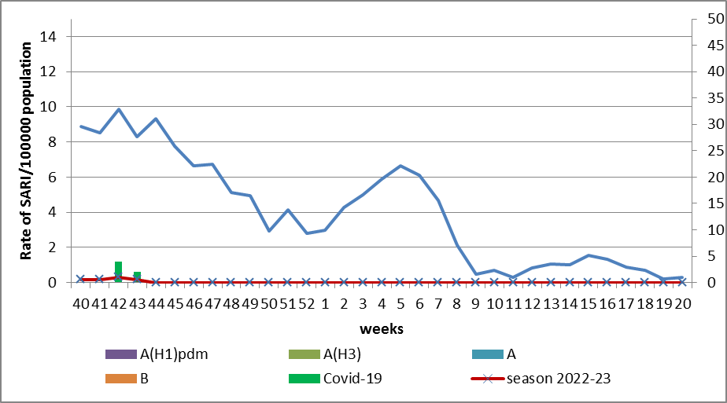
Fig.2 The dynamic of recorded SARI cases and the number of laboratory confirmed influenza and SARS-CoV-2 cases in season 2022 – 2023 in four sentinel centers of Ukraine.
According to weekly ECDC-WHO (https://flunewseurope.org), during the 42nd week the influenza activity is on off-season levels in European region. Scotland and Germany informed about regional influenza activity, there were laboratory confirmed influenza A and B viruses with dominance of A(H3). Kazakhstan informed about wide spread and circulation of influenza A and B viruses.
From the beginning of the season there were detected in sentinel clinics 94.7% of influenza A (A(H1)pdm – 24.6%, A(H3) – 75.4%) and influenza B – 2.6%.
According to data of FluNet platform (Global Influenza Programme) (https://www.who.int/tools/flunet) form the beginning of the 2022 – 2023 season in National Influenza Centers there were detected by PCR method 88.4% of influenza A and 1.6% of influenza B. Among them 18.3% belong to A(H1), 81.7% - to A(H3) and 33.0% - to influenza B/Victoria.
So according to data of influenza sentinel surveillance system the morbidity indexes are on off-season levels. No influenza cases were detected in Ukraine.

Performed by:
Alla Mironenko, MD, DSc, Professor
Olga Holubka, PhD

