L.V. Gromashevsky Institute of Epidemiology and Infectious Diseases National Academy of Medical Science of Ukraine

Scientific Influenza and ARI Center

Weekly Bulletin for Influenza and COVID-19 Epidemic Situation in Ukraine by 4 Sentinel Centers
(Кyiv, Dnipro, Odessa, Khmelnitsky)
Week 45, 2022

Loaded on website www.ukrinfluenza.com.ua
Since 2008 the system of ILI* and SARI* sentinel surveillance has been functioning in Ukraine. The sentinel centers are located in different geographical areas of the country: in Kyiv, Dnipro, Odessa and Khmelnytsky, which include 15 sentinel stations: 9 hospitals and 6 polyclinics.
* - ILI and SARI case definitions include cases of respiratory diseases caused by other respiratory viruses: influenza, adenovirus, parainfluenza virus, rhinovirus, RSV and SARS-CoV-2.
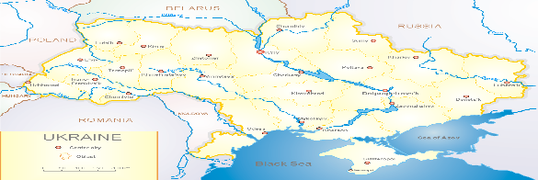
According to data of influenza sentinel surveillance system in Ukraine in 6 policlinics of 4 sentinel cities of Ukraine during the 45th week (07.11 – 13.11.2022) the quantity of outpatient, which meet the definition of ILI was 58 cases (5.9 per 100 thousand). The decrease of morbidity level was 53.2% in comparison with the previous week and 27.5% less than the index of previous year (8.1 per 100 thousand population in 2021) (fig. 1).

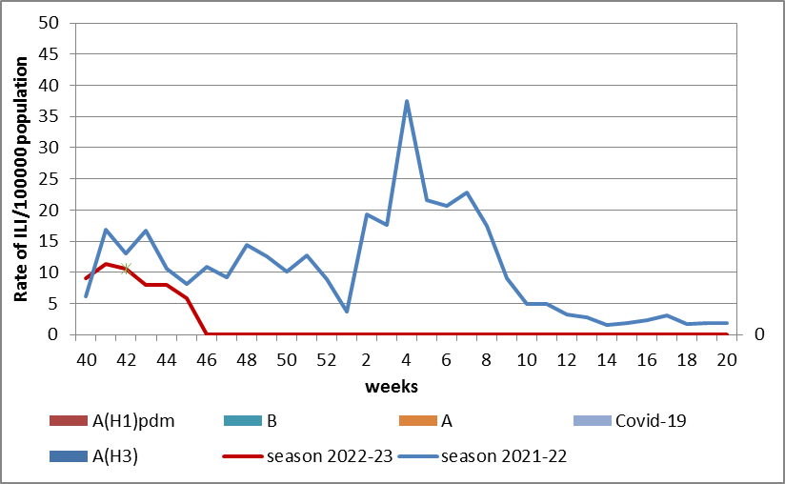

Fig.1. The dynamic of recorded ILI cases and number of laboratory confirmed influenza and SARS-CoV-2 cases in 4 sentinel centers of Ukraine in the 2022 – 2023 season.
During the 45th week in 9 hospitals of 4 sentinel centers there were hospitalized 506 patients, this is 22.0% more than during previous week. The proportion of hospitalized patients is 2.4%. During the 45th week there were 12 SARI patients (0.5 per 100 thousand). The increase of morbidity level was 25.0% in comparison with the previous week and was 3 times less than the index of previous year (9.3 per 100 thousand in 2021). There were detected 2 cases of SARS-CoV-2 among adults (fig. 2).

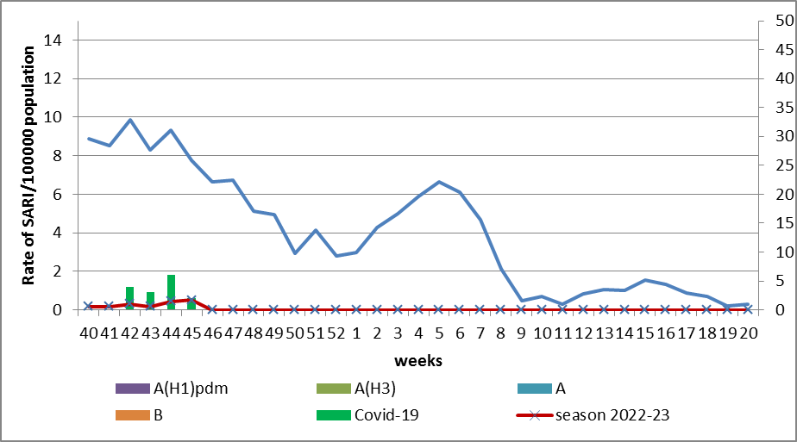

Fig.2 The dynamic of recorded SARI cases and the number of laboratory confirmed influenza and SARS-CoV-2 cases in season 2022 – 2023 in four sentinel centers of Ukraine.

From the 40th to the 45th week there were investigated 23 samples from ILI and SARI patients by PCR method. There were laboratory confirmed 15 COVID-19 cases (65.2%). There were not detected any influenza cases.

According to weekly ECDC-WHO (https://flunewseurope.org), during the 45th week the influenza activity is on off-season levels but higher than the previous 4 epidemic seasons. According to data of sentinel entities of primary health care three counties reported about the activity of seasonal influenza: Germany, Kazakhstan and United Kingdom (Scotland). In all monitoring systems there were identified influenza A and B viruses with a preponderance of A(H3) in sentinel and non-sentinel epidemic surveillance systems.
From the beginning of the season 2022-2023 there were detected by PCR method 9678 influenza cases (7.1%); among them 88.2% of influenza A and 11.8% of influenza B in sentinel clinics and intensive care units. Among them 17.6% belong to A(H1), 82.4% - to A(H3).
According to data of PHC of MOH of Ukraine during the reported week the part of confirmed COVID-19 cases decreased by 7.7% both among adults and among children (-5.9%).
So according to sentinel surveillance of Ukraine the morbidity indexes are on off-season levels with gradual increase of indexes which can be due to respiratory infections caused by other pathogens except influenza virus and SARS-CoV-2 virus which leads to increase of relevant indicators without detection of influenza viruses.

Performed by:
Alla Mironenko, MD, DSc, Professor
Olga Holubka, PhD

