L.V. Gromashevsky Institute of Epidemiology and Infectious Diseases National Academy of Medical Science of Ukraine

Scientific Influenza and ARI Center

Weekly Bulletin for Influenza and COVID-19 Epidemic Situation in Ukraine by 4 Sentinel Centers
(Кyiv, Dnipro, Odessa, Khmelnitsky)
Week 47, 2022

Loaded on website www.ukrinfluenza.com.ua
Since 2008 the system of ILI* and SARI* sentinel surveillance has been functioning in Ukraine. The sentinel centers are located in different geographical areas of the country: in Kyiv, Dnipro, Odessa and Khmelnytsky, which include 15 sentinel stations: 9 hospitals and 6 polyclinics.
* - ILI and SARI case definitions include cases of respiratory diseases caused by other respiratory viruses: influenza, adenovirus, parainfluenza virus, rhinovirus, RSV and SARS-CoV-2.
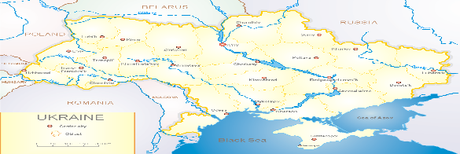
According to data of influenza sentinel surveillance system in Ukraine in 6 policlinics of 4 sentinel cities of Ukraine during the 47th week (21.11 – 27.11.2022) the quantity of outpatient, which meet the definition of ILI was 75 cases (7.6 per 100 thousand). The decrease of morbidity level was 20.2% in comparison with the previous week and 17.6% less than the index of previous year (9.2 per 100 thousand population in 2021) (fig. 1).

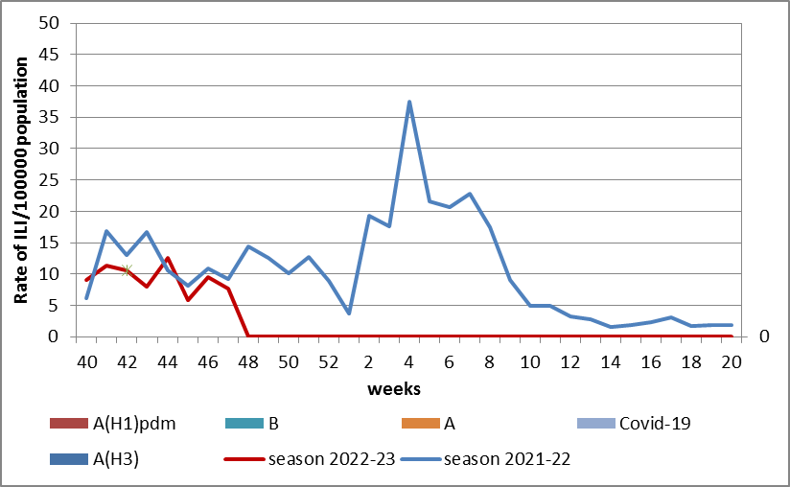

Fig.1. The dynamic of recorded ILI cases and number of laboratory confirmed influenza and SARS-CoV-2 cases in 4 sentinel centers of Ukraine in the 2022 – 2023 season.

During the 47th week in 9 hospitals of 4 sentinel centers there were hospitalized 555 patients, among them 384 children (69.2%) with a suspicion of SARI; this is 12.1% more than during the previous week. The proportion of hospitalized patients is 2.7%. During the 47th week there were 15 SARI patients (0.6 per 100 thousand), among them – 9 children under 17 years old. The increase of morbidity level was 87.5% in comparison with the previous week, but was 90% less than the index of previous year (6.7 per 100 thousand). There were laboratory confirmed 3 viruses of SARS-CoV-2 among adults and 2 viruses of influenza A among children (fig. 2).

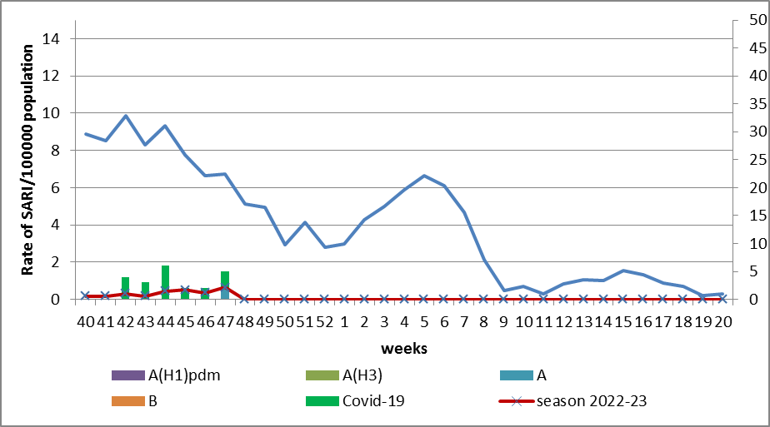

Fig.2 The dynamic of recorded SARI cases and the number of laboratory confirmed influenza and SARS-CoV-2 cases in season 2022 – 2023 in four sentinel centers of Ukraine.

From the 40th to the 47th week there were investigated 42 samples from ILI and SARI patients by PCR method. There were laboratory confirmed 22 viruses among them – 20 SARS-CoV-2 viruses (48.0%) and 2 influenza A viruses.
According to weekly ECDC-WHO (https://flunewseurope.org), on the 46th week in the countries of European region has been observing the exceeding of epidemic threshold by 10% during last two weeks which indicates the beginning of influenza season in the European region.
There were reported about the exceeding of epidemic threshold by 10% by such countries: Germany, Greece, Israel, Spain, Kazakhstan, Kyrgyzstan, Netherlands, Portugal, United Kingdom and France.
In all monitoring systems there were identified influenza A and B viruses with a preponderance of A(H3) in sentinel and non-sentinel epidemic surveillance systems.

From the beginning of the season 2022-2023 there were detected by PCR method 1519 influenza cases (9.0%) among 16959 investigated sentinel samples. Among them 87.3% - influenza A and 12.7% - influenza B. 14.6% belong to influenza A(H1)pdm and 85.4% - to A(H3). 3 influenza B viruses belong to B/Victoria lineage.
According to data of PHC of MOH of Ukraine during the reported week the part of confirmed COVID-19 cases decreased by 7.7% both among adults and among children (-5.9%), 102 fatal cases were registered among people 60+, this is 1% less than during the previous week.
So according to sentinel surveillance of Ukraine the morbidity indexes are on off-season levels with gradual increase of indexes which is caused by simultaneous circulation of SARS-CoV-2 and influenza viruses.

Performed by:
Alla Mironenko, MD, DSc, Professor
Olga Holubka, PhD

