L.V. Gromashevsky Institute of Epidemiology and Infectious Diseases National Academy of Medical Science of Ukraine

Scientific Influenza and ARI Center

Weekly Bulletin for Influenza Epidemic Situation in Ukraine by 4 Sentinel Centers
(Кyiv, Dnipro, Odessa, Khmelnitsky)
Week 48, 2021

Loaded on website www.ukrinfluenza.com.ua

Since 2008 the system of ILI and SARI sentinel surveillance has been functioning in Ukraine. The sentinel centers are located in different geographical areas of the country: in Kyiv, Dnipro, Odessa and Khmelnytsky, which include 15 sentinel stations: 9 hospitals and 6 polyclinics.
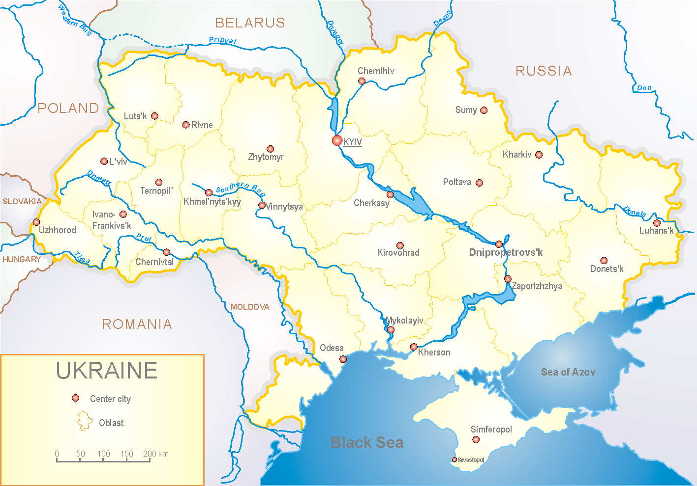
Influenza epidemic season the second year takes place on the background of SARS-CoV-2 pandemic both in Ukraine and in the world.
According to data of influenza sentinel surveillance system in Ukraine in 6 policlinics of 4 sentinel cities of Ukraine the quantity of outpatient, which meet the definition of ILI during the 48th week (29.11.2021 – 05.12.2021) was 142 cases (13.4 per 100 thousand). The increase of morbidity levels was 56.0% in comparison with the previous week and 16.2% less than the index of previous year (index 12.6 per 100 thousand – 2020) (fig. 1).

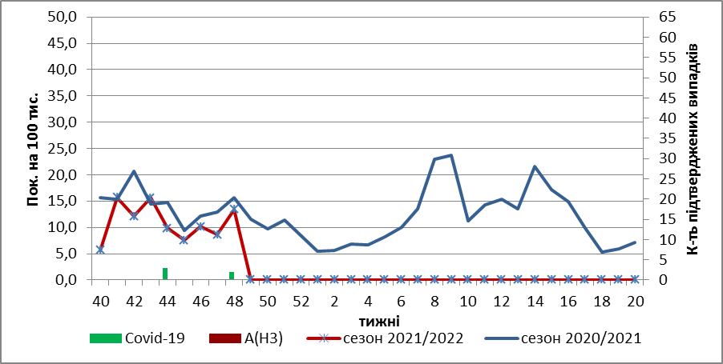

Fig.1. The dynamic of recorded ILI cases and number of laboratory confirmed influenza and SARS-CoV-2 cases in 4 sentinel centers of Ukraine in the 2021 – 2022 season.

During the 48th week in 9 hospitals of 4 sentinel centers there were hospitalized 724 patients. This is 6.3% less than during the previous week. The quantity of SARI patients (patients which meet the definition SARI) was 119 cases (4.7 per 100 thousand). The decrease of morbidity level was 24.2% in comparison with the previous week and was 4.2 times more than the index of previous year (1.1 per 100 thousand in 2020) (fig. 2).
Fig.2 The dynamic of recorded SARI cases and the number of laboratory confirmed influenza and SARS-CoV-2 cases in season 2021 – 2022 in four sentinel centers of Ukraine.
From the 40th to the 48th week there were investigated 72 samples from ILI and SARI patients by PCR method. There were laboratory confirmed 47 SARS-CoV-2 viruses, influenza B virus – 1, 2 – rhinoviruses, 2 – RSV (fig. 3).
Fig. 3. Number of laboratory confirmed SARS-CoV-2 positive cases in sentinel centers of Ukraine in season 2021-2022

So, according to sentinel surveillance the SARI and ILI morbidity indexes are on the background levels with sporadic cases of influenza B.
According to weekly ECDC-WHO influenza activity in European countries have increased, among SARI patients influenza A(H3) prevails.
From the beginning of the season in European countries there were investigated 12121 samples from ILI and SARI patients by PCR method. Among them there were laboratory confirmed 218 (1.8%) influenza viruses: influenza A – 210 (96.3%) and 8 (3.7%) – influenza B. Among them influenza A (unsubtypted) – 62 (29.6%), influenza A(H3) – 145 (69.0%) and 3 (1.4%) - influenza A(H1)pdm.

Performed by:
Alla Mironenko, MD, DSc
Olga Holubka, PhD

