L.V. Gromashevsky Institute of Epidemiology and Infectious Diseases National Academy of Medical Science of Ukraine

Scientific Influenza and ARI Center

Weekly Bulletin for Influenza and COVID-19 Epidemic Situation in Ukraine by 4 Sentinel Centers
(Кyiv, Dnipro, Odessa, Khmelnitsky)
Week 48, 2022

Loaded on website www.ukrinfluenza.com.ua
Since 2008 the system of ILI* and SARI* sentinel surveillance has been functioning in Ukraine. The sentinel centers are located in different geographical areas of the country: in Kyiv, Dnipro, Odessa and Khmelnytsky, which include 15 sentinel stations: 9 hospitals and 6 polyclinics.
* - ILI and SARI case definitions include cases of respiratory diseases caused by other respiratory viruses: influenza, adenovirus, parainfluenza virus, rhinovirus, RSV and SARS-CoV-2.
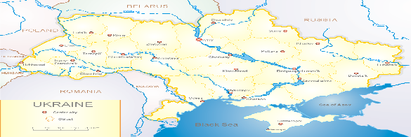
According to data of influenza sentinel surveillance system in Ukraine in 6 policlinics of 4 sentinel cities of Ukraine during the 48th week (28.11 – 04.12.2022) the quantity of outpatient, which meet the definition of ILI was 59 cases (6.0 per 100 thousand). The decrease of morbidity level was 21.3% in comparison with the previous week and 3 times less than the index of previous year (14.4 per 100 thousand population in 2021). The decrease of registering of morbidity levels was due to massive missile attack of russian federation on the infrastructure of Ukraine which caused the switching off power in the territory of Ukraine for about 3 days (fig. 1).
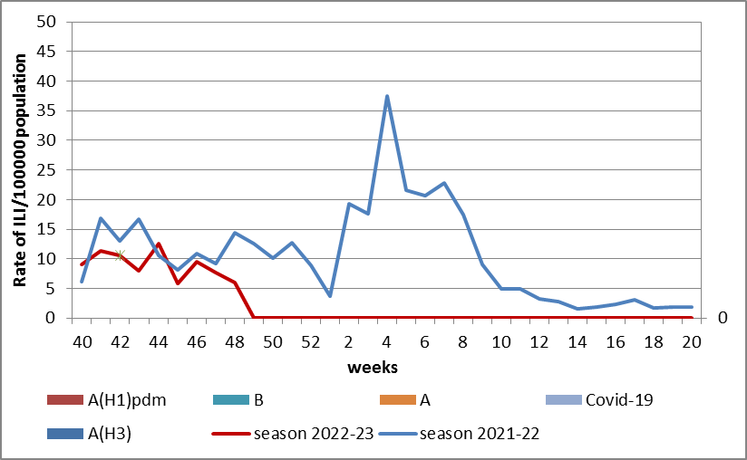

Fig.1. The dynamic of recorded ILI cases and number of laboratory confirmed influenza and SARS-CoV-2 cases in 4 sentinel centers of Ukraine in the 2022 – 2023 season.
During the 48th week in 9 hospitals of 4 sentinel centers there were hospitalized 532 patients, among them 376 children (70.7%) with a suspicion of SARI; this is 4.1% less than during the previous week. The proportion of hospitalized patients is 2.8%. During the 48th week there were 15 SARI patients (0.6 per 100 thousand), among them – 7 children under 17 years old. The index didn’t change in comparison with the previous week, but was 87.0% less than the index of previous year (5.1 per 100 thousand). There were laboratory confirmed 3 viruses of SARS-CoV-2 among adults and 1 viruses of influenza A among children (fig. 2).

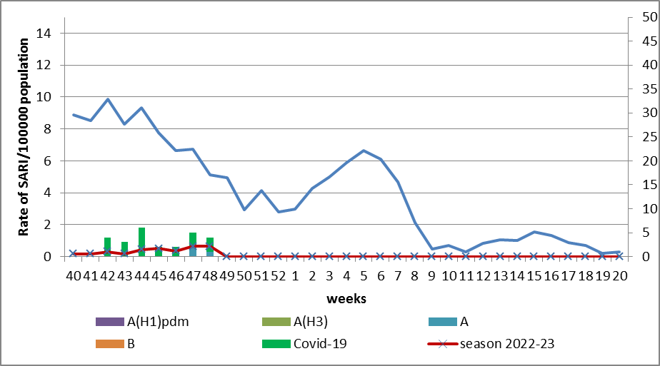

Fig.2 The dynamic of recorded SARI cases and the number of laboratory confirmed influenza and SARS-CoV-2 cases in season 2022 – 2023 in four sentinel centers of Ukraine.

From the 40th to the 48th week there were investigated 54 samples from ILI and SARI patients by PCR method. There were laboratory confirmed 26 viruses (49.0%), among them – 23 SARS-CoV-2 viruses and 3 influenza A viruses.
According to weekly ECDC-WHO (https://flunewseurope.org), on the 47th week in the countries of European region has been observing the exceeding of epidemic threshold by 10% during last three weeks, so the influenza epidemic was declared in the European region.
There were reported about the exceeding of epidemic threshold more than 10% by such countries: Germany, Greece, Israel, Spain, Italy, Kazakhstan, Kyrgyzstan, Luxemburg, Republic of Moldova, Uzbekistan and France.
In all monitoring systems there were identified influenza A and B viruses with a preponderance of A(H3) in sentinel and non-sentinel epidemic surveillance systems.

From the beginning of the season 2022-2023 there were detected by PCR method 2207 influenza cases (10.2%) among 21579 investigated sentinel samples. Among them 89.1% - influenza A and 10.9% - influenza B. 14.1% belong to influenza A(H1)pdm and 85.9% - to A(H3). 115 influenza B viruses belong to B/Victoria lineage, 125 – influenza B.
According to data of PHC of MOH of Ukraine during the reported week the part of confirmed COVID-19 cases decreased by 26.1% both among adults and among children (-30.4%), 80 fatal cases were registered among people 60+, this is 21.6% less than during the previous week.
So according to sentinel surveillance of Ukraine the morbidity indexes are on off-season levels with gradual increase of indexes which is caused by simultaneous circulation of SARS-CoV-2 and influenza viruses.

Performed by:
Alla Mironenko, MD, DSc, Professor
Olga Holubka, PhD

