L.V. Gromashevsky Institute of Epidemiology and Infectious Diseases National Academy of Medical Science of Ukraine

Scientific Influenza and ARI Center

Weekly Bulletin for Influenza and COVID-19 Epidemic Situation in Ukraine by 4 Sentinel Centers
(Кyiv, Dnipro, Odessa, Khmelnitsky)
Week 49, 2022

Loaded on website www.ukrinfluenza.com.ua

Since 2008 the system of ILI* and SARI* sentinel surveillance has been functioning in Ukraine. The sentinel centers are located in different geographical areas of the country: in Kyiv, Dnipro, Odessa and Khmelnytsky, which include 15 sentinel stations: 9 hospitals and 6 polyclinics.
* - ILI and SARI case definitions include cases of respiratory diseases caused by other respiratory viruses: influenza, adenovirus, parainfluenza virus, rhinovirus, RSV and SARS-CoV-2.
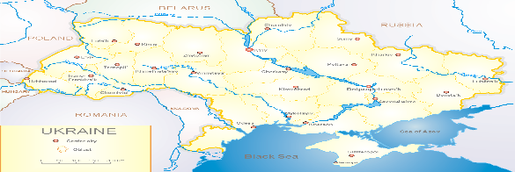
According to data of influenza sentinel surveillance system in Ukraine in 6 policlinics of 4 sentinel cities of Ukraine during the 49th week (05.12 – 11.12.2022) the quantity of outpatient, which meet the definition of ILI was 47 cases (4.8 per 100 thousand). The decrease of morbidity level was 20.3% in comparison with the previous week and 3 times less than the index of previous year (12.6 per 100 thousand population in 2021) (fig. 1).

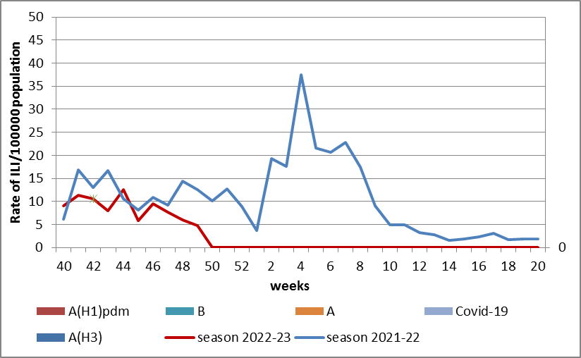

Fig.1. The dynamic of recorded ILI cases and number of laboratory confirmed influenza and SARS-CoV-2 cases in 4 sentinel centers of Ukraine in the 2022 – 2023 season.
During the 49th week in 9 hospitals of 4 sentinel centers there were hospitalized 690 patients, among them 478 children (69.3%) with a suspicion of SARI; this is 25.9% more than during the previous week. The proportion of hospitalized patients is 3.4%. During the 49th week there were 23 SARI patients (1.0 per 100 thousand), among them – 15 children (3.4 per 100 thousand) under 17 years old. The increase of morbidity levels was 53.3% in comparison with the previous week, but was 80.0% less than the index of previous year (4.9 per 100 thousand - 2021). There were laboratory confirmed 3 viruses of SARS-CoV-2 among adults and 9 viruses of influenza A among children (fig. 2).

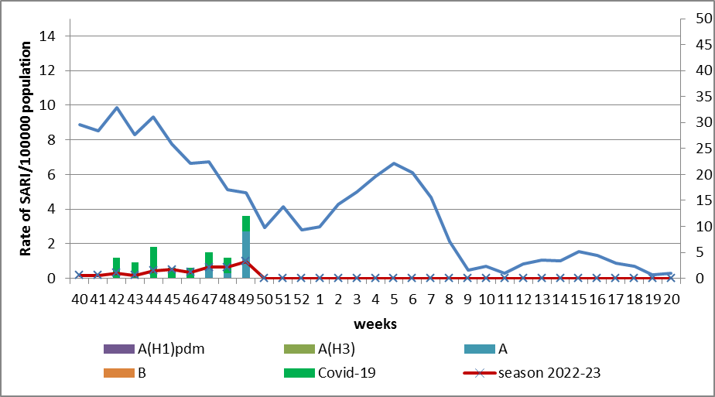

Fig.2 The dynamic of recorded SARI cases and the number of laboratory confirmed influenza and SARS-CoV-2 cases in season 2022 – 2023 in four sentinel centers of Ukraine.

From the 40th to the 49th week there were investigated 70 samples from ILI and SARI patients by PCR method. There were laboratory confirmed 38 viruses (55.0%), among them – 26 SARS-CoV-2 viruses and 12 influenza A viruses.

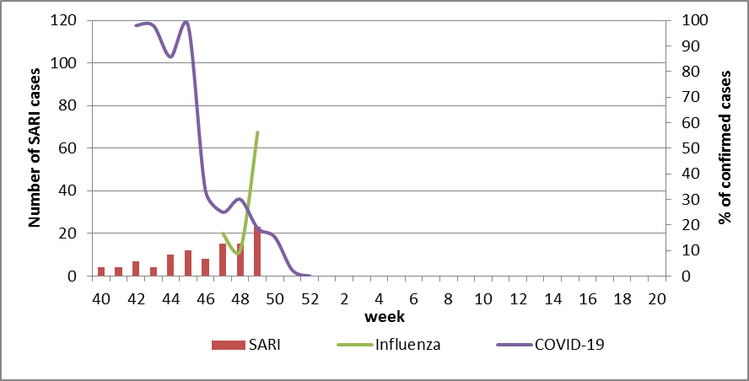

Fig. 3 Percentage of confirmed influenza and COVID-19 cases among hospitalized patients with SARI from the 40th week 2022 to the 20th week 2023.

According to Fig. 3 we can see that the simultaneous circulation of both pathogens leads to effect of “scissors”: the percentage of virological confirmations of COVID-19 decreases among patients with activation of influenza virus with significant increase of positive influenza cases.
According to weekly ECDC-WHO (https://flunewseurope.org), on the 48th week in the countries of European region the influenza epidemic continues and the influenza activity increases. Another 14 countries reported about regional or widespread activity and the epidemic intensity fluctuate from medium to very high.
A lot of countries have the exceeding of epidemic threshold from 15% to 20%. According to data of sentinel entities of 5 countries (Germany, Greece, Italy, Kyrgyzstan and Uzbekistan) among examined patients 40% are positive for influenza.
There were reported about the exceeding of epidemic threshold more than 10% by such countries: Germany, Greece, Israel, Spain, Italy, Kazakhstan, Kyrgyzstan, Luxemburg, Republic of Moldova, Uzbekistan and France.
There were identified influenza A and B viruses with a preponderance of A(H3) in sentinel epidemic surveillance systems. At the first time in the current season the dominance of A(H1)pdm was recorded in the systems of non-sentinel epidemic surveillance.
From the beginning of the season 2022-2023 there were detected by PCR method 3030 influenza cases (12.0%) among 25886 investigated sentinel samples. Among them 90.0% - influenza A and 10.0% - influenza B. 12.4% belong to influenza A(H1)pdm and 87.6% - to A(H3). 128 influenza B viruses belong to B/Victoria lineage, 163 – influenza B.
According to data of PHC of MOH of Ukraine during the 49th week the part of confirmed COVID-19 cases decreased by 3.6% both among adults and among children (-12.0%) in comparison with previous week. 80 fatal cases were registered among people 60+, this is 32.5% less than during the previous week.
So according to sentinel surveillance of Ukraine the morbidity indexes are on background levels with significant increase of indexes which is caused by simultaneous circulation of SARS-CoV-2 and influenza viruses.

Performed by:
Alla Mironenko, MD, DSc, Professor
Olga Holubka, PhD

