L.V. Gromashevsky Institute of Epidemiology and Infectious Diseases National Academy of Medical Science of Ukraine

Scientific Influenza and ARI Center

Weekly Bulletin for Influenza Epidemic Situation in Ukraine by 4 Sentinel Centers
(Кyiv, Dnipropetrovsk, Odesa, Khmelnitsky)
Week 49, 2016

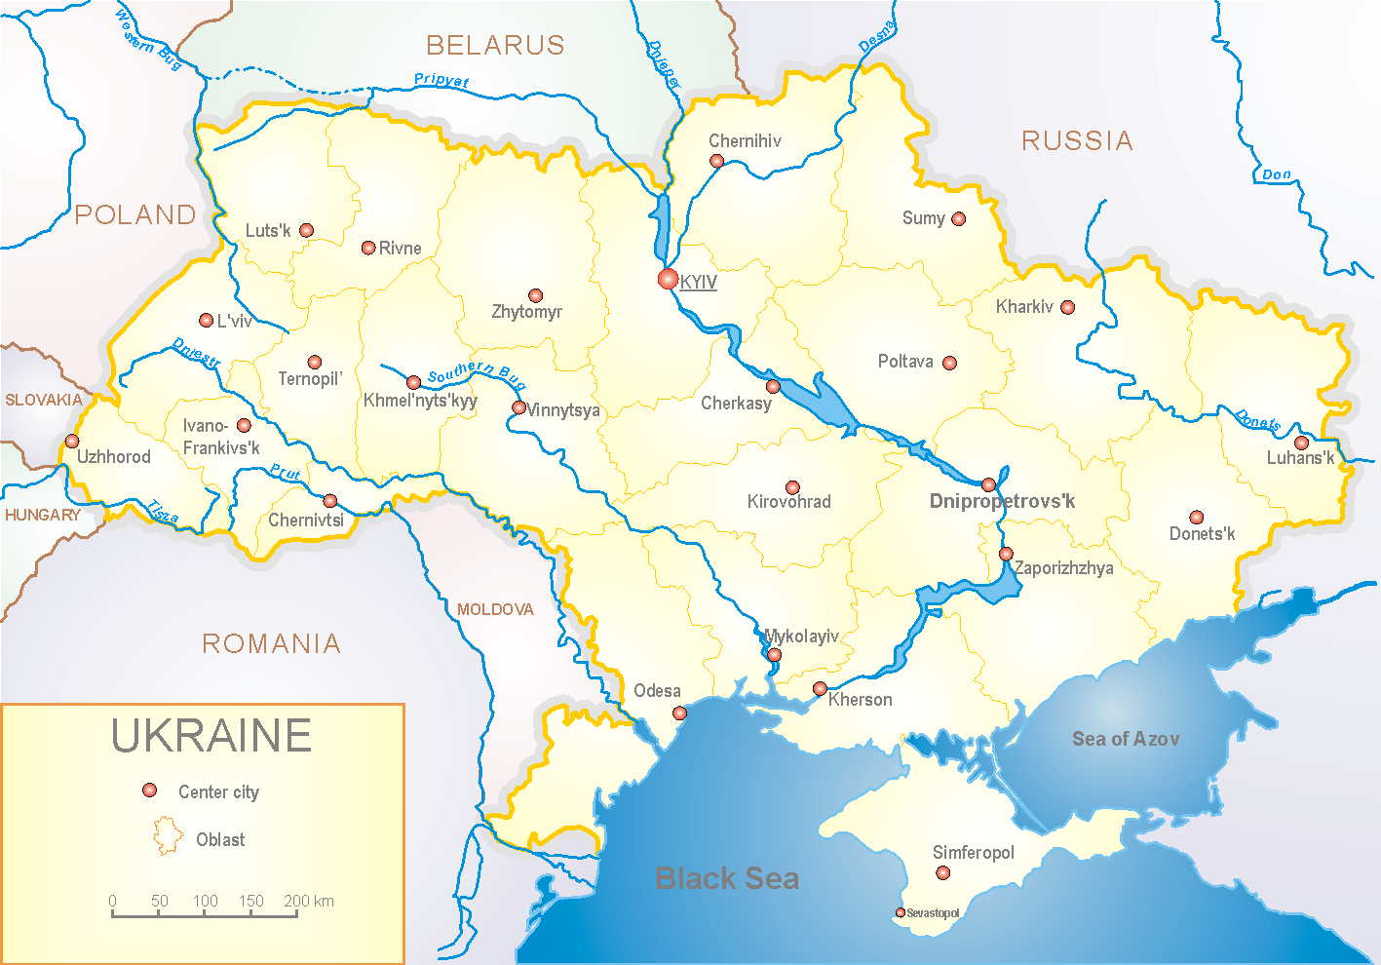
Since 2008 the system of ILI and SARI sentinel surveillance has been functioning in Ukraine. The sentinel centers are located in different geographical areas of the country: in Kyiv, Dnipropetrovsk, Odessa and Khmelnytskyi, which include 18 sentinel stations: 10 hospitals and 8 polyclinics.

According to data of influenza sentinel surveillance system in Ukraine in 8 policlinics of 4 sentinel centers the quantity of outpatient, which meet the definition of ILI during the 49th week (05.12 – 11.12.16) was 92 cases (44.3 per 100 thousand) corresponding population. In comparison with the previous week there was the increase of morbidity level – 3.4%. There were 4 laboratory confirmed influenza cases A(H3) and 4 – influenza A (H1) and 10 – influenza A (unsubtyped) (fig. 1).

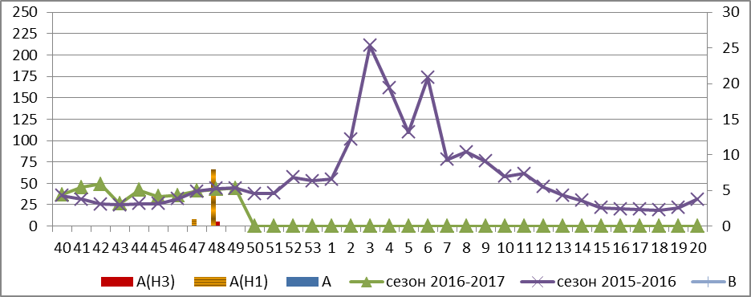

Fig.1. The dynamic of ILI cases and number of laboratory confirmed influenza cases in 4 sentinel cities of Ukraine in the 2016 – 2017 season.

During the 49th week in 10 hospitals of 4 sentinel centers there were hospitalized 1703 patients, this is 23.3% more than during the previous week. The quantity of SARI patients (patients which meet the definition SARI) was 156 cases (5.25 per 100 thousand) the level of morbidity increased in 2.3 times in comparison with the previous week. There were laboratory confirmed 13 influenza cases A(H3) and 18 – influenza A (unsubtyped) during the week (fig. 2).

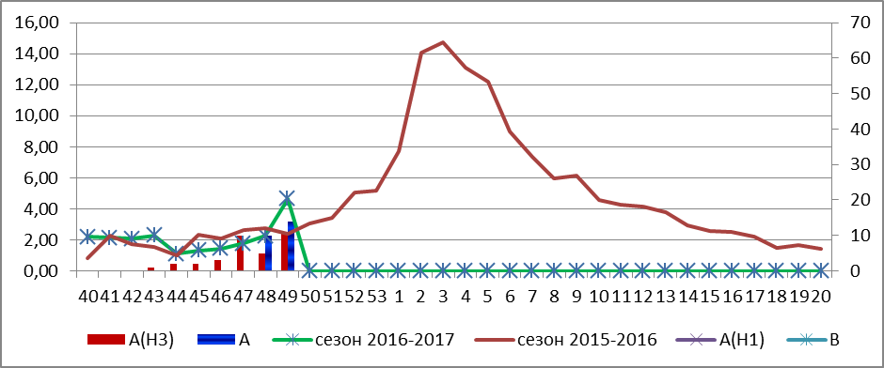

Fig.2 The dynamic of SARI cases and the number of laboratory confirmed influenza in season 2016 – 2017 in four sentinel centers of Ukraine.

The proportion of SARI cases was 9.2% from the total number of hospitalizations and it increased in 1.8 times in comparison with the previous week (fig. 3).
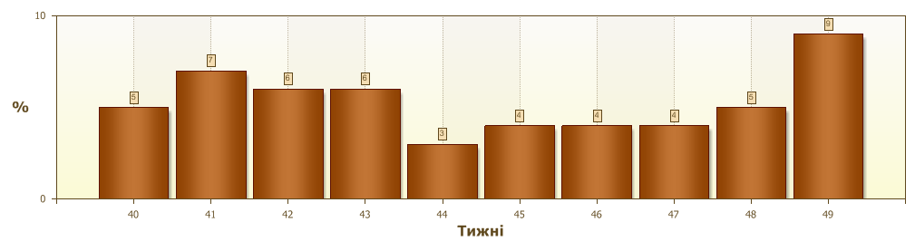
Fig.3. Proportion of SARI from the total number of hospitalizations in 10 hospitals of sentinel centers.

From 40th to 49th week 2016-2017 there were investigated 174 samples from ILI and SARI patients by PCR method. There were detected 103 positive influenza samples: 38 – influenza viruses A(unsubtyped), 9 – influenza virus A(H1) and 56 – influenza viruses A(H3) (fig.4).

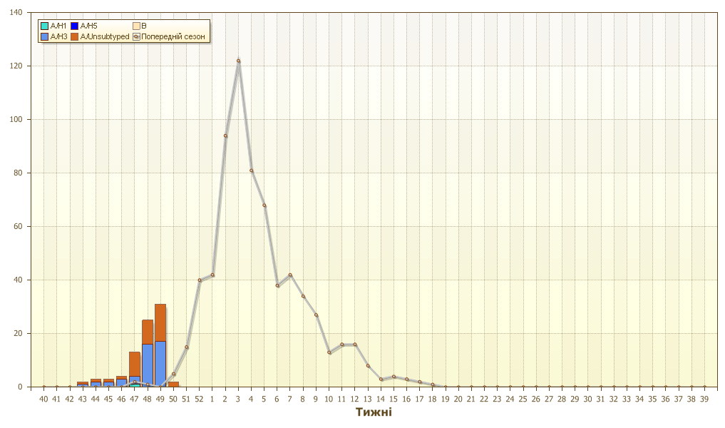

Fig.4. The number of laboratory confirmed influenza cases among ILI and SARI patients in season 2016 – 2017 in four sentinel centers of Ukraine.

Performed by:
Alla Mironenko, MD, DSc
Olga Holubka, PhD

