L.V. Gromashevsky Institute of Epidemiology and Infectious Diseases National Academy of Medical Science of Ukraine

Scientific Influenza and ARI Center

Weekly Bulletin for Influenza Epidemic Situation in Ukraine by 4 Sentinel Centers
(Кyiv, Dnipro, Odessa, Khmelnitsky)
Week 49, 2021

Loaded on website www.ukrinfluenza.com.ua

Since 2008 the system of ILI and SARI sentinel surveillance has been functioning in Ukraine. The sentinel centers are located in different geographical areas of the country: in Kyiv, Dnipro, Odessa and Khmelnytsky, which include 15 sentinel stations: 9 hospitals and 6 polyclinics.
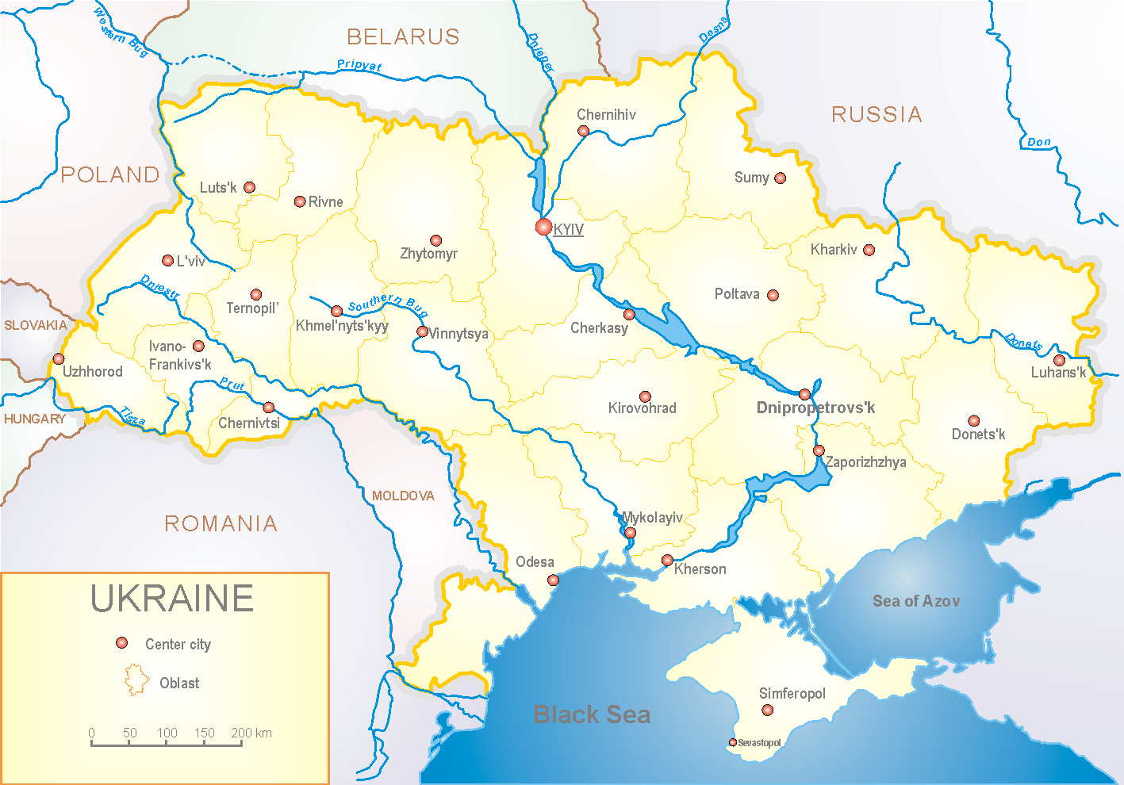
Influenza epidemic season the second year takes place on the background of SARS-CoV-2 pandemic both in Ukraine and in the world.
According to data of influenza sentinel surveillance system in Ukraine in 6 policlinics of 4 sentinel cities of Ukraine the quantity of outpatient, which meet the definition of ILI during the 49th week (06.12.2021 – 12.12.2021) was 124 cases (11.7 per 100 thousand). The decrease of morbidity levels was 12.7% in comparison with the previous week and 1.6% more than the index of previous year (index 11.5 per 100 thousand – 2020) (fig. 1).

Fig.1. The dynamic of recorded ILI cases and number of laboratory confirmed influenza and SARS-CoV-2 cases in 4 sentinel centers of Ukraine in the 2021 – 2022 season.

During the 49th week in 9 hospitals of 4 sentinel centers there were hospitalized 792 patients. This is 9.4% more than during the previous week. The quantity of SARI patients (patients which meet the definition SARI) was 115 cases (4.7 per 100 thousand). The decrease of morbidity level was 3.4% in comparison with the previous week and was 87.8% more than the index of previous year (0.5 per 100 thousand in 2020) (fig. 2).
Fig.2 The dynamic of recorded SARI cases and the number of laboratory confirmed influenza and SARS-CoV-2 cases in season 2021 – 2022 in four sentinel centers of Ukraine.
From the 40th to the 49th week there were investigated 88 samples from ILI and SARI patients by PCR method. There were laboratory confirmed 59 SARS-CoV-2 viruses, influenza A(H3) virus – 1, influenza B virus – 1, 2 – rhinoviruses, 2 – RSV (fig. 3).
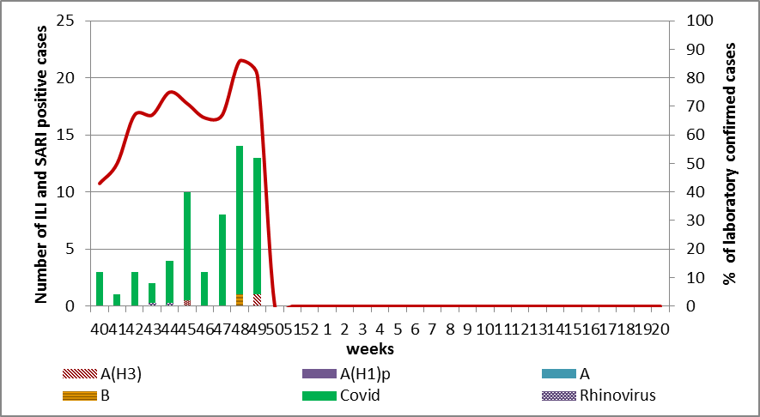

Fig. 3. Number of laboratory confirmed SARS-CoV-2 positive cases in sentinel centers of Ukraine in season 2021-2022

So, according to sentinel surveillance the SARI and ILI morbidity indexes are on the background levels with sporadic cases of influenza B and A(H3).
According to weekly ECDC-WHO influenza activity in European countries increase in different countries with different intensity, among SARI patients influenza A(H3) prevails. Among 43 Member States that provide data on geographical distribution: 18 provide data about the absence of flu activity, 12 countries (in different parts of the Region) informed about sporadic cases, 4 countries (Albania, Norway, Slovakia, France) informed about local activity, 4 (Kyrgyzstan, Republic of Moldova, Northern Macedonia, Kosovo) – about regional flu activity and 5 countries (Belarus, Kazakhstan, Russian Federation, Turkey, Sweden) – about widespread influenza activity.
From the beginning of the season in European countries there were investigated 15147 samples from ILI and SARI patients by PCR method. Among them there were laboratory confirmed 431 (2.8%) influenza viruses: influenza A – 416 (96.5%) and 15 (3.5%) – influenza B. Among them influenza A (unsubtypted) – 172 (41.3%), influenza A(H3) – 234 (56.3%) and 10 (2.4%) - influenza A(H1)pdm.
The genetic characteristic of 186 influenza viruses have been examined for the current season: 183 influenza A(H3) viruses belong to the strain А/Bangladesh/4005/2020A(H3), 1 - A(H1)pdm09 virus is represented by the strain А/Guangdond-Maonan/SWL1536/2019.
2 influenza B viruses type Victoria: 1 of them belongs to the strain В/Washington/02/2019 and 1 – to the strain В/ Austria/1359412/2021.

Performed by:
Alla Mironenko, MD, DSc
Olga Holubka, PhD

