L.V. Gromashevsky Institute of Epidemiology and Infectious Diseases National Academy of Medical Science of Ukraine

Scientific Influenza and ARI Center

Weekly Bulletin for Influenza Epidemic Situation in Ukraine by 4 Sentinel Centers
(Кyiv, Dnipro, Odesa, Khmelnitsky)
Week 4, 2017

Loaded on website www.ukrinfluenza.com.ua
Since 2008 the system of ILI and SARI sentinel surveillance has been functioning in Ukraine. The sentinel centers are located in different geographical areas of the country: in Kyiv, Dnipro, Odessa and Khmelnytskyi, which include 18 sentinel stations: 10 hospitals and 8 polyclinics.
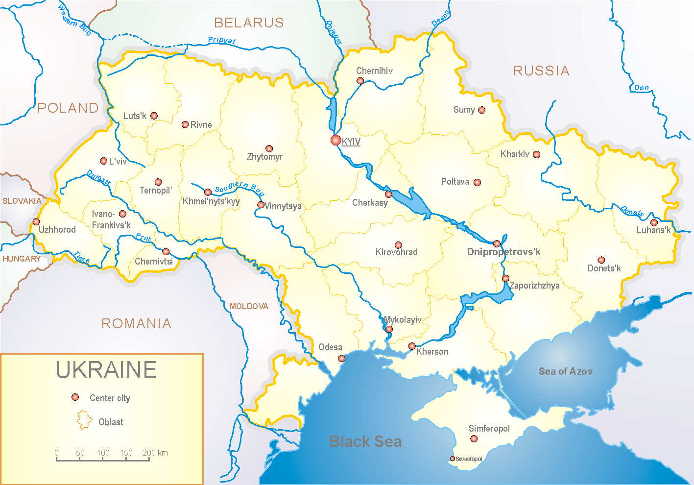

According to data of influenza sentinel surveillance system in Ukraine in 8 policlinics of 4 sentinel centers the quantity of outpatient, which meet the definition of ILI during the 4th week (23.01 – 29.01.17) was 110 cases (53.0 per 100 thousand corresponding population). In comparison with the previous week the decline of morbidity level was 0.9%. There were 2 laboratory confirmed influenza cases A(H3) (fig.1).
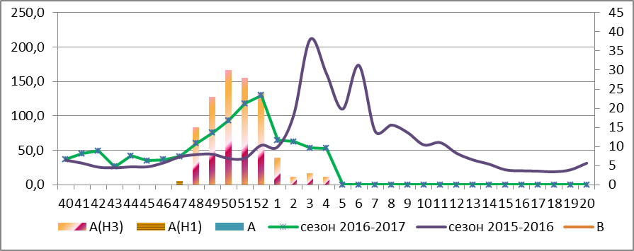

Fig.1. The dynamic of ILI cases and number of laboratory confirmed influenza cases in 4 sentinel centers of Ukraine in the 2016 – 2017 season.

During the 4th week in 10 hospitals of 4 sentinel centers there were hospitalized 1110 patients, this is 4.8% more than during the previous week. The quantity of SARI patients (patients which meet the definition SARI) was 60 cases (2.02 per 100 thousand); the decline of morbidity levels was 34.1% in comparison with the previous week. During the week there were laboratory confirmed 6 influenza cases A(H3) (fig. 2).

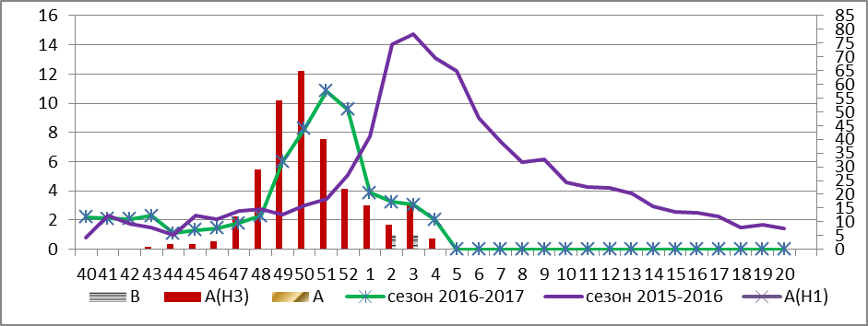
Fig.2 The dynamic of SARI cases and the number of laboratory confirmed influenza in season 2016 – 2017 in four sentinel centers of Ukraine.

During the 4th week the proportion of SARI cases was 5.4% (fig. 3).
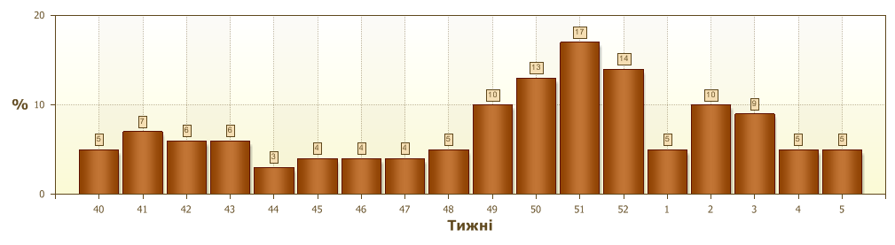
Fig.3. Proportion of SARI from the total number of hospitalizations in 10 hospitals of sentinel centers.
From 40th to 4th week 2016-2017 there were investigated 635 samples from ILI and SARI patients by PCR method. There were detected 433 positive influenza samples: 194 – influenza viruses A(unsubtyped), 1 – influenza virus A(H1), 236 – influenza viruses A(H3) and 2 – influenza virus B (fig.4). There were isolated 85 isolates of A influenza virus on MDCK/SIAT cell culture.
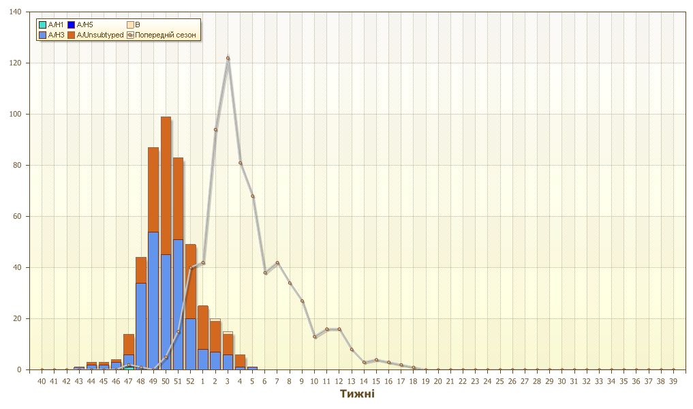
Fig.4. The number of laboratory confirmed influenza cases among ILI and SARI patients in season 2016 – 2017 in four sentinel centers of Ukraine.

The highest percentage of confirmed A(H3) influenza cases is recorded among children 15 – 17 years old – 74%, in the age group 18 – 29 – 72% and 30 – 64 – 68%. The circulation of influenza virus A(H3) has been continuing in the country.

Performed by:
Alla Mironenko, MD, DSc
Olga Holubka, PhD

