L.V. Gromashevsky Institute of Epidemiology and Infectious Diseases National Academy of Medical Science of Ukraine

Scientific Influenza and ARI Center

Weekly Bulletin for Influenza Epidemic Situation in Ukraine by 4 Sentinel Centers
(Кyiv, Dnipro, Odessa, Khmelnitsky)
Week 50, 2021

Loaded on website www.ukrinfluenza.com.ua

Since 2008 the system of ILI and SARI sentinel surveillance has been functioning in Ukraine. The sentinel centers are located in different geographical areas of the country: in Kyiv, Dnipro, Odessa and Khmelnytsky, which include 15 sentinel stations: 9 hospitals and 6 polyclinics.
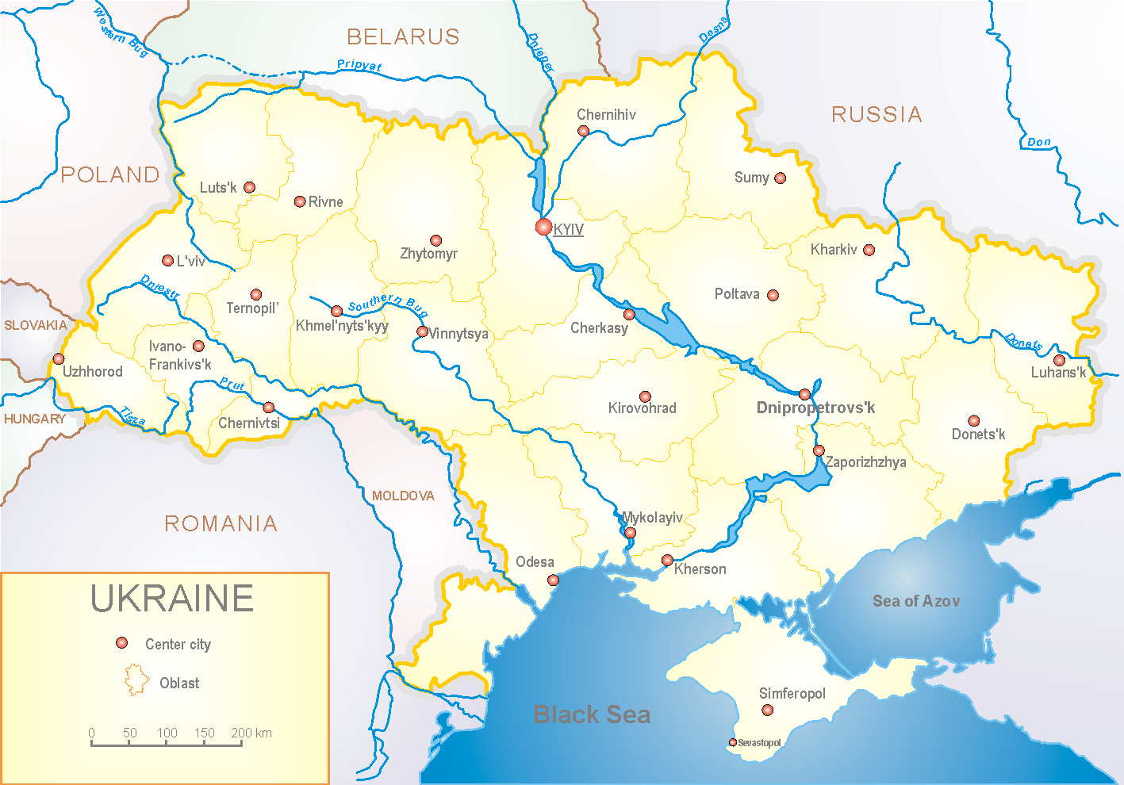
Influenza epidemic season the second year takes place on the background of SARS-CoV-2 pandemic both in Ukraine and in the world.
According to data of influenza sentinel surveillance system in Ukraine in 6 policlinics of 4 sentinel cities of Ukraine the quantity of outpatient, which meet the definition of ILI during the 50th week (13.12.2021 – 19.12.2021) was 99 cases (9.4 per 100 thousand). The decrease of morbidity levels was 20.2% in comparison with the previous week and 4.0% less than the index of previous year (index 9.8 per 100 thousand – 2020). 2 influenza A(H3) viruses were detected in a child in the age group 5 – 14 years (fig. 1).

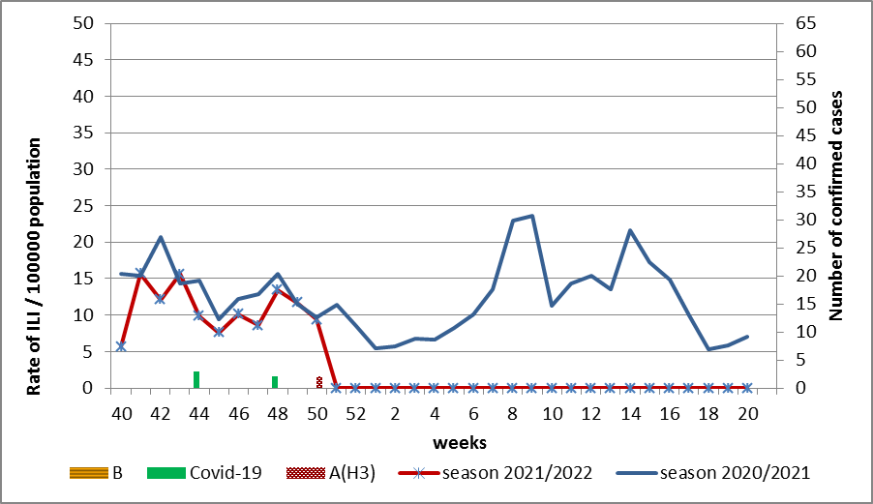

Fig.1. The dynamic of recorded ILI cases and number of laboratory confirmed influenza and SARS-CoV-2 cases in 4 sentinel centers of Ukraine in the 2021 – 2022 season.
During the 50th week in 9 hospitals of 4 sentinel centers there were hospitalized 669 patients. This is 15.5% less than during the previous week. The quantity of SARI patients (patients which meet the definition SARI) was 68 cases (2.7 per 100 thousand). The decrease of morbidity level was 40.9% in comparison with the previous week and was 72.1% more than the index of previous year (0.7 per 100 thousand in 2020). There were detected 2 influenza A(H3) viruses among children 5 - 14 years old (fig. 2).

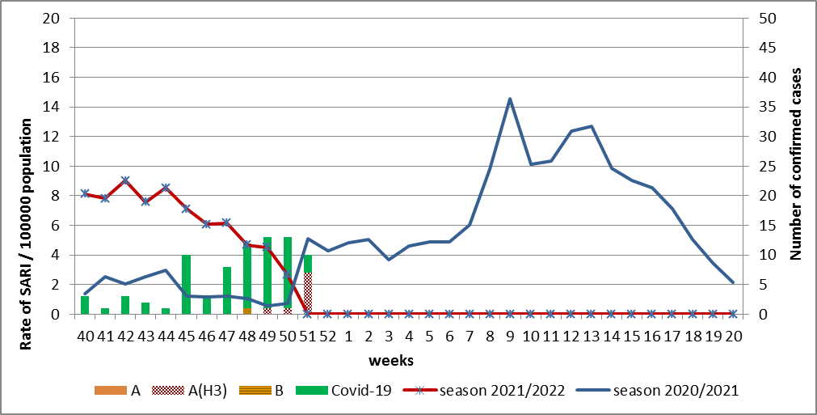

Fig.2 The dynamic of recorded SARI cases and the number of laboratory confirmed influenza and SARS-CoV-2 cases in season 2021 – 2022 in four sentinel centers of Ukraine.
From the 40th to the 50th week there were investigated 103 samples from ILI and SARI patients by PCR method. There were laboratory confirmed 71 SARS-CoV-2 viruses, influenza A(H3) virus – 3, influenza B virus – 1, 2 – rhinoviruses, 2 – RSV (fig. 3).

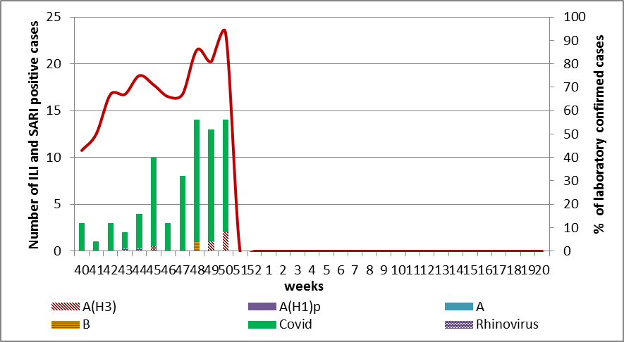

Fig. 3. Number of laboratory confirmed SARS-CoV-2 positive cases in sentinel centers of Ukraine in season 2021-2022

So, according to sentinel surveillance the SARI and ILI morbidity indexes are on the background levels with sporadic cases of influenza B and A(H3).
According to weekly ECDC-WHO influenza activity in European countries increase, among SARI patients influenza A(H3) predominates. 5 countries provided data that seasonal influenza activity is 10% higher than epidemic threshold according to data of sentinel ambulatory or hospital sites. These countries are Israel (66%), Armenia (47%), Sweden (43%), Russian Federation (35%), and Republic of Moldova (15%). CDC announces the beginning of influenza epidemic in European region.
From the beginning of the season in European countries there were investigated 15828 samples from ILI and SARI patients by PCR method and 581 (3.7%) of influenza viruses were laboratory confirmed: influenza A – 563 (96.9%) and 18 (3.1%) – influenza B. Among them: influenza A (unsubtypted) – 202 (35.9%), influenza A(H3) – 351 (62.3%) and 10 (1.8%) - influenza A(H1)pdm.
The genetic characteristic of 287 influenza viruses have been examined for the current season: 282 influenza A(H3) viruses belong to the strain А/Bangladesh/4005/2020A(H3), 1 - А/Denmark/3264/2019 (H3N2), 1 - A(H1)pdm09 virus is represented by the strain А/Guangdond-Maonan/SWL1536/2019.
2 influenza B viruses type Victoria: 1 of them belongs to the strain В/Washington/02/2019 and 1 – to the strain В/ Austria/1359412/2021.
From the 40th to the 50th week there were investigated 191 influenza A(H3) viruses and 1 A(H1)pdm virus for sensitivity to neuraminidase inhibitors and 124 influenza A(H3) viruses and 1 A(H1)pdm – for sensitivity to baloxavir marboxil. Amino acid substitutions which correlated with decreased sensitivity were not detected.

Performed by:
Alla Mironenko, MD, DSc
Olga Holubka, PhD

