L.V. Gromashevsky Institute of Epidemiology and Infectious Diseases National Academy of Medical Science of Ukraine

Scientific Influenza and ARI Center

Weekly Bulletin for Influenza and COVID-19 Epidemic Situation in Ukraine by 4 Sentinel Centers
(Кyiv, Dnipro, Odessa, Khmelnitsky)
Week 50, 2022

Loaded on website www.ukrinfluenza.com.ua
Since 2008 the system of ILI* and SARI* sentinel surveillance has been functioning in Ukraine. The sentinel centers are located in different geographical areas of the country: in Kyiv, Dnipro, Odessa and Khmelnytsky, which include 15 sentinel stations: 9 hospitals and 6 polyclinics.
* - ILI and SARI case definitions include cases of respiratory diseases caused by other respiratory viruses: influenza, adenovirus, parainfluenza virus, rhinovirus, RSV and SARS-CoV-2.
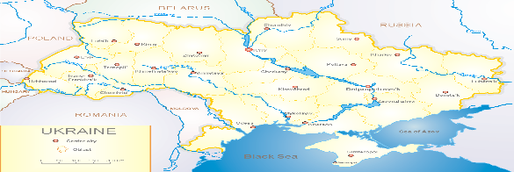
According to data of influenza sentinel surveillance system in Ukraine in 6 policlinics of 4 sentinel cities of Ukraine during the 50th week (12.12 – 18.12.2022) the quantity of outpatient, which meet the definition of ILI was 65 cases (6.6 per 100 thousand). The increase of morbidity level was 38.3% in comparison with the previous week and was 34.3% less than the index of previous year (10.0 per 100 thousand population in 2021) (fig. 1).
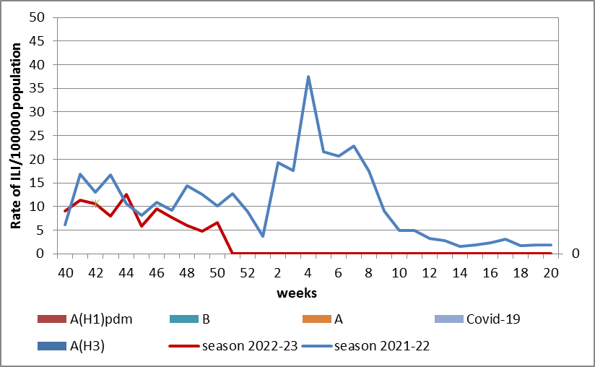
Fig.1. The dynamic of recorded ILI cases and number of laboratory confirmed influenza and SARS-CoV-2 cases in 4 sentinel centers of Ukraine in the 2022 – 2023 season.

During the 50th week in 9 hospitals of 4 sentinel centers there were hospitalized 719 patients, among them 503 children (70.0%) with a suspicion of SARI; this is 7.3% more than during the previous week. The proportion of hospitalized patients is 6.7%. During the 50th week there were 48 SARI patients (2.1 per 100 thousand), among them – 34 children (7.6 per 100 thousand) under 17 years old. The increase of morbidity levels was 2 times more than the indexes of previous week, but was 29.0% less than the index of previous year (2.9 per 100 thousand - 2021). There were laboratory confirmed 5 viruses of SARS-CoV-2 and 20 viruses of influenza A and 1 influenza B virus among adults and children (fig. 2).
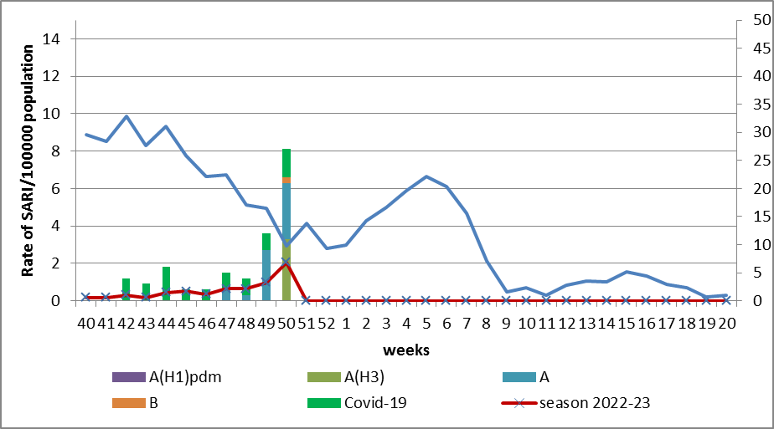
Fig.2 The dynamic of recorded SARI cases and the number of laboratory confirmed influenza and SARS-CoV-2 cases in season 2022 – 2023 in four sentinel centers of Ukraine.
From the 40th to the 50th week there were investigated 103 samples from ILI and SARI patients by PCR method. There were laboratory confirmed 65 viruses (64.0%), among them – 31 SARS-CoV-2 viruses, 33influenza A viruses and 1 influenza B virus.
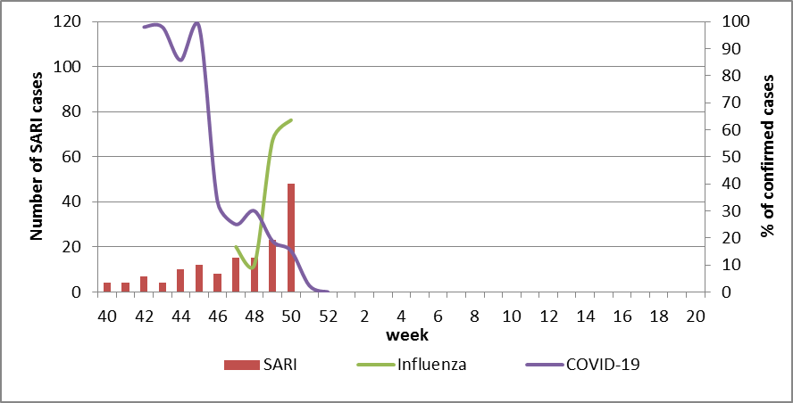
Fig. 3. Percentage of confirmed influenza and COVID-19 cases among hospitalized patients with SARI from the 40th week 2022 to the 20th week 2023.
.

The increase of intensity of epidemic influenza process with gradual increase of proportion of confirmed cases (82.0%) leads to decline of COVID-19 activity among population (fig. 3).
According to weekly ECDC-WHO (https://flunewseurope.org), on the 49th week in the countries of European region the influenza epidemic continues and the influenza activity increases significantly. 27 countries have already reported about regional or widespread activity and the epidemic intensity fluctuate from medium to very high.
A lot of countries have the exceeding of epidemic threshold more than by 23%. According to data of sentinel entities of 9 countries (Germany, Greece, Italy, Georgia, Kyrgyzstan, Lithuania, Portugal, Slovakia and Uzbekistan) among examined patients more than 40% are positive for influenza.
There were identified influenza A and B viruses with a preponderance of A(H3) in sentinel epidemic surveillance systems. The dominance of A(H1)pdm influenza viruses continue in the systems of non-sentinel epidemic surveillance. But according to data of sentinel clinics, beginning from the 47th week influenza A(H1)pdm09 and B viruses dominate in the countries of Eastern part of European region. The highest percentage of positive influenza cases were in such countries: Lithuania (50%), Kyrgyzstan (38%), Ireland (29%), Ukraine (27%), Malta (20%), russian federation (19%), Kazakhstan (12%) and North Macedonia (12%).
From the beginning of the season 2022-2023 there were detected by PCR method 4465 influenza cases (13.9%) among 32008 investigated sentinel samples. Among them 91.5% - influenza A and 8.5% - influenza B. 15.6% belong to influenza A(H1)pdm and 84.4% - to A(H3). 140 influenza B viruses belong to B/Victoria lineage, 241 – influenza B, lineage is not identified (fig. 4).

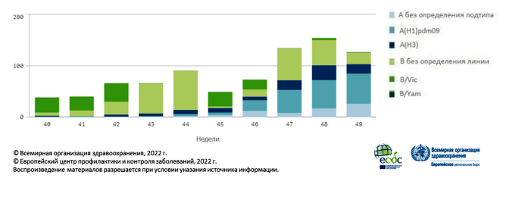
Fig. 4. Detection of influenza viruses according to results of sentinel epidemic surveillance of SARI in European region in season 2022-2023.

From the beginning of season there were genetically characterized 184 influenza A(H1)pdm09 viruses, 183 of them belong to clade 6B.1A.5a.2, among them 113 (61.4%) were represented by viruses A/Norway/25089/2022, 69 (37.5%) - A/Sydney/5/202 and 1 (0,5%) – A/Victoria/2570/2019. 1 virus belong to clade 6B.1A.5a.1and was represented by AH1/Guangdong-Maonan/SWL1536/2019.
Among 348 influenza A(H3) viruses, which were genetically characterized, 342 belong to clade 3C.2a1b.2a.2. Among them 133 (38.2%) were represented by viruses A/Slovenia/8720/2022, 189 (54.3%) – AH3/Bangladesh/4005/2020 and 20 (5,7%) – A/Darwin/9/2021. 6 (1,7%) viruses were not assigned to any subclade.
There were genetically characterized 31 influenza B/Victoria virus, 19 of them belong to clade V1A.3a.2 and represented by viruses B/Ausrtia/1359417/2021 and 12 (38.7%) of them were not assigned to any subclade.
According to data of PHC of MOH of Ukraine during the 50th week the part of confirmed COVID-19 cases decreased by 10.9% both among adults and among children (-2.9%) in comparison with previous week. 56 fatal cases were registered among people 60+, this is 3.7% more than during the previous week.
So according to sentinel surveillance of Ukraine there is the simultaneous circulation of SARS-CoV-2 and influenza viruses. The intensity of epidemic influenza process increases during the second week, the highest part of confirmed cases is among children (70.0%), but the part of confirmed COVID-19 cases significantly decreased due to activation of influenza, which displace SARS-CoV-2 virus.

Performed by:
Alla Mironenko, MD, DSc, Professor
Olga Holubka, PhD

