L.V. Gromashevsky Institute of Epidemiology and Infectious Diseases National Academy of Medical Science of Ukraine

Scientific Influenza and ARI Center

Weekly Bulletin for Influenza Epidemic Situation in Ukraine by 4 Sentinel Centers
(Кyiv, Dnipro, Odesa, Khmelnitsky)
Week 50, 2016

Loaded on website www.ukrinfluenza.com.ua
Since 2008 the system of ILI and SARI sentinel surveillance has been functioning in Ukraine. The sentinel centers are located in different geographical areas of the country: in Kyiv, Dnipro, Odessa and Khmelnytskyi, which include 18 sentinel stations: 10 hospitals and 8 polyclinics.
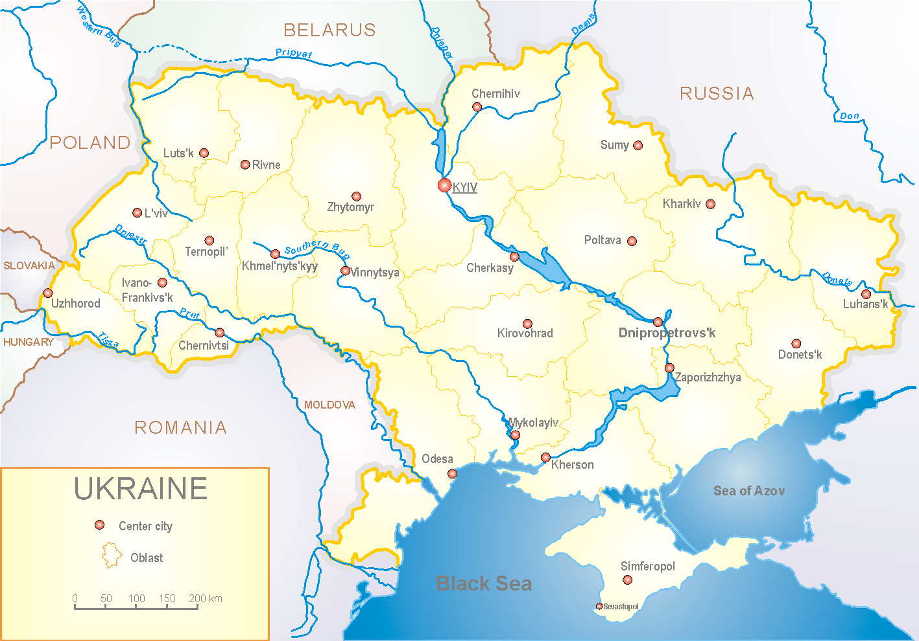

According to data of influenza sentinel surveillance system in Ukraine in 8 policlinics of 4 sentinel centers the quantity of outpatient, which meet the definition of ILI during the 50th week (12.12 – 18.12.16) was 189 cases (91.1 per 100 thousand) corresponding population. In comparison with the previous week there was the increase of morbidity level –20.4%. There were 18 laboratory confirmed influenza cases A(H3) (fig.1)

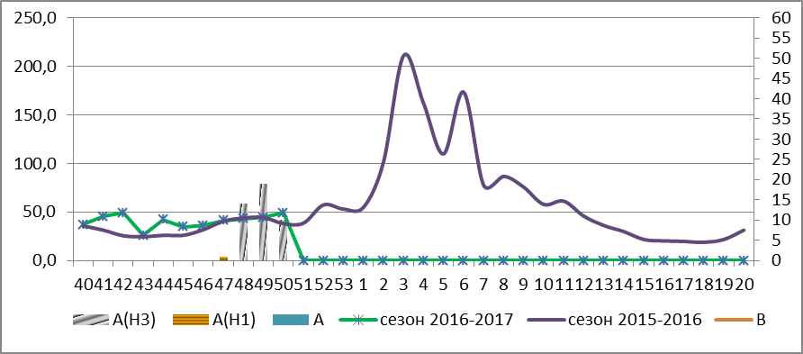

Fig.1. The dynamic of ILI cases and number of laboratory confirmed influenza cases in 4 sentinel centers of Ukraine in the 2016 – 2017 season.

During the 50th week in 10 hospitals of 4 sentinel centers there were hospitalized 1909 patients, this is 12.1% more than during the previous week. The quantity of SARI patients (patients which meet the definition SARI) was 226 cases (7.61 per 100 thousand); the increase of morbidity level was 27.7% in comparison with the previous week. During the week there were laboratory confirmed 34 influenza cases A(H3) (fig. 2)

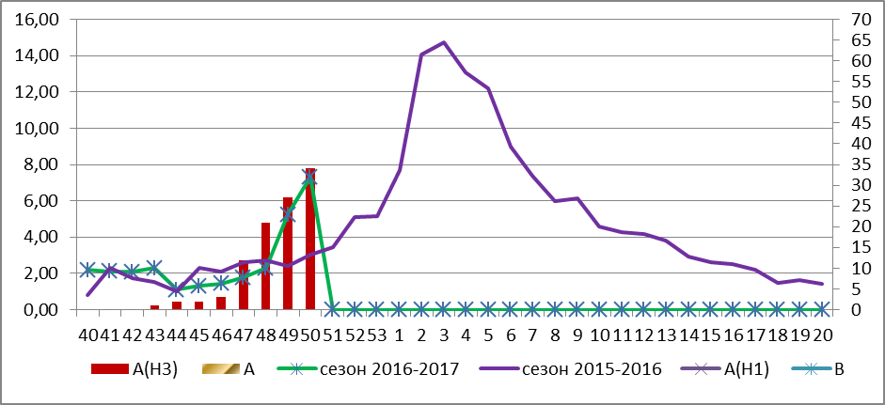

Fig.2 The dynamic of SARI cases and the number of laboratory confirmed influenza in season 2016 – 2017 in four sentinel centers of Ukraine.

During the 50th week the proportion of SARI cases was 11.8% from the total number of hospitalizations and it increased by 0.8% in comparison with the previous week (fig. 3).

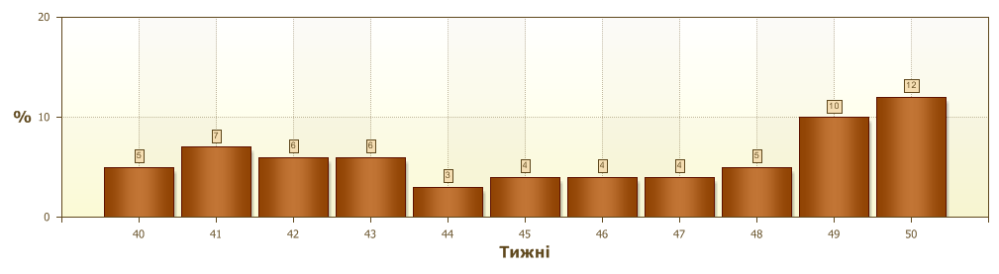
Fig.3. Proportion of SARI from the total number of hospitalizations in 10 hospitals of sentinel centers.

From 40th to 50th week 2016-2017 there were investigated 305 samples from ILI and SARI patients by PCR method. There were detected 165 positive influenza samples: 14 – influenza viruses A(unsubtyped), 1 – influenza virus A(H1) and 150 – influenza viruses A(H3) (fig.4).

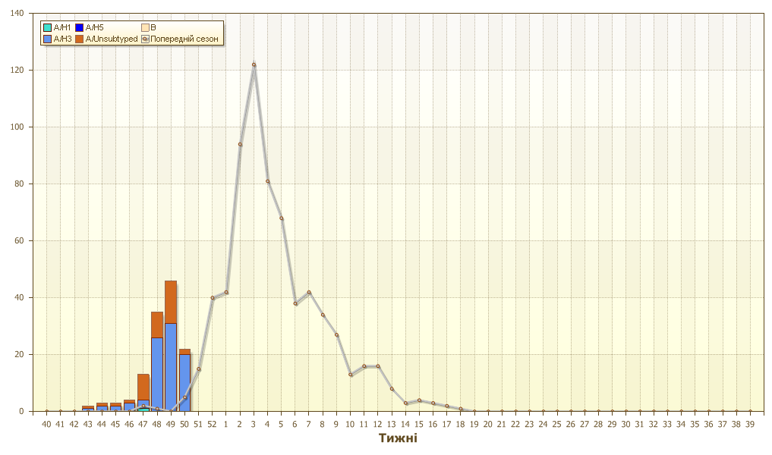

Fig.4. The number of laboratory confirmed influenza cases among ILI and SARI patients in season 2016 – 2017 in four sentinel centers of Ukraine.

So, during the 50th week 2016 the gradual growth of morbidity level has been continuing, especially due to SARI cases and the reason is the active circulation of influenza virus A(H3).

Performed by:
Alla Mironenko, MD, DSc
Olga Holubka, PhD

