L.V. Gromashevsky Institute of Epidemiology and Infectious Diseases National Academy of Medical Science of Ukraine

Scientific Influenza and ARI Center

Weekly Bulletin for Influenza and COVID-19 Epidemic Situation in Ukraine by 4 Sentinel Centers
(Кyiv, Dnipro, Odessa, Khmelnitsky)
Week 51, 2022

Loaded on website www.ukrinfluenza.com.ua
Since 2008 the system of ILI* and SARI* sentinel surveillance has been functioning in Ukraine. The sentinel centers are located in different geographical areas of the country: in Kyiv, Dnipro, Odessa and Khmelnytsky, which include 15 sentinel stations: 9 hospitals and 6 polyclinics.
* - ILI and SARI case definitions include cases of respiratory diseases caused by other respiratory viruses: influenza, adenovirus, parainfluenza virus, rhinovirus, RSV and SARS-CoV-2.
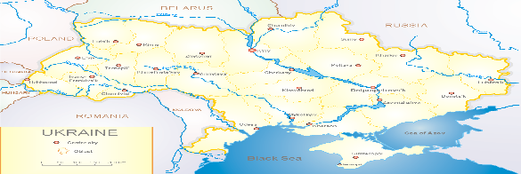
According to data of influenza sentinel surveillance system in Ukraine in 6 policlinics of 4 sentinel cities of Ukraine during the 51st week (19.12 – 25.12.2022) the quantity of outpatient, which meet the definition of ILI was 49 cases (5.0 per 100 thousand). The decrease of morbidity level was 24.6% in comparison with the previous week and was 60.8% less than the index of previous year (12.7 per 100 thousand population in 2021). 1 influenza A virus was confirmed among children (fig.1).
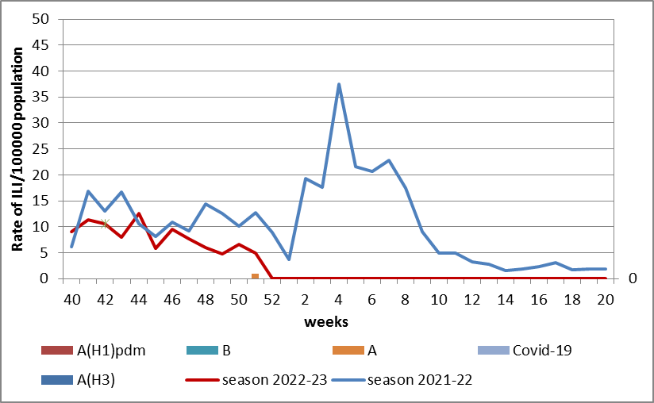

Fig.1. The dynamic of recorded ILI cases and number of laboratory confirmed influenza and SARS-CoV-2 cases in 4 sentinel centers of Ukraine in the 2022 – 2023 season.
During the 51st week in 9 hospitals of 4 sentinel centers there were hospitalized 794 patients, among them 529 children (66.6%) with a suspicion of SARI; this is 10.4% more than during the previous week. The proportion of hospitalized patients is 8.8%. 70 SARI patients were detected (3.0 per 100 thousand), 52 of them (11.6 per 100 thousand) - children under 17 years old. The increase of morbidity levels was 45.8% in comparison with the previous week, but was 27.0% less than the index of previous year (4.1 per 100 thousand - 2021). 1 SARS-CoV-2 virus and 31 influenza A viruses were laboratory confirmed among adults and children (fig. 2).

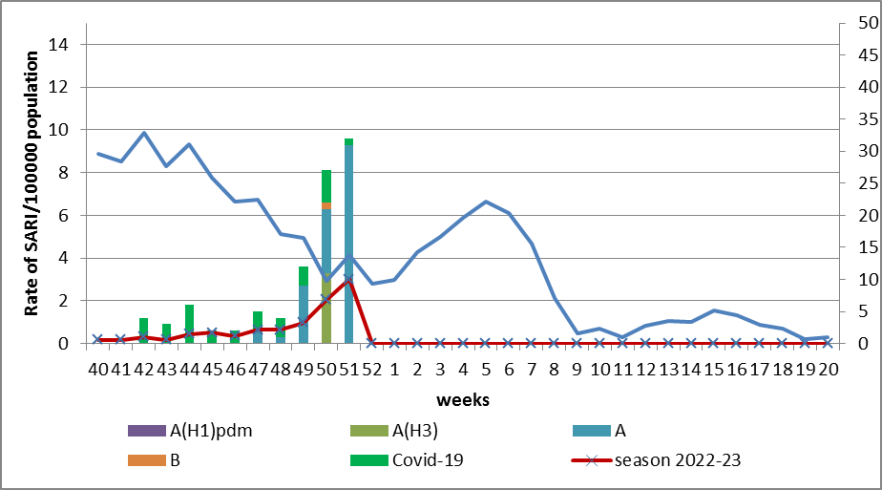

Fig.2 The dynamic of recorded SARI cases and the number of laboratory confirmed influenza and SARS-CoV-2 cases in season 2022 – 2023 in four sentinel centers of Ukraine.
From the 40th to the 51st week there were investigated 149 samples from ILI and SARI patients by PCR method. There were laboratory confirmed 98 viruses (66.0%), among them – 32 (33.0%) SARS-CoV-2 viruses, 65(67.0%) influenza A viruses and 1 influenza B virus.

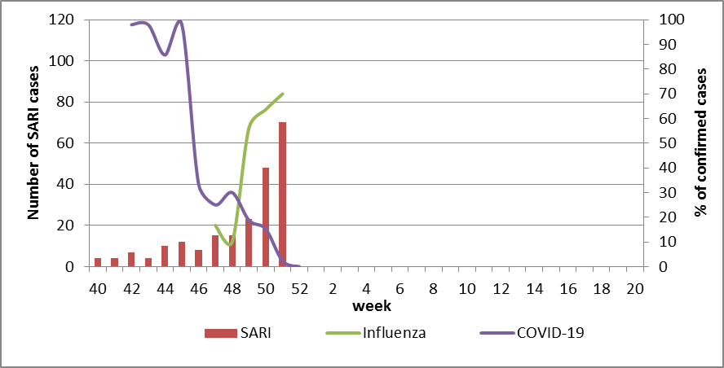

Fig. 3. Percentage of confirmed influenza and COVID-19 cases among hospitalized patients with SARI from the 40th week 2022 to the 20th week 2023.
The increase of intensity of epidemic influenza process with gradual increase of proportion of confirmed cases (72.0%) leads to sharp decline of COVID-19 activity among population (fig. 3).
According to weekly ECDC-WHO (https://flunewseurope.org), on the 50th week in the countries of European region the influenza epidemic continues and the influenza activity increases significantly. 33 countries have already reported about regional or widespread activity and the epidemic intensity fluctuate from medium to very high.
A lot of countries have the exceeding of epidemic threshold more than by 30%. According to data of sentinel entities of 14 countries (Germany, Luxemburg, Kyrgyzstan, Lithuania, Portugal, Slovakia, Uzbekistan, Poland, Republic of Moldova, Slovenia, Finland, France, Switzerland and Estonia) among examined patients more than 40% are positive for influenza.
The circulation of influenza viruses in the European region is mixed. In general in sentinel samples of primary health care entities influenza A(H3) viruses predominate, in samples from SARI patients – influenza A(H1)pdm09 viruses. The proportion of A(H1)pdm09 viruses recently begin to increase.
From the beginning of the season 2022-2023 there were detected by PCR method 6443 influenza cases (16.6%) among 38776 investigated sentinel samples. Among them 92.8% - influenza A and 7.2% - influenza B. 16.1% belong to influenza A(H1)pdm and 83.9% - to A(H3). 155 influenza B viruses belong to B/Victoria lineage, 309 – influenza B, lineage is not identified.
From the beginning of season there were genetically characterized 217 influenza A(H1)pdm09 viruses, 216 of them belong to clade 6B.1A.5a.2, among them 131 (61.0%) were represented by viruses A/Norway/25089/2022, 84 (39.0%) - A/Sydney/5/202 and 1 (0,5%) – A/Victoria/2570/2019. 1 virus (0.5%) belong to clade 6B.1A.5a.1and was represented by AH1/Guangdong-Maonan/SWL1536/2019.
Among 379 influenza A(H3) viruses, which were genetically characterized, 371 belong to clade 3C.2a1b.2a.2. Among them 147 (39.0%) were represented by viruses A/Slovenia/8720/2022, 204 (54.0%) – AH3/Bangladesh/4005/2020 and 20 (5,0%) – A/Darwin/9/2021. 8 (2.0 %) viruses were not assigned to any subclade.
There were genetically characterized 44 influenza B/Victoria virus, 30 (68.0 %) of them belong to clade V1A.3a.2 and represented by viruses B/Ausrtia/1359417/2021 and 14 (32.0%) of them were not assigned to any subclade.
According to data of PHC of MOH of Ukraine during the 51st week the part of confirmed COVID-19 cases increased by 1.7% among adults and decreased among children (-0.2%) in comparison with previous week. 70 fatal cases were registered among people 60+, this is 25.0% more than during the previous week.
So according to sentinel surveillance of Ukraine there is the simultaneous circulation of SARS-CoV-2 and influenza viruses. The intensity of epidemic influenza process increases during the third week, the highest part of confirmed cases is among children (75.0%), but the part of confirmed COVID-19 cases significantly decreased due to activation of influenza, which displace SARS-CoV-2 virus.
Performed by:
Alla Mironenko, MD, DSc, Professor
Olga Holubka, PhD

