L.V. Gromashevsky Institute of Epidemiology and Infectious Diseases National Academy of Medical Science of Ukraine

Scientific Influenza and ARI Center

Weekly Bulletin for Influenza and COVID-19 Epidemic Situation in Ukraine by 4 Sentinel Centers
(Кyiv, Dnipro, Odessa, Khmelnitsky)
Week 52, 2022

Loaded on website www.ukrinfluenza.com.ua
Since 2008 the system of ILI* and SARI* sentinel surveillance has been functioning in Ukraine. The sentinel centers are located in different geographical areas of the country: in Kyiv, Dnipro, Odessa and Khmelnytsky, which include 15 sentinel stations: 9 hospitals and 6 polyclinics.
* - ILI and SARI case definitions include cases of respiratory diseases caused by other respiratory viruses: influenza, adenovirus, parainfluenza virus, rhinovirus, RSV and SARS-CoV-2.
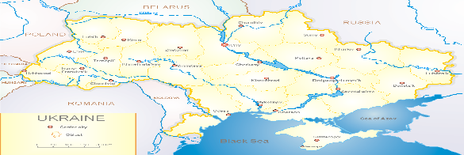
According to data of influenza sentinel surveillance system in Ukraine in 6 policlinics of 4 sentinel cities of Ukraine during the 52nd week (26.12 – 01.01.2023) the quantity of outpatient, which meet the definition of ILI was 87 cases (8.8 per 100 thousand). The increase of morbidity level was 77.6% in comparison with the previous week and was 1.1% less than the index of previous year (8.9 per 100 thousand population in 2021). 1 influenza A virus was confirmed among children (fig.1)

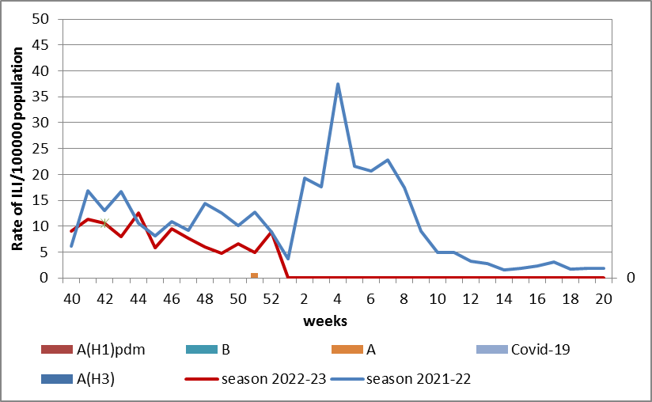

Fig.1. The dynamic of recorded ILI cases and number of laboratory confirmed influenza and SARS-CoV-2 cases in 4 sentinel centers of Ukraine in the 2022 – 2023 season.
During the 52nd week in 9 hospitals of 4 sentinel centers there were hospitalized 757 patients, among them 517 children (68.3%) with a suspicion of SARI; this is 4.7% less than during the previous week. The proportion of hospitalized patients is 8.6%. 65 SARI patients were detected (2.8 per 100 thousand), 44 of them (9.9 per 100 thousand) - children under 17 years old. The decrease of morbidity levels was 7.1% in comparison with the previous week. The intensive indicator of this week corresponds the index of previous year (2.8 per 100 thousand - 2021). 17 influenza A viruses were laboratory confirmed among adults and children (fig. 2).

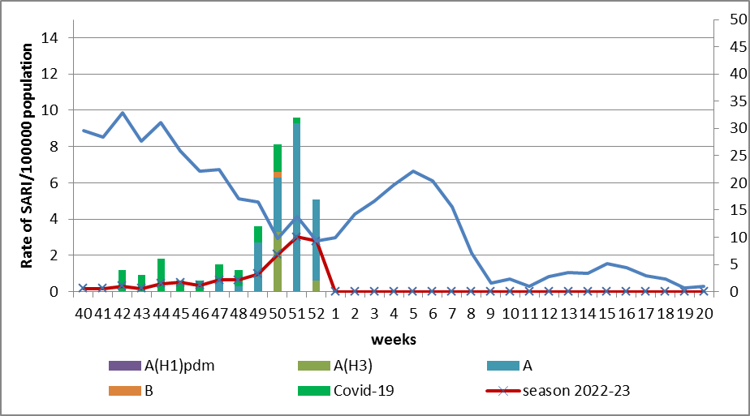

Fig.2 The dynamic of recorded SARI cases and the number of laboratory confirmed influenza and SARS-CoV-2 cases in season 2022 – 2023 in four sentinel centers of Ukraine.
From the 40th to the 52nd week there were investigated 180 samples from ILI and SARI patients by PCR method. There were laboratory confirmed 115 viruses (64.0%), among them – 32 (27.0%) SARS-CoV-2 viruses, 83 (73.0%) influenza A viruses and 1 influenza B virus.

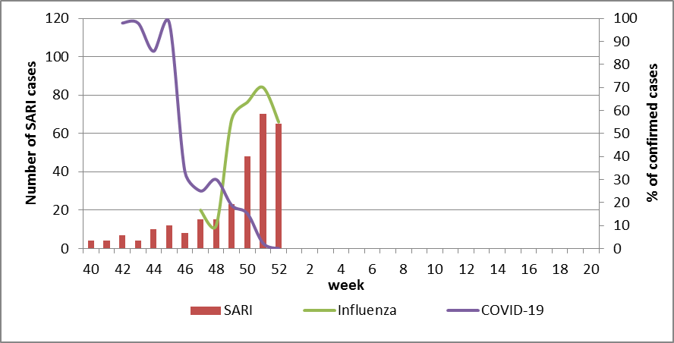

Fig. 3. Percentage of confirmed influenza and COVID-19 cases among hospitalized patients with SARI from the 40th week 2022 to the 20th week 2023.

The intensity of epidemic influenza process is still high. The highest percentage of laboratory confirmed influenza cases was on the 51st week of the season 2022 – 2023 and was 70.0%. Beginning from the 49th week we can observe the rapid decrease of COVID-19 activity among population due to influenza virus activation, which can be seem on the fig. 3.
According to weekly ECDC-WHO (https://flunewseurope.org), on the 52nd week in the countries of European region the influenza epidemic continues, the intensity of epidemic influenza process is still high, but the statistical morbidity indicators and the percentage of confirmed cases decreased during the reported week.
According to data of sentinel entities of 16 countries of the Region more than 50% of examined patients are positive for influenza. The highest percentage of positive influenza cases among SARI patients are in Romania (64%), Ukraine (59%), russian federation (49%) and Serbia (43%).
The circulation of influenza viruses in the European region is mixed. In general in sentinel samples of primary health care entities influenza A(H3) viruses predominate, in samples from SARI patients – influenza A(H1)pdm09 viruses. The proportion of A(H1)pdm09 viruses recently begin to increase. A(H1)pdm09 viruses also predominate in samples from non-sentinel patients.
From the beginning of the season 2022-2023 there were detected by PCR method 9603 influenza cases (20.0%) among 47319 investigated sentinel samples. Among them 93.0% - influenza A and 7.0% - influenza B. 20.0% belong to influenza A(H1)pdm and 80.0% - to A(H3). 200 influenza B viruses belong to B/Victoria lineage, 446 – influenza B, lineage is not identified
From the beginning of season there were genetically characterized 242 influenza A(H1)pdm09 viruses, 138 (57.0%) were represented by viruses A/Norway/25089/2022, 102 (42.0%) - A/Sydney/5/202 and 1 (0,5%) – A/Victoria/2570/2019. 1 virus (0.5%) belong to clade 6B.1A.5a.1and was represented by AH1/Guangdong-Maonan/SWL1536/2019.
475 influenza A(H3) viruses were genetically characterized. 147 of them (21.0%) were represented by viruses AH3/Bangladesh/4005/2020 and 11 viruses were not assigned to any subclade.
There were genetically characterized 57 influenza B/Victoria virus, 44 (68.0 %) of them belong to clade V1A.3a.2, 38 viruses were represented by viruses B/Ausrtia/1359417/2021 and 19 (33.0%) of them were not assigned to any subclade.
According to data of PHC of MOH of Ukraine during the 52nd week the part of confirmed COVID-19 cases decreased by 26.5% among adults and among children (-37.4%) in comparison with previous week. 47 fatal cases were registered among people 60+, this is 32.9% less than during the previous week.
So according to sentinel surveillance of Ukraine there is the simultaneous circulation of SARS-CoV-2 and influenza viruses. The intensity of epidemic influenza process is still high; the percentage of confirmed cases is 59.0% and is registered both among adults and children. There are no confirmed COVID-19 cases during the second week.

Performed by:
Alla Mironenko, MD, DSc, Professor
Olga Holubka, PhD

