L.V. Gromashevsky Institute of Epidemiology and Infectious Diseases National Academy of Medical Science of Ukraine

Scientific Influenza and ARI Center

Weekly Bulletin for Influenza Epidemic Situation in Ukraine by 4 Sentinel Centers
(Кyiv, Dnipro, Odessa, Khmelnitsky)
Week 1, 2021

Loaded on website www.ukrinfluenza.com.ua
Since 2008 the system of ILI and SARI sentinel surveillance has been functioning in Ukraine. The sentinel centers are located in different geographical areas of the country: in Kyiv, Dnipro, Odessa and Khmelnytsky, which include 17 sentinel stations: 9 hospitals and 8 polyclinics.
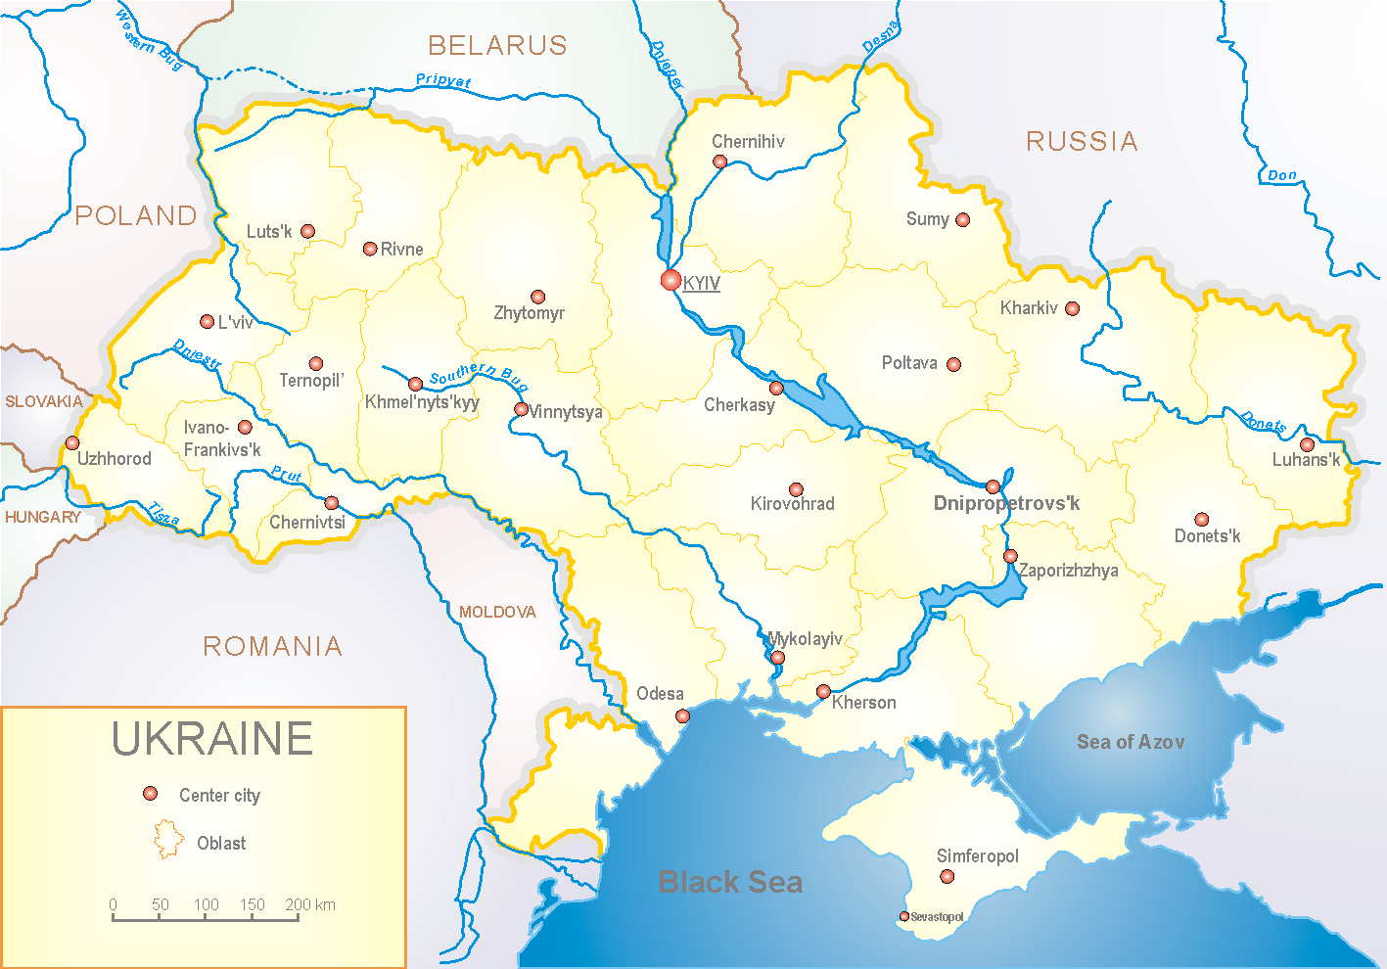
Influenza epidemic season 2020-2021 take place on the background of SARS-CoV-2 pandemic both in Ukraine and in the world.
According to data of influenza sentinel surveillance system in Ukraine in 8 policlinics of 4 sentinel cities of Ukraine the quantity of outpatient, which meet the definition of ILI during the 1st week (04.01.2021 – 10.01.2021) was 57 cases (5.4 per 100 thousand). The decrease of morbidity level was 36.7% in comparison with the previous week (53rd week – 6.9 per 100 thousand population) (fig. 1).

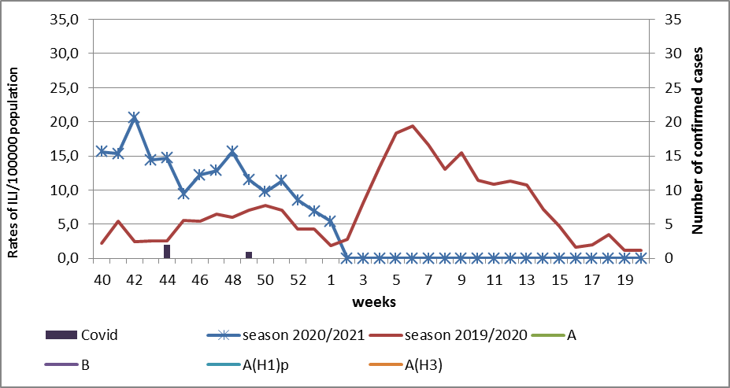

Fig.1. The dynamic of recorded ILI cases and number of laboratory confirmed influenza cases in 4 sentinel centers of Ukraine in the 2020 – 2021 season.

During the 1st week in 9 hospitals of 4 sentinel centers there were hospitalized 490 patients. This is 2.9% more than during the previous week (476 patients). The quantity of SARI patients (patients which meet the definition SARI) was 123 cases (4.83 per 100 thousand). The decrease of morbidity level was 10.2% in comparison with the previous week (53rd week – 5.4 per 100 thousand population) (fig. 2).
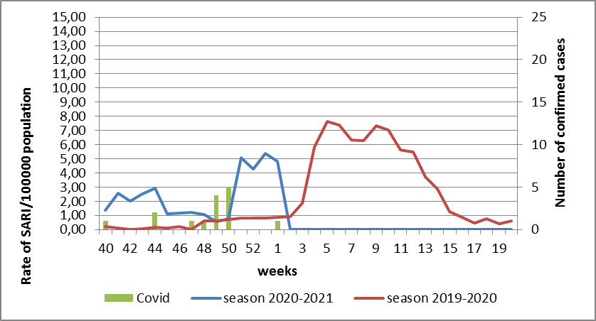

Fig.2 The dynamic of recorded SARI cases and the number of laboratory confirmed influenza in season 2020 – 2021 in four sentinel centers of Ukraine.

From the 40th to the 1st week of 2020-2021 season there were investigated 16 samples from ILI and SARI patients by PCR method. There were laboratory confirmed 8 COVID cases (fig. 3).

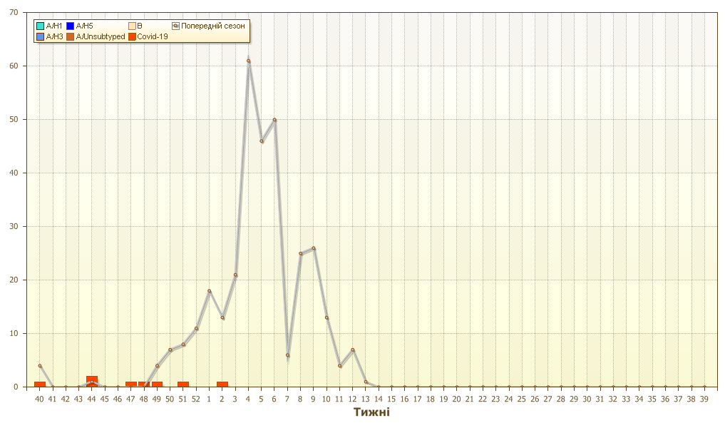
Fig. 3. Number of laboratory confirmed SARS-CoV-2 positive cases in sentinel centers of Ukraine in season 2020-2021.

So, according to sentinel surveillance the SARI and ILI morbidity indexes are on the background levels. There were not any confirmed influenza cases.
According to weekly ECDC-WHO influenza activity in European countries is at the off-season levels. There are two confirmed influenza A(H1)pdm cases and 6 – influenza B cases, among them there is 1 B/Victoria in sentinel clinics.

Performed by:
Alla Mironenko, MD, DSc
Olga Holubka, PhD

