L.V. Gromashevsky Institute of Epidemiology and Infectious Diseases National Academy of Medical Science of Ukraine

Scientific Influenza and ARI Center

Weekly Bulletin for Influenza Epidemic Situation in Ukraine by 4 Sentinel Centers
(Кyiv, Dnipro, Odessa, Khmelnitsky)
Week 10, 2021

Loaded on website www.ukrinfluenza.com.ua
Since 2008 the system of ILI and SARI sentinel surveillance has been functioning in Ukraine. The sentinel centers are located in different geographical areas of the country: in Kyiv, Dnipro, Odessa and Khmelnytsky, which include 17 sentinel stations: 9 hospitals and 8 polyclinics.
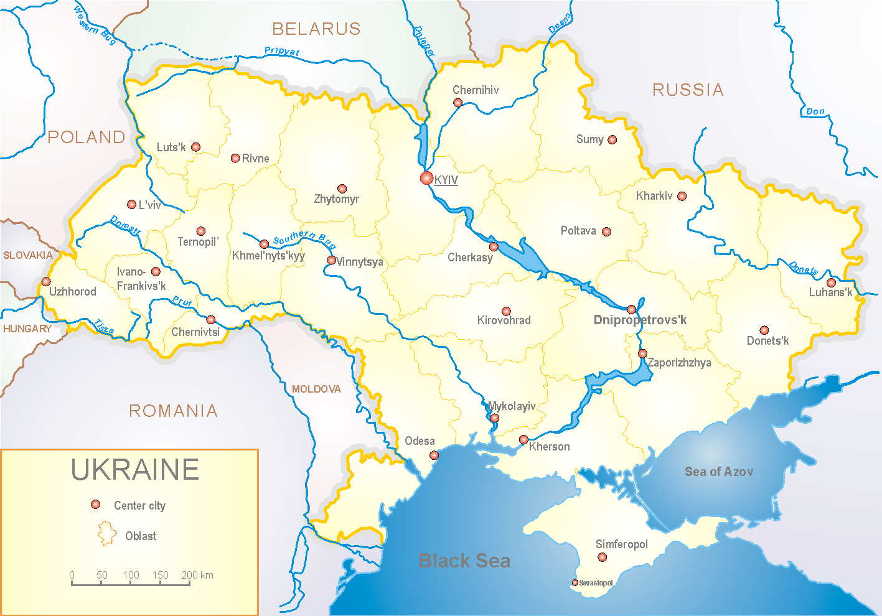
Influenza epidemic season 2020-2021 take place on the background of SARS-CoV-2 pandemic both in Ukraine and in the world.
According to data of influenza sentinel surveillance system in Ukraine in 8 policlinics of 4 sentinel cities of Ukraine the quantity of outpatient, which meet the definition of ILI during the 10th week (08.03.2021 – 14.03.2021) was 119 cases (11.3 per 100 thousand). The decrease of morbidity level was 52.4% in comparison with the previous week (fig. 1).

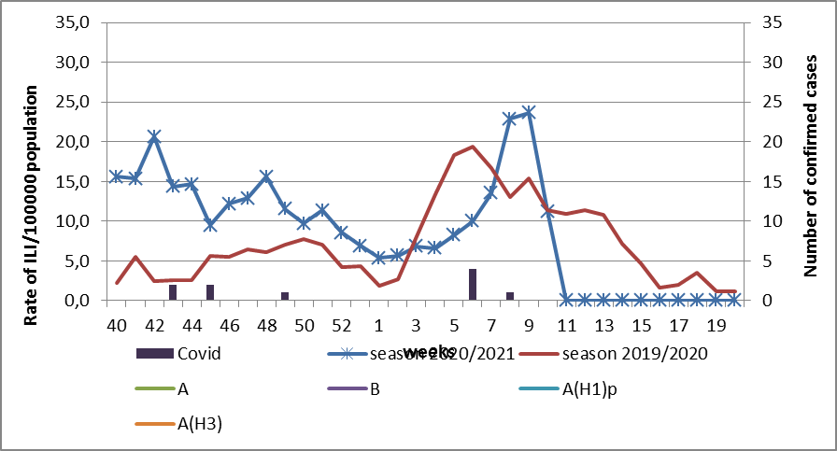

Fig.1. The dynamic of recorded ILI cases and number of laboratory confirmed influenza and SARS-CoV-2 cases in 4 sentinel centers of Ukraine in the 2020 – 2021 season.
During the 10th week in 9 hospitals of 4 sentinel centers there were hospitalized 989 patients. This is 31.0% less than during the previous week. The quantity of SARI patients (patients which meet the definition SARI) was 256 cases (10.0 per 100 thousand). The decrease of morbidity level was 12.5% in comparison with the previous week (fig. 2).
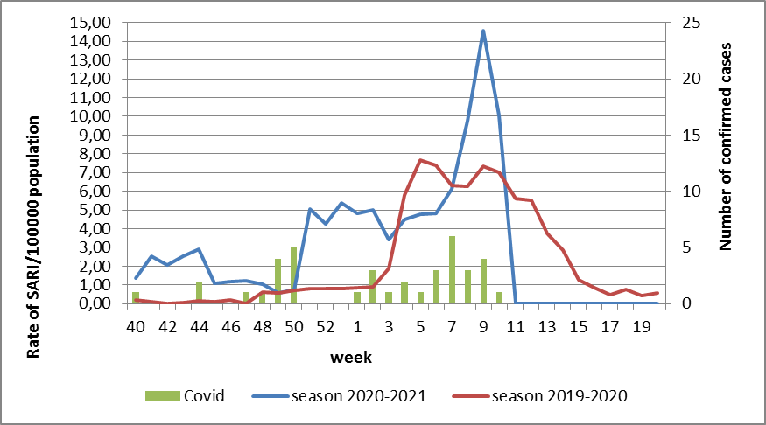

Fig.2 The dynamic of recorded SARI cases and the number of laboratory confirmed influenza and SARS-CoV-2 cases in season 2020 – 2021 in four sentinel centers of Ukraine.

From the 40th to the 10th week of 2020-2021 season there were investigated 85 samples from ILI and SARI patients by PCR method. There were laboratory confirmed 49 (57.6%) SARS-CoV-2 cases (fig. 3).

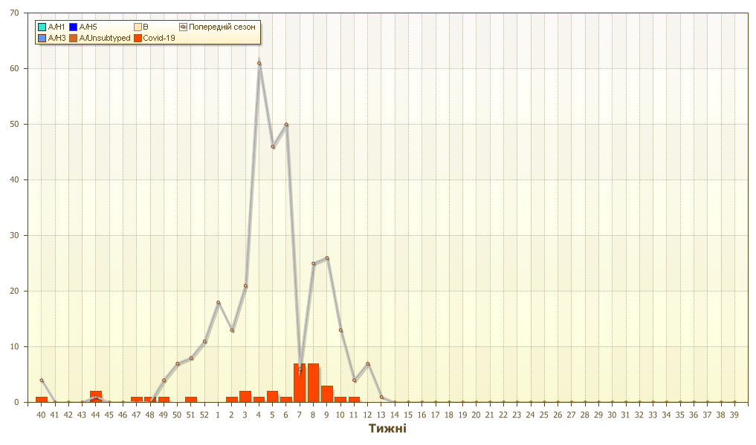
Fig. 3. Number of laboratory confirmed SARS-CoV-2 positive cases in sentinel centers of Ukraine in season 2020-2021.

During 10th week the quantity of hospitalized patients is still high among age groups 30 – 64 and 65+: 139 and 103 patients accordingly. Proportion of SARI from the total number of hospitalizations is 25.9% (fig. 4).

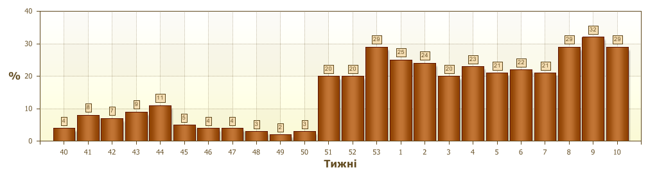
Fig. 4 Proportion of SARI from the total number of hospitalizations in the hospitals of sentinel centers.

So, according to sentinel surveillance we can observe the decrease of SARI and ILI morbidity levels. There were not any confirmed influenza cases.
According to weekly ECDC-WHO influenza activity in European countries is at the background and low levels.
Anti-epidemic measures which were taken to prevent the spreading of SARS-CoV-2 significantly affected epidemic process of influenza in the world.
From the beginning of the season in European countries there were investigated 489 089 samples from ILI and SARI patients by PCR method. Among them there were laboratory confirmed 728 influenza viruses. Among them influenza A – 365 (50.1%): 42 (11.5%) – influenza A(H1)pdm, 44 (12.1%) – influenza A(H3) and 279 (76.4%) – influenza A unsubtyped. There were also detected 364 (50.0%) influenza B cases, among them there were 8 (2.2%) – B/Victoria, 2 (0.5%) – B/Yamagata and 354 (97.3%) – influenza B (lineage is not detected).
The genetic characteristic of 11 influenza viruses have been examined for the current season: 2 influenza A(H3) viruses belong to the strain А/Slovenia/1637/2020, 1 - belongs to the strain A/Denmark/3264/2019 and 1 – belongs to А/Hong Kong/2671/2019. Influenza A(H1)pdm09 virus is represented by the strain А/Guangdond-Maonan/SWL1536/2019.
6 influenza B viruses type Victoria: 2 of them belong to the strain В/Washington/02/2019 and 4 – don’t belong to any clade.

Performed by:
Alla Mironenko, MD, DSc
Olga Holubka, PhD

