L.V. Gromashevsky Institute of Epidemiology and Infectious Diseases National Academy of Medical Science of Ukraine

Scientific Influenza and ARI Center

Weekly Bulletin for Influenza Epidemic Situation in Ukraine by 4 Sentinel Centers
(Кyiv, Dnipro, Odessa, Khmelnitsky)
Week 11, 2021

Loaded on website www.ukrinfluenza.com.ua
Since 2008 the system of ILI and SARI sentinel surveillance has been functioning in Ukraine. The sentinel centers are located in different geographical areas of the country: in Kyiv, Dnipro, Odessa and Khmelnytsky, which include 17 sentinel stations: 9 hospitals and 8 polyclinics.
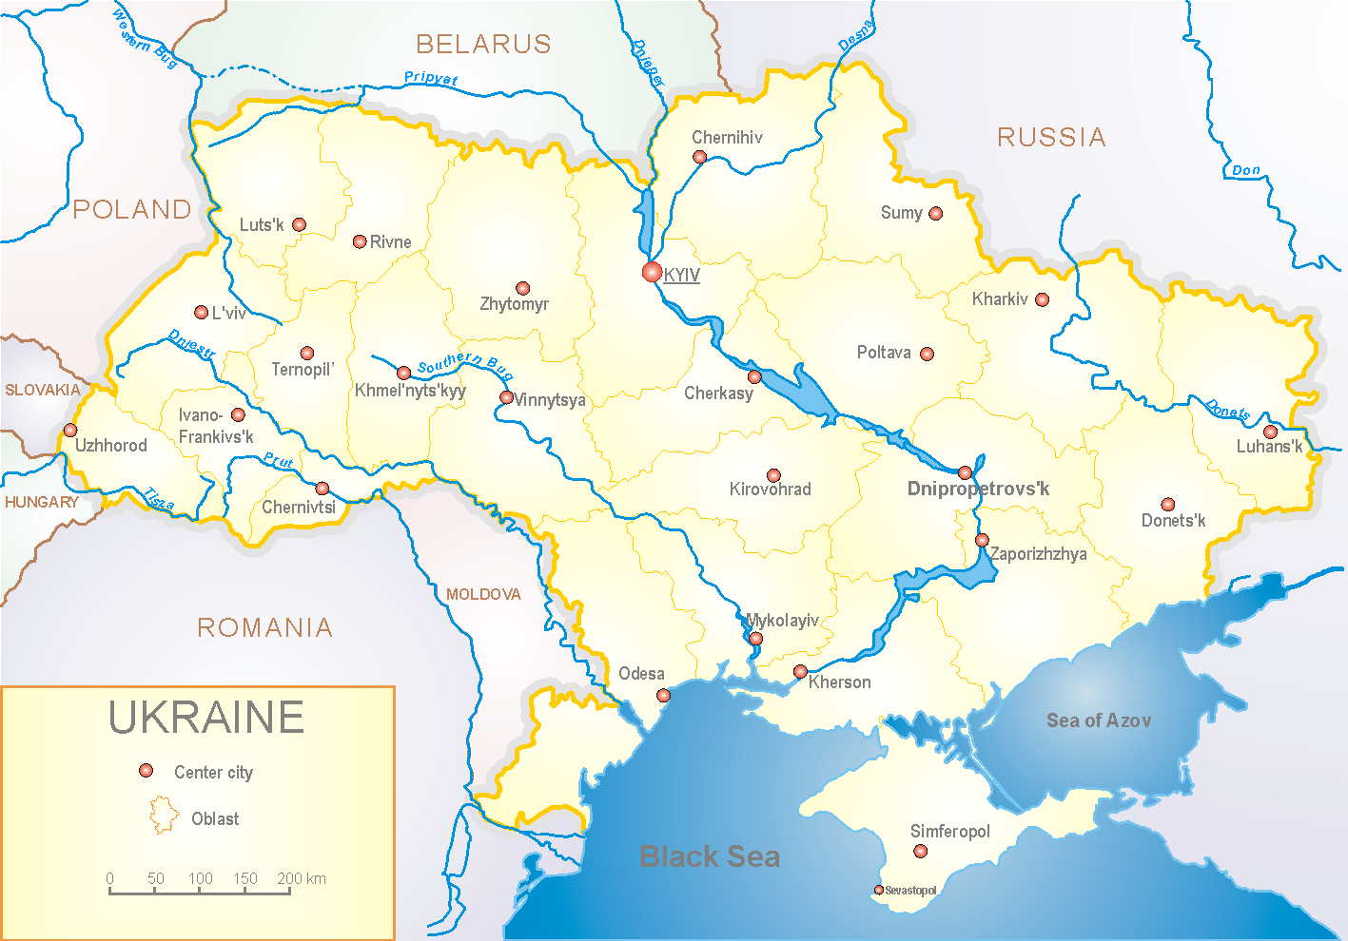

Influenza epidemic season 2020-2021 take place on the background of SARS-CoV-2 pandemic both in Ukraine and in the world.
According to data of influenza sentinel surveillance system in Ukraine in 8 policlinics of 4 sentinel cities of Ukraine the quantity of outpatient, which meet the definition of ILI during the 11th week (15.03.2021 – 21.03.2021) was 151 cases (14.3 per 100 thousand). The increase of morbidity level was 27.0% due to adults in comparison with the previous week. It is 31.0% more than the index of previous year (10.9 per 100 thousand in 2020) (fig. 1).

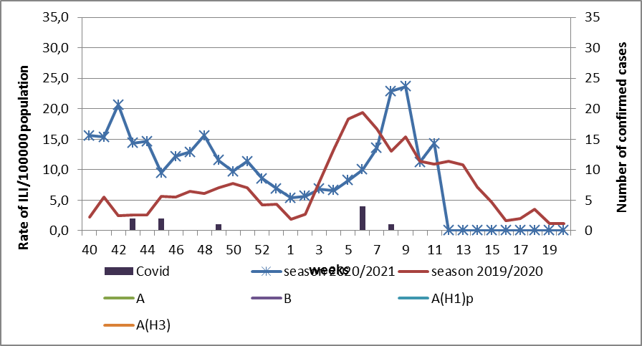

Fig.1. The dynamic of recorded ILI cases and number of laboratory confirmed influenza and SARS-CoV-2 cases in 4 sentinel centers of Ukraine in the 2020 – 2021 season.

During the 11th week in 9 hospitals of 4 sentinel centers there were hospitalized 1080 patients. This is 9.2% more than during the previous week. The quantity of SARI patients (patients which meet the definition SARI) was 265 cases (10.4 per 100 thousand). The increase of morbidity level was 2.7% due to adults in comparison with the previous week and 1.8 times more than the morbidity index of the previous year (index 5.6 in 2020) (fig. 2).
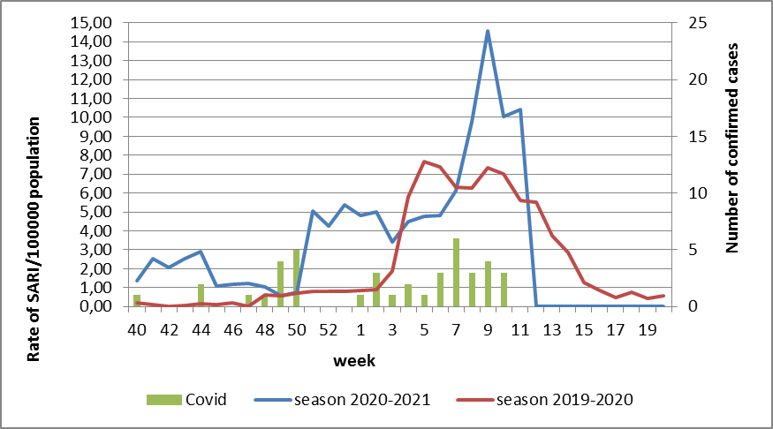

Fig.2 The dynamic of recorded SARI cases and the number of laboratory confirmed influenza and SARS-CoV-2 cases in season 2020 – 2021 in four sentinel centers of Ukraine.

From the 40th to the 11th week of 2020-2021 season there were investigated 98 samples from ILI and SARI patients by PCR method. There were laboratory confirmed 51 (52.0%) SARS-CoV-2 cases (fig. 3).

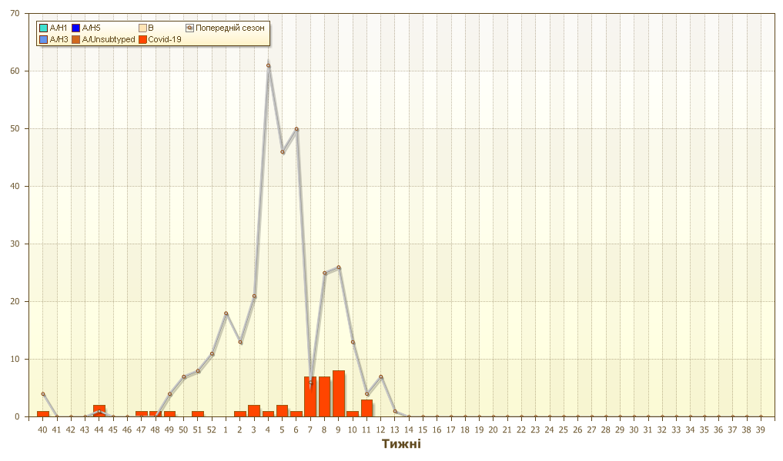
Fig. 3. Number of laboratory confirmed SARS-CoV-2 positive cases in sentinel centers of Ukraine in season 2020-2021.

During 11th week the quantity of hospitalized patients is still high among age groups 30 – 64 and 65+: 145 and 104 patients per week accordingly. Part of hospitalized children is 42.7%. Proportion of SARI from the total number of hospitalizations is 27.8% (fig. 4).
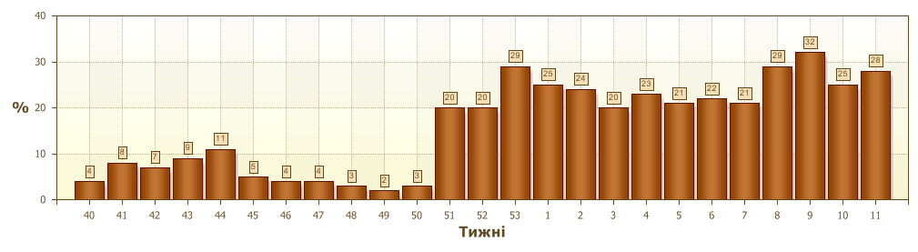
Fig. 4 Proportion of SARI from the total number of hospitalizations in the hospitals of sentinel centers.
So, according to sentinel surveillance we can observe the increase of SARI and ILI morbidity levels due to circulation of respiratory infections and SARS-CoV-2. There were not any confirmed influenza cases.
According to weekly ECDC-WHO intensity of epidemic process in European countries is at the off-season level.
Anti-epidemic measures which were taken to prevent the spreading of SARS-CoV-2 significantly affected epidemic process of influenza in the world.
From the beginning of the season in European countries there were investigated 490 199 samples from ILI and SARI patients by PCR method. Among them there were laboratory confirmed 744 influenza viruses. Among them influenza A – 377 (50.7%): 43 (11.4%) – influenza A(H1)pdm, 45 (11.9%) – influenza A(H3) and 289 (76.7%) – influenza A unsubtyped. There were also detected 367 (49.3%) influenza B cases, among them there were 8 (2.2%) – B/Victoria, 2 (0.5%) – B/Yamagata and 357 (97.3%) – influenza B (lineage is not detected).
The genetic characteristic of 11 influenza viruses have been examined for the current season: 2 influenza A(H3) viruses belong to the strain А/Slovenia/1637/2020, 1 - belongs to the strain A/Denmark/3264/2019 and 1 – belongs to А/Hong Kong/2671/2019. Influenza A(H1)pdm09 virus is represented by the strain А/Guangdond-Maonan/SWL1536/2019.
6 influenza B viruses type Victoria: 2 of them belong to the strain В/Washington/02/2019 and 4 – don’t belong to any clade.

Performed by:
Alla Mironenko, MD, DSc
Olga Holubka, PhD

