L.V. Gromashevsky Institute of Epidemiology and Infectious Diseases National Academy of Medical Science of Ukraine
National Influenza Center

Weekly Bulletin for Influenza Epidemic Situation in Ukraine by 4 Sentinel Centers
(Кyiv, Dnipropetrovsk, Odessa, Khmelnitsky)
Week 15, 2016

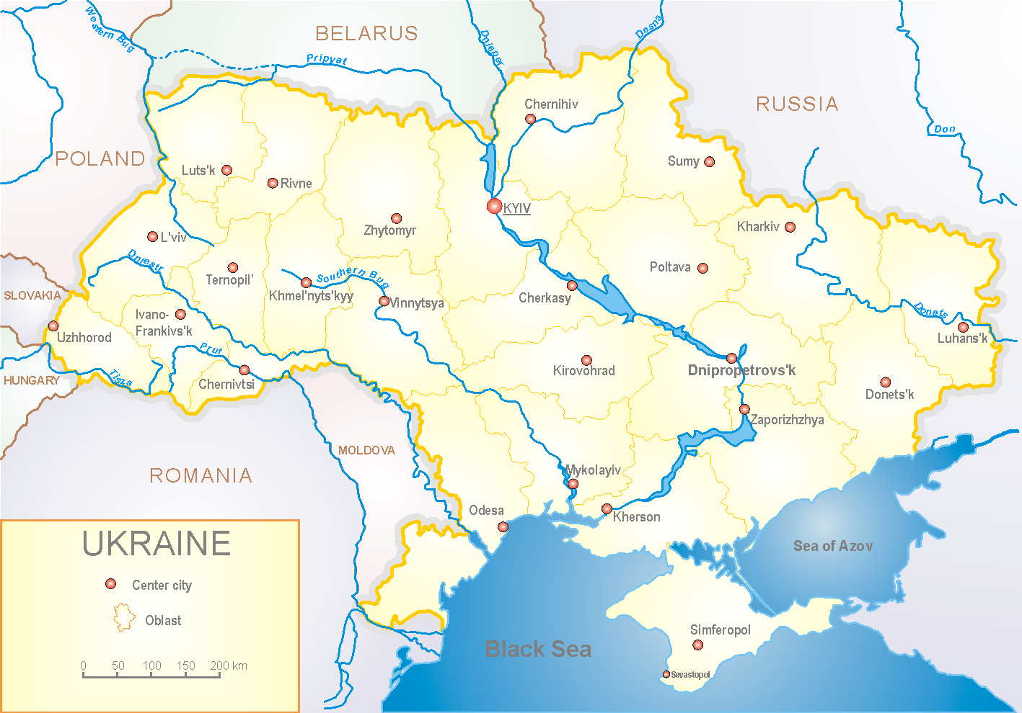
Since 2008 the system of ILI and SARI sentinel surveillance has been functioning in Ukraine. The sentinel centers are located in different geographical areas of the country: in Kyiv, Dnipropetrovsk, Odessa and Khmelnytskyi, which include 18 sentinel stations: 10 hospitals and 8 polyclinics.

According to data of sentinel surveillance system in 8 policlinics of 4 sentinel cities of Ukraine the quantity of outpatient, which meet the definition of ILI during the 15th week (11.04 - 17.04.16) was 45 cases (21.7 per 100 thousand) corresponding population. In comparison with the previous week the decline rate of morbidity was 27.4% (fig. 1).

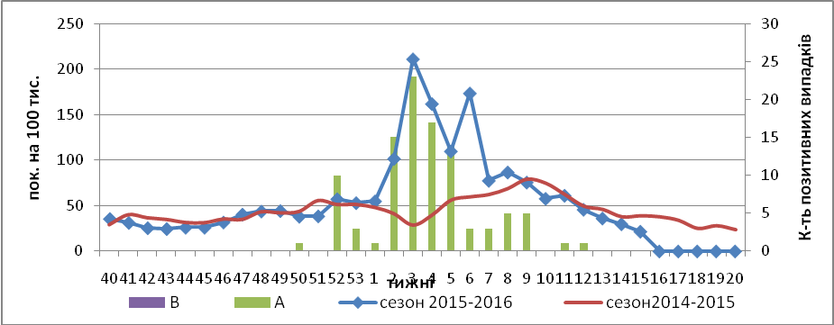

Fig.1. Dynamic of registered ILI cases and number of laboratory confirmed influenza cases in 4 sentinel cities of Ukraine in the 2015 – 2016 season.

During the 15th week in 10 hospitals of 4 sentinel cities there were hospitalized 1128 patients, this is 2.1% less than during the previous week. The quantity of SARI patients (patients which meet the definition SARI) was 77 cases (2.6 per 100 thousand); the decline rate of morbidity was 11.5% in comparison with the previous week (fig. 2 – 4).

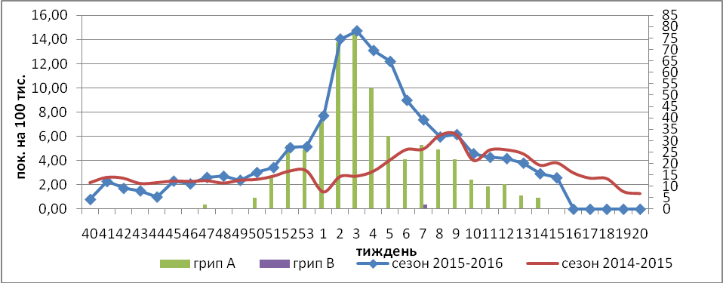

Fig.2. The dynamic of registered SARI cases and the number of laboratory confirmed influenza in season 2015 – 2016 in four sentinel cities of Ukraine.

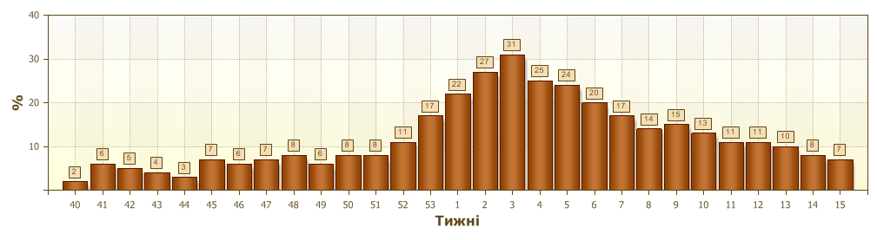
Fig.3. Proportion of SARI from the total number of hospitalizations in 4 sentinel cities of Ukraine in 2015 – 2016 season.

From the beginning of epidemic season among SARI patients there were laboratory confirmed 340 cases of influenza A(H1)pdm, 39 cases – influenza A(H3), 120 cases of influenza A (unsubtyped) and 1 case – influenza B

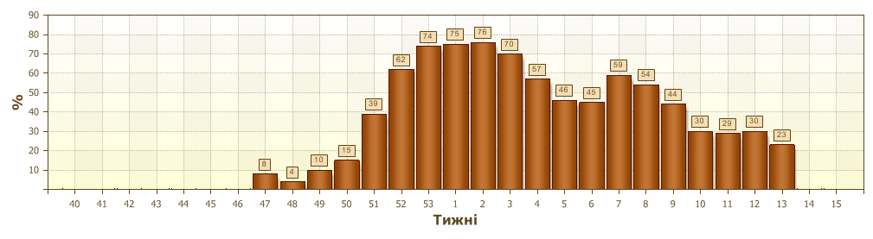

Fig.4. Proportion of laboratory confirmed influenza from all SARI examined in hospitals of 4 sentinel cities of Ukraine in 2015 – 2016 season.

From 40th to 15th week of 2015 – 2016 there were investigated 1672 samples from ILI and SARI patients by PCR method. There were detected 624 (37.3%) positive influenza samples: 410 – influenza viruses A(H1)pdm, 171 – influenza A (unsubtyped), 42 – A(H3), 1 – influenza B.
From the beginning of epidemic season there were isolated 316 influenza viruses on MDCK cell culture.

Performed by:
Alla Mironenko, MD, DSc
Olga Holubka, PhD.

Виконавці:
д.мед.н. Міроненко А.П.
к.мед.н. Голубка О.С.

