L.V. Gromashevsky Institute of Epidemiology and Infectious Diseases National Academy of Medical Science of Ukraine

Scientific Influenza and ARI Center

Weekly Bulletin for Influenza Epidemic Situation in Ukraine by 4 Sentinel Centers
(Кyiv, Dnipro, Odessa, Khmelnitsky)
Week 15, 2020

Loaded on website www.ukrinfluenza.com.ua

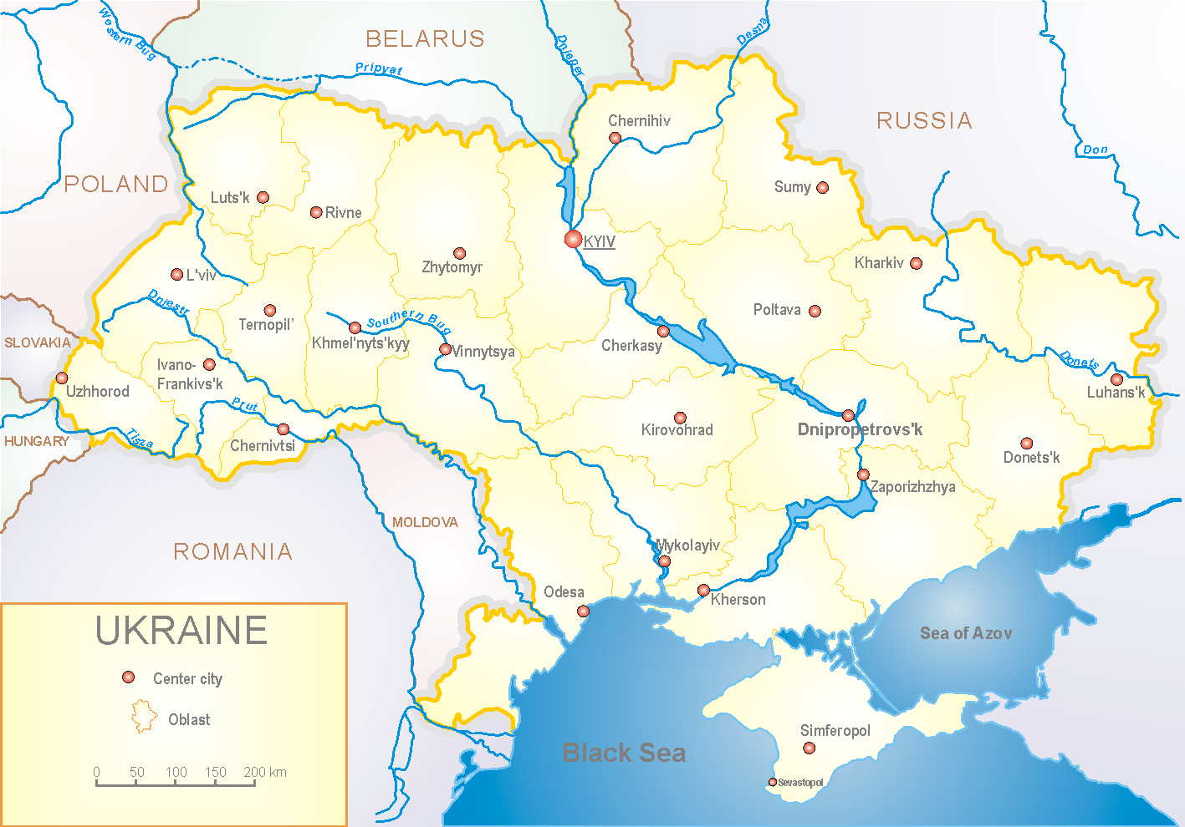
Since 2008 the system of ILI and SARI sentinel surveillance has been functioning in Ukraine. The sentinel centers are located in different geographical areas of the country: in Kyiv, Dnipro, Odessa and Khmelnytsky, which include 18 sentinel stations: 9 hospitals and 8 polyclinics.

According to data of influenza sentinel surveillance system in Ukraine in 8 policlinics of 4 sentinel cities of Ukraine the quantity of outpatient, which meet the definition of ILI during the 15th week (06.04. – 12.04.2020) was 50 cases (4.7 per 100 thousand). The decrease of morbidity level was 34.2% (fig. 1).

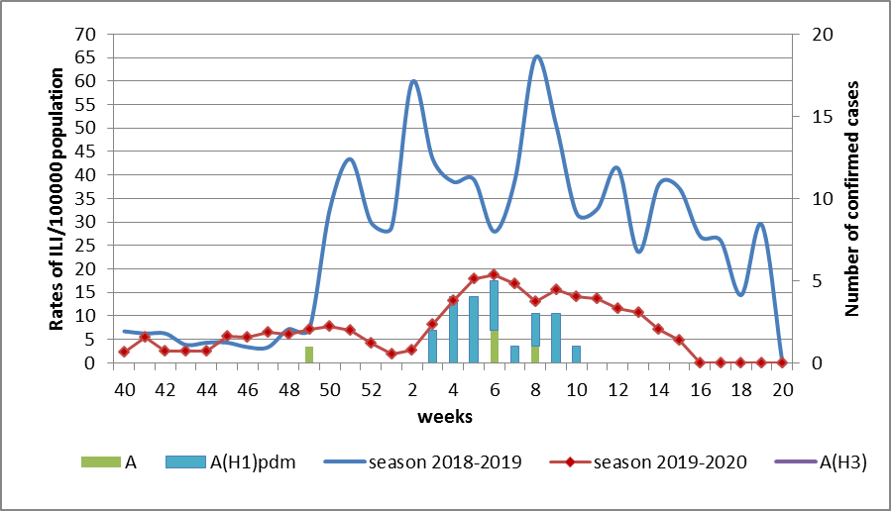

Fig.1. The dynamic of recorded ILI cases and number of laboratory confirmed influenza cases in 4 sentinel centers of Ukraine in the 2019 – 2020 season.

During the 15th week in 9 hospitals of 4 sentinel centers there were hospitalized 462 patients. This is 17.8% less than during the previous week. The quantity of SARI patients (patients which meet the definition SARI) was 32 cases (1.26 per 100 thousand). The decrease of morbidity level was 56.2%. There were laboratory confirmed 1 influenza viruses A(H1)pdm (fig. 2).

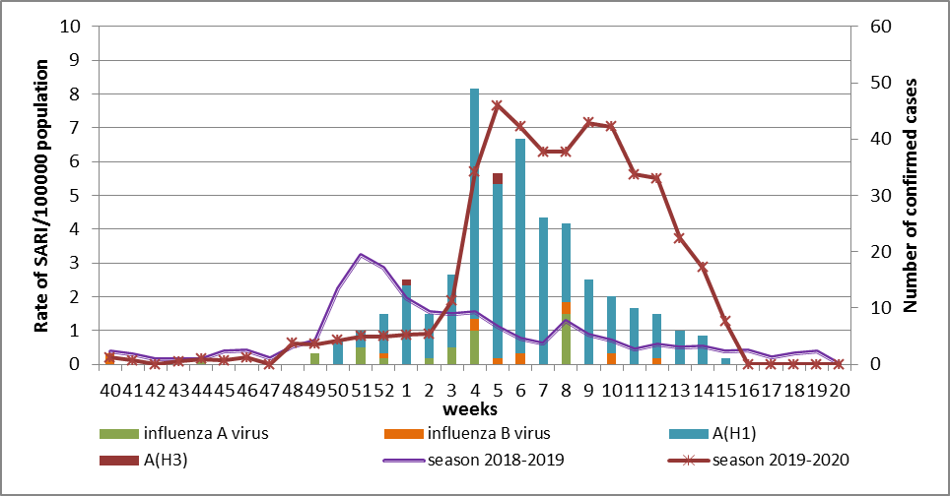

Fig.2 The dynamic of recorded SARI cases and the number of laboratory confirmed influenza in season 2019 – 2020 in four sentinel centers of Ukraine.

Proportion of SARI from the total number of hospitalizations is 6.9% (fig. 3).

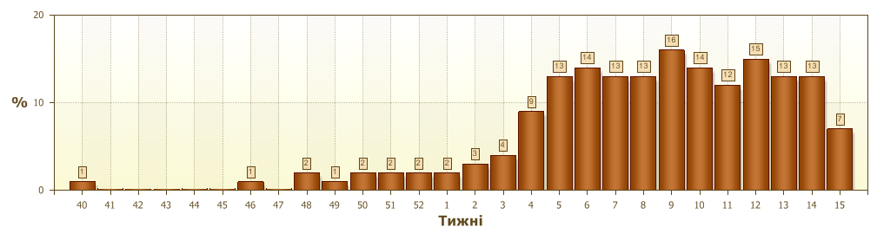
Fig. 3 Proportion of SARI from the total number of hospitalizations

From the 40th to the 15th week of 2019-2020 season there were investigated 525 samples from ILI and SARI patients by PCR method. There were laboratory confirmed 316 (60.6%) influenza viruses: 28 (8.9%) – influenza A (unsubtyped), 273 (86.4%) – influenza A(H1)pdm, 2 (0.6%) – influenza A(H3), 13 (4.1 %) – influenza B (6 – influenza B/Victoria) (fig. 4).

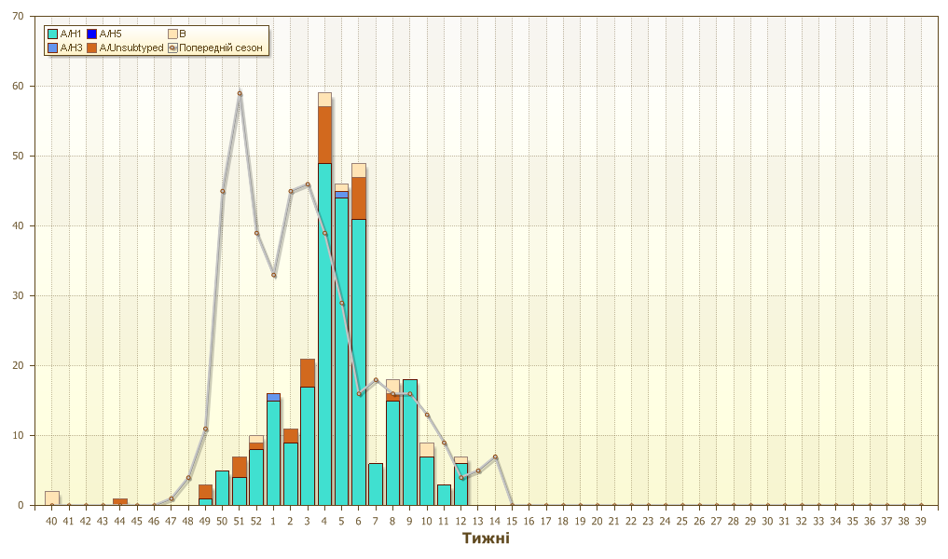 Fig.4. Number of laboratory confirmed influenza positive cases in sentinel centers of Ukraine.

So, we can observe a significant decrease of ILI and SARI morbidity levels, it is caused by the introduction of quarantine (from the 12th of March 2020) in response to COVID-19 pandemic. Quarantine measures influence the epidemic process, certainty of epidemiological and virological data in Ukraine.
Three fatal cases were registered in sentinel hospitals during this flu season. One of them is in age group ˃5 in Dnipro, 1 - in age group 30-64 in Odessa and the other is in the age group 65+ in Kyiv.

Performed by:
Alla Mironenko, MD, DSc
Olga Holubka, PhD

