L.V. Gromashevsky Institute of Epidemiology and Infectious Diseases National Academy of Medical Science of Ukraine

Scientific Influenza and ARI Center

Weekly Bulletin for Influenza Epidemic Situation in Ukraine by 4 Sentinel Centers
(Кyiv, Dnipro, Odessa, Khmelnitsky)
Week 16, 2021

Loaded on website www.ukrinfluenza.com.ua
Since 2008 the system of ILI and SARI sentinel surveillance has been functioning in Ukraine. The sentinel centers are located in different geographical areas of the country: in Kyiv, Dnipro, Odessa and Khmelnytsky, which include 17 sentinel stations: 9 hospitals and 8 polyclinics.
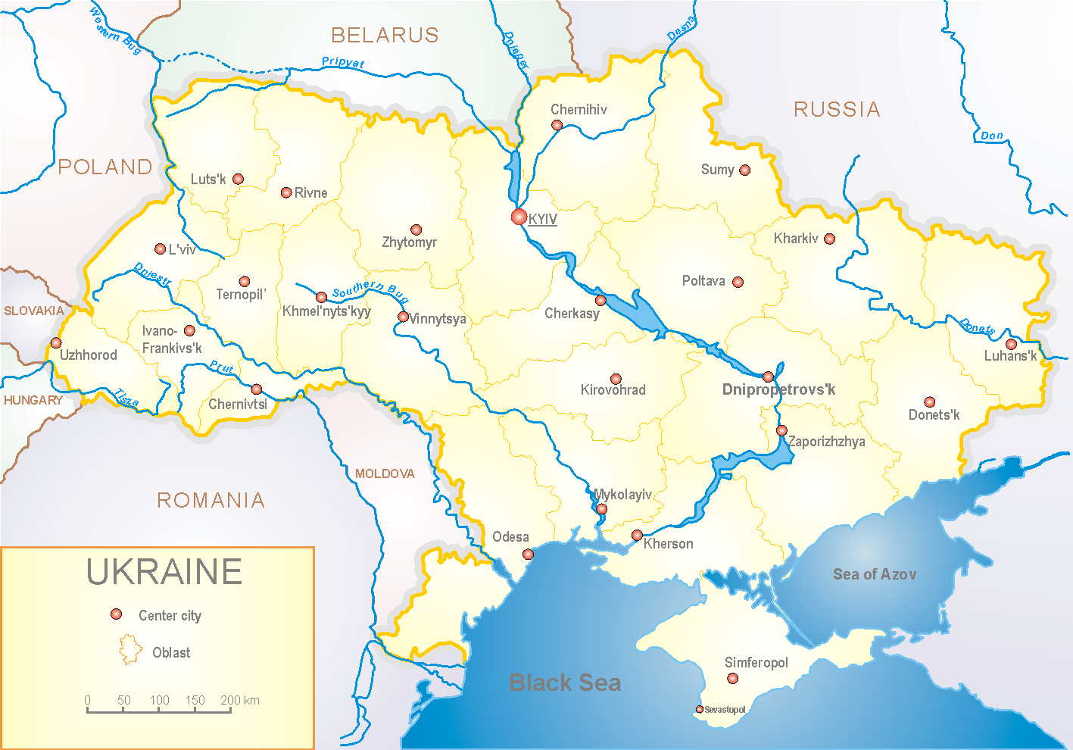

Influenza epidemic season 2020-2021 take place on the background of SARS-CoV-2 pandemic both in Ukraine and in the world.
According to data of influenza sentinel surveillance system in Ukraine in 8 policlinics of 4 sentinel cities of Ukraine the quantity of outpatient, which meet the definition of ILI during the 16th week (19.04.2021 – 25.04.2021) was 157 cases (14.9 per 100 thousand). The decrease of morbidity level was 13.7% in comparison with the previous week (fig. 1).

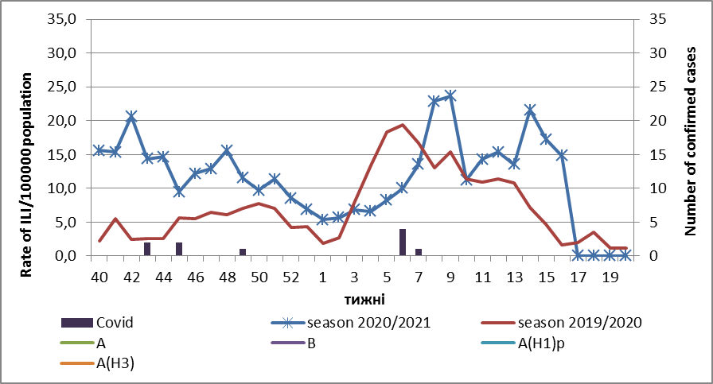

Fig.1. The dynamic of recorded ILI cases and number of laboratory confirmed influenza and SARS-CoV-2 cases in 4 sentinel centers of Ukraine in the 2020 – 2021 season.
During the 16th week in 9 hospitals of 4 sentinel centers there were hospitalized 867 patients. This is 3.58% more than during the previous week. The quantity of SARI patients (patients which meet the definition SARI) was 218 cases (8.56 per 100 thousand). The decrease of morbidity level was 5.2% in comparison with the previous week (fig. 2).

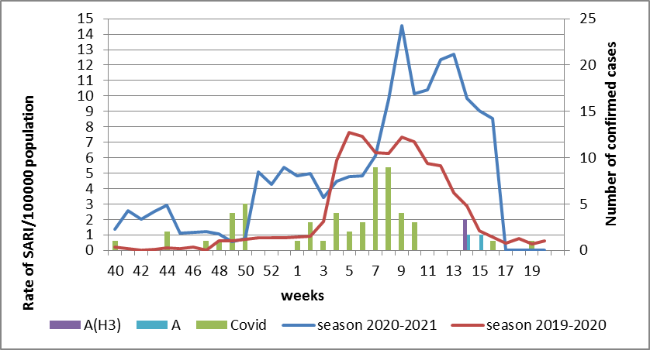

Fig.2 The dynamic of recorded SARI cases and the number of laboratory confirmed influenza and SARS-CoV-2 cases in season 2020 – 2021 in four sentinel centers of Ukraine.
From the 40th to the 16th week of 2020-2021 season there were investigated 135 samples from ILI and SARI patients by PCR method. There were laboratory confirmed 65 (52.0%) SARS-CoV-2 cases, 2 influenza A cases (unsubtyped) and 1 influenza A (H3) case (fig. 3).
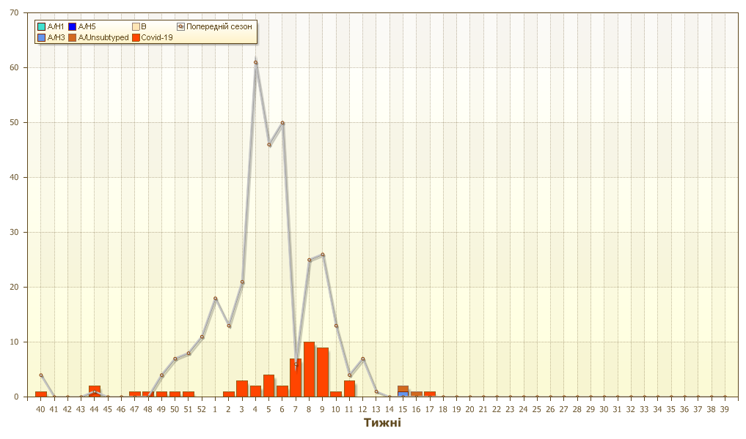
Fig. 3. Number of laboratory confirmed SARS-CoV-2 positive cases in sentinel centers of Ukraine in season 2020-2021.

During 11th week the quantity of hospitalized patients is still high among age groups 30 – 64 and 65+: 145 and 104 patients per week accordingly. Part of hospitalized children is 42.7%. Proportion of SARI from the total number of hospitalizations is 27.8% (fig. 4).
The highest percentage of severe cases among hospitalized patients is registered among such age groups: 30 – 64 and 65+ from 40% up to 52%accordingly. Proportion of SARI from the total number of hospitalizations is 25.1% (fig. 4).

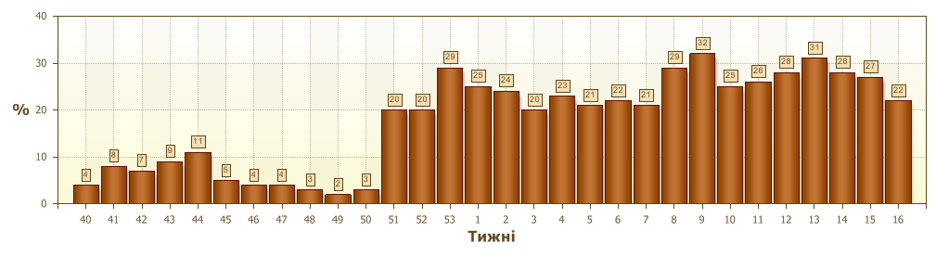
Fig. 4 Proportion of SARI from the total number of hospitalizations in the hospitals of sentinel centers.
So, according to sentinel surveillance data we can observe the decrease of SARI and ILI morbidity levels. According to data of influenza surveillance system there were laboratory confirmed 2 influenza A cases (unsubtyped) and 1 A(H3) influenza case in Odessa.
According to weekly ECDC-WHO intensity of epidemic process in European countries is at the off-season levels.
There are sporadic influenza cases in European countries. 791 influenza cases are laboratory confirmed, this is 0.1% from the total number of examined patients. Influenza A(H3) virus prevails among the confirmed cases.
Anti-epidemic measures which were taken to prevent the spreading of SARS-CoV-2 significantly affected epidemic process of influenza in the world.

Performed by:
Alla Mironenko, MD, DSc
Olga Holubka, PhD

