L.V. Gromashevsky Institute of Epidemiology and Infectious Diseases National Academy of Medical Science of Ukraine

Scientific Influenza and ARI Center

Weekly Bulletin for Influenza Epidemic Situation in Ukraine by 4 Sentinel Centers
(Кyiv, Dnipro, Odessa, Khmelnitsky)
Week 19, 2021

Loaded on website www.ukrinfluenza.com.ua

Since 2008 the system of ILI and SARI sentinel surveillance has been functioning in Ukraine. The sentinel centers are located in different geographical areas of the country: in Kyiv, Dnipro, Odessa and Khmelnytsky, which include 17 sentinel stations: 9 hospitals and 8 polyclinics.
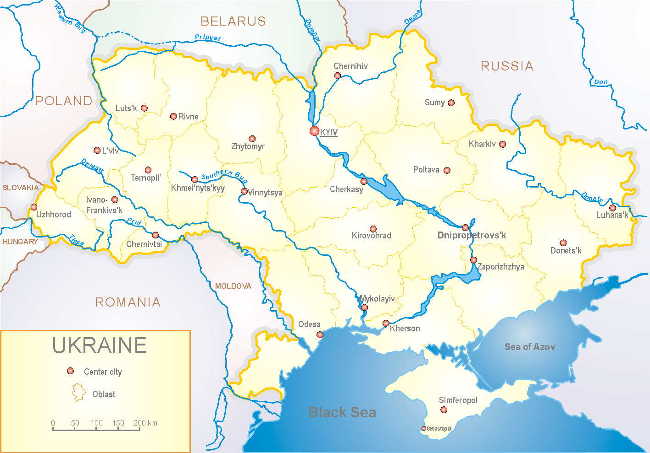
Influenza epidemic season 2020-2021 take place on the background of SARS-CoV-2 pandemic both in Ukraine and in the world.
According to data of influenza sentinel surveillance system in Ukraine in 8 policlinics of 4 sentinel cities of Ukraine the quantity of outpatient, which meet the definition of ILI during the 19th week (10.05.2021 – 16.05.2021) was 62 cases (5.9 per 100 thousand). The increase of morbidity level was 10.7% in comparison with the previous week. It is 31.0% more than the index of previous year (10.9 per 100 thousand in 2020) (fig. 1).
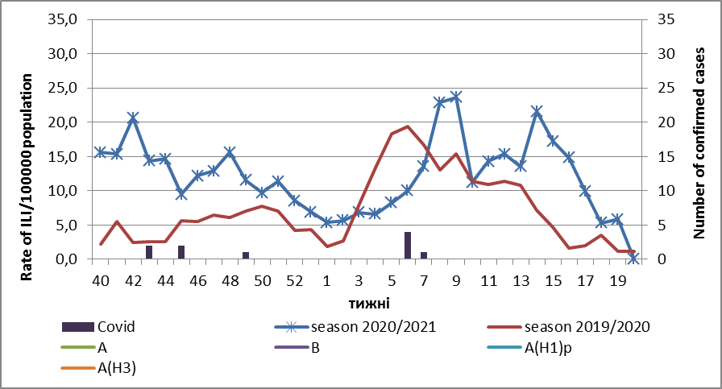
Fig.1. The dynamic of recorded ILI cases and number of laboratory confirmed influenza and SARS-CoV-2 cases in 4 sentinel centers of Ukraine in the 2020 – 2021 season.

During the 19th week in 9 hospitals of 4 sentinel centers there were hospitalized 523 patients. This is 4.5% less than during the previous week. The quantity of SARI patients (patients which meet the definition SARI) was 84 cases (3.3 per 100 thousand). The decrease of morbidity level was 34.4% in comparison with the previous week (fig. 2).

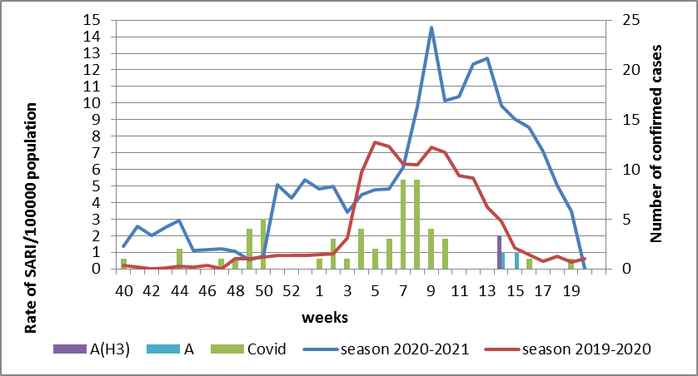

Fig.2 The dynamic of recorded SARI cases and the number of laboratory confirmed influenza and SARS-CoV-2 cases in season 2020 – 2021 in four sentinel centers of Ukraine.

From the 40th to the 19th week of 2020-2021 season there were investigated 160 samples from ILI and SARI patients by PCR method. There were laboratory confirmed 65 (40.6%) SARS-CoV-2 cases, 2 influenza A cases (unsubtyped) and 1 influenza A (H3) case (fig. 3).
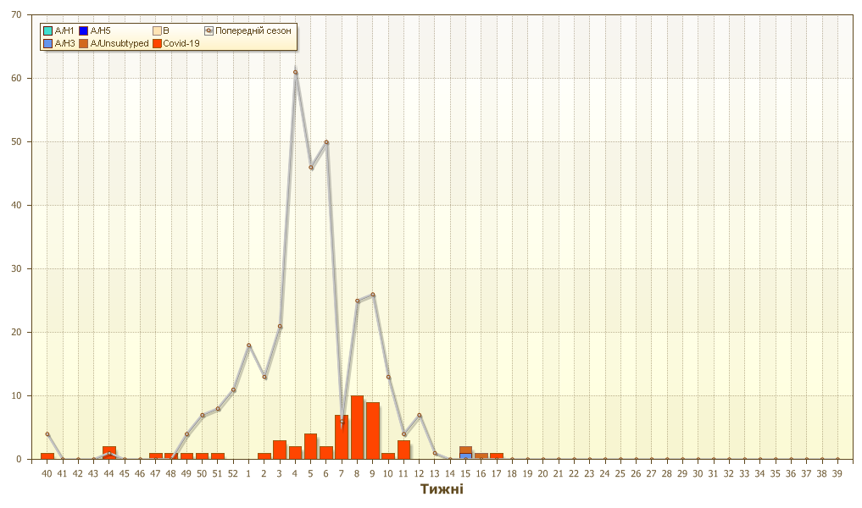
Fig. 3. Number of laboratory confirmed SARS-CoV-2 positive cases in sentinel centers of Ukraine in season 2020-2021.
Proportion of SARI from the total number of hospitalizations is 16.1% (fig. 4).
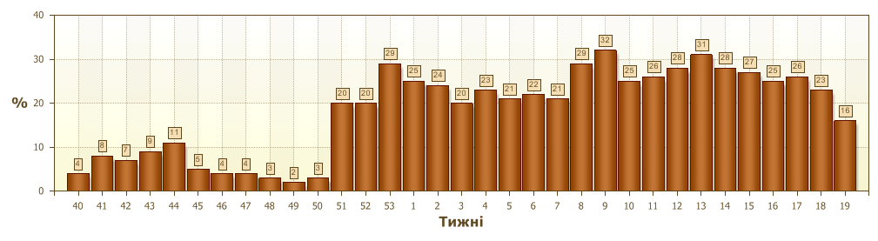
Fig. 4 Proportion of SARI from the total number of hospitalizations in the hospitals of sentinel centers.

So, the epidemic season is almost over. The recorded ILI and SARI cases, which were caused by other respiratory infections, in particular SARS-CoV-2 significantly decreased.
In Ukraine and European counties the epidemic influenza season 2020-2021 significantly differs from previous seasons, the influenza morbidity level didn’t reach the threshold values and the intensity of influenza epidemic process was at the off-season levels during the whole season. Anti-epidemic measures which were taken to prevent the spreading of SARS-CoV-2 significantly affected epidemic process of influenza in the world.
According to data of influenza surveillance system there were laboratory confirmed 2 influenza A cases (unsubtyped) and 1 A(H3) influenza case in Odessa.
According to weekly ECDC-WHO intensity of epidemic process in European countries from the beginning of season there were investigated 819 965 samples from ILI and SARI patients by PCR method. Among them there were laboratory confirmed 876 (0.1%) influenza viruses. Among them influenza A – 451 (51.5%): 41 (9.1%) – influenza A(H1)pdm, 56 (12.4%) – influenza A(H3) and 354 (78.5%) – influenza A unsubtyped. There were also detected 425 (48.5%) influenza B cases, among them there were 13 (3.05%) – B/Victoria, 2 (0.7%) – B/Yamagata and 409 (96.2%) – influenza B (lineage is not detected).

Performed by:
Alla Mironenko, MD, DSc
Olga Holubka, PhD

