L.V. Gromashevsky Institute of Epidemiology and Infectious Diseases National Academy of Medical Science of Ukraine

Scientific Influenza and ARI Center

Weekly Bulletin for Influenza Epidemic Situation in Ukraine by 4 Sentinel Centers
(Кyiv, Dnipro, Odessa, Khmelnitsky)
Week 2, 2020

Loaded on website www.ukrinfluenza.com.ua

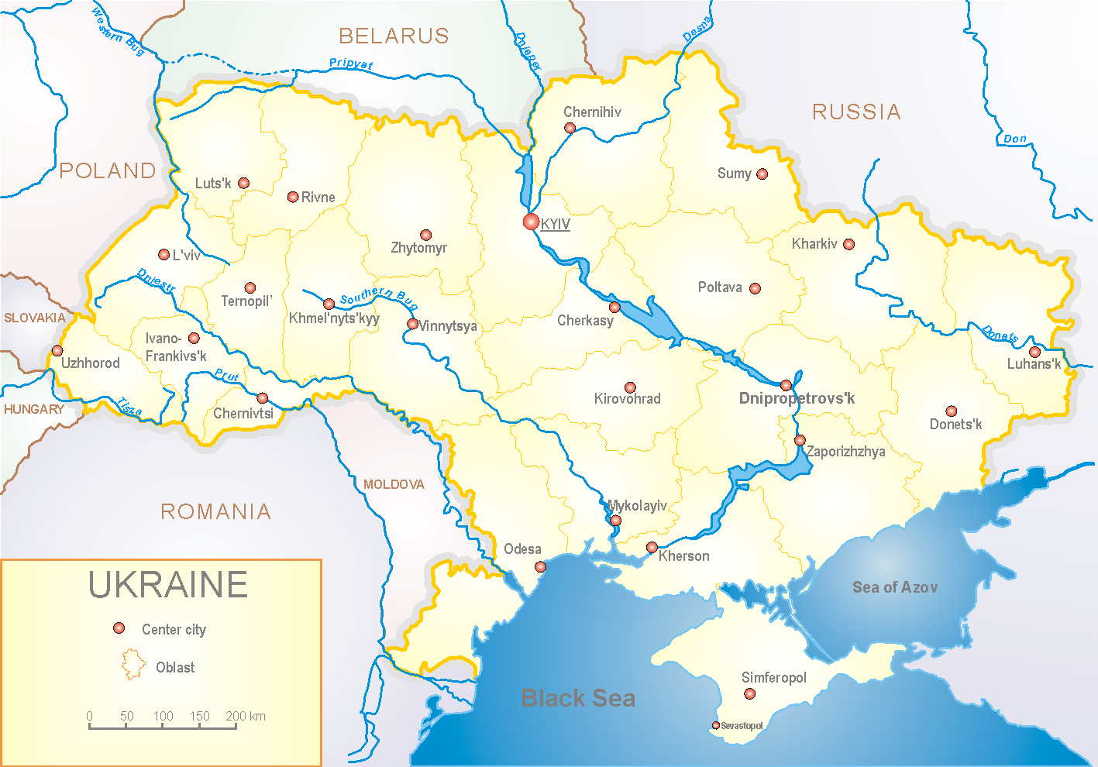
Since 2008 the system of ILI and SARI sentinel surveillance has been functioning in Ukraine. The sentinel centers are located in different geographical areas of the country: in Kyiv, Dnipro, Odessa and Khmelnytsky, which include 18 sentinel stations: 10 hospitals and 8 polyclinics
.

According to data of influenza sentinel surveillance system in Ukraine in 8 policlinics of 4 sentinel cities of Ukraine the quantity of outpatient, which meet the definition of ILI during the 2nd week (06.01.2020 –12.01.2020) was 29 cases (2.7 per 100 thousand). The increase of morbidity level was 45.0% (fig. 1).

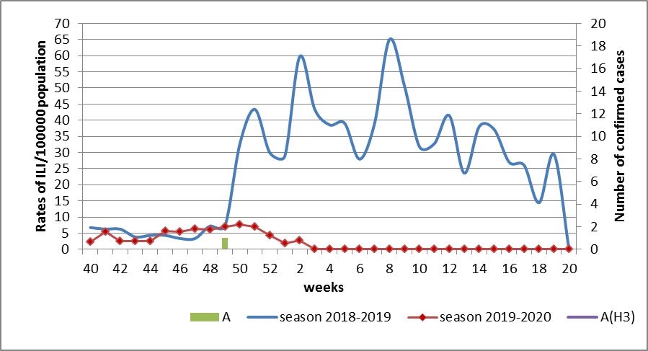

Fig.1. The dynamic of recorded ILI cases and number of laboratory confirmed influenza cases in 4 sentinel centers of Ukraine in the 2019 – 2020 season.

During the 2nd week in 10 hospitals of 4 sentinel centers there were hospitalized 943 patients. This is 4.6% more than during the previous week. The quantity of SARI patients (patients which meet the definition SARI) was 23 cases (0.9 per 100 thousand). The increase of morbidity level was 4.5% (fig. 2).

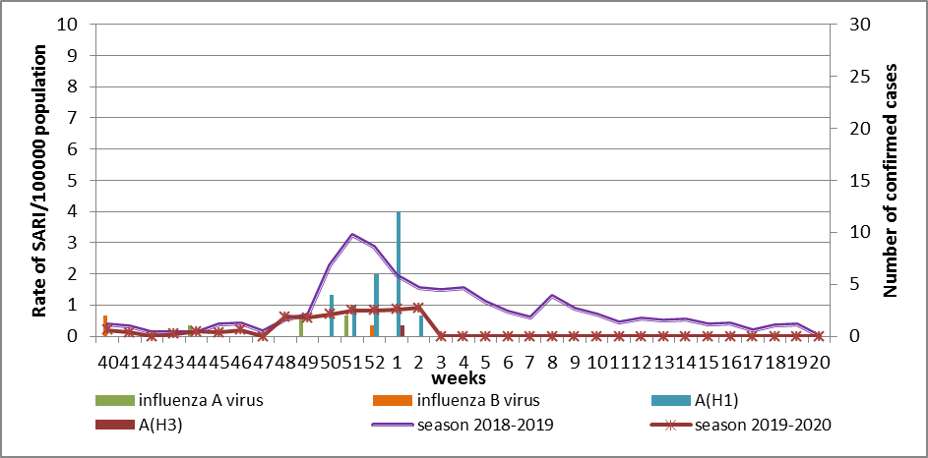

Fig.2 The dynamic of recorded SARI cases and the number of laboratory confirmed influenza in season 2019 – 2020 in four sentinel centers of Ukraine.

From the 40th to the 2nd week of 2019-2020 season there were investigated 100 samples from ILI and SARI patients by PCR method. There were laboratory confirmed 37 influenza viruses: 6 (16.2%) – influenza A (unsubtyped), 27 (73%) – influenza A(H1)pdm, 1 (2.7%) – influenza A(H3), 3 (8.1%) – influenza B (2 – influenza B/Victoria) (fig. 3).
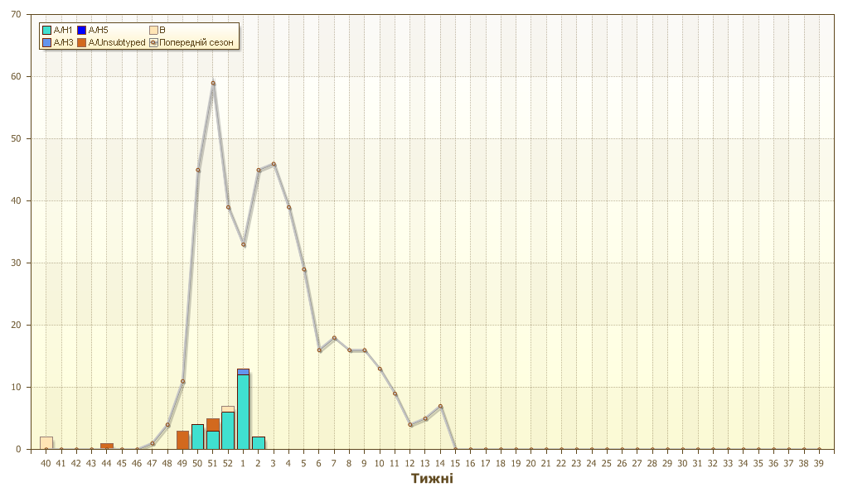
Fig.3. Number of laboratory confirmed influenza positive cases in sentinel centers of Ukraine.
So, the rates of ILI and SARI morbidity meet the seasonal levels. Influenza A(H1)pdm virus predominates among confirmed cases (73%).
According to data of ECDC-WHO weekly bulletin rates of morbidity are on background or low levels in European countries but influenza A(H3) virus and influenza B/Victoria predominate there.

Performed by:
Alla Mironenko, MD, DSc
Olga Holubka, PhD

