L.V. Gromashevsky Institute of Epidemiology and Infectious Diseases National Academy of Medical Science of Ukraine

Scientific Influenza and ARI Center

Weekly Bulletin for Influenza Epidemic Situation in Ukraine by 4 Sentinel Centers
(Кyiv, Dnipro, Odessa, Khmelnitsky)
Week 20, 2021

Loaded on website www.ukrinfluenza.com.ua
Since 2008 the system of ILI and SARI sentinel surveillance has been functioning in Ukraine. The sentinel centers are located in different geographical areas of the country: in Kyiv, Dnipro, Odessa and Khmelnytsky, which include 17 sentinel stations: 9 hospitals and 8 polyclinics.
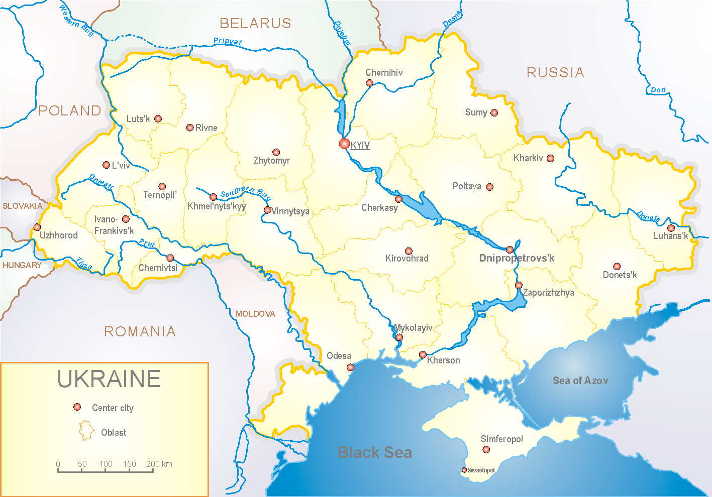

Influenza epidemic season 2020-2021 take place on the background of SARS-CoV-2 pandemic both in Ukraine and in the world.
According to data of influenza sentinel surveillance system in Ukraine in 8 policlinics of 4 sentinel cities of Ukraine the quantity of outpatient, which meet the definition of ILI during the 20th week (17.05.2021 – 23.05.2021) was 75 cases (7.1 per 100 thousand). The increase of morbidity level was 21.0% in comparison with the previous week (fig. 1). During the 2020-2021 season there were 4417 ILI cases (418.1 per 100 thousand), this is 1.7 times more than during the previous year.

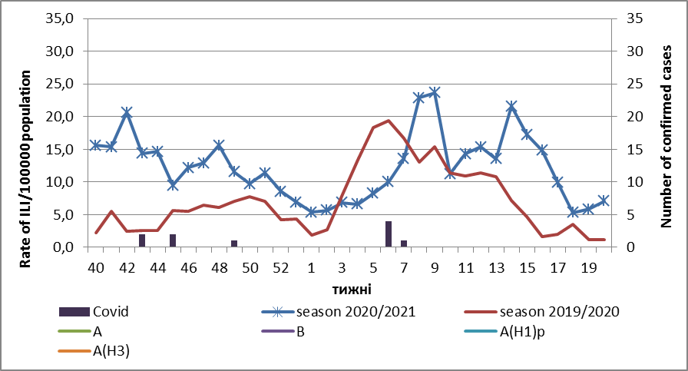
Fig.1. The dynamic of recorded ILI cases and number of laboratory confirmed influenza and SARS-CoV-2 cases in 4 sentinel centers of Ukraine in the 2020 – 2021 season.

During the 20th week in 9 hospitals of 4 sentinel centers there were hospitalized 572 patients. This is 9.4% more than during the previous week. The quantity of SARI patients (patients which meet the definition SARI) was 55 cases (2.16 per 100 thousand). The decrease of morbidity level was 37.5% in comparison with the previous week (fig. 2). During the 2020-2021 season there were hospitalized 25179 patients and registered 4617 SARI cases (181.3 per 100 thousand), this is 2.3 times more than the indexes of previous year.

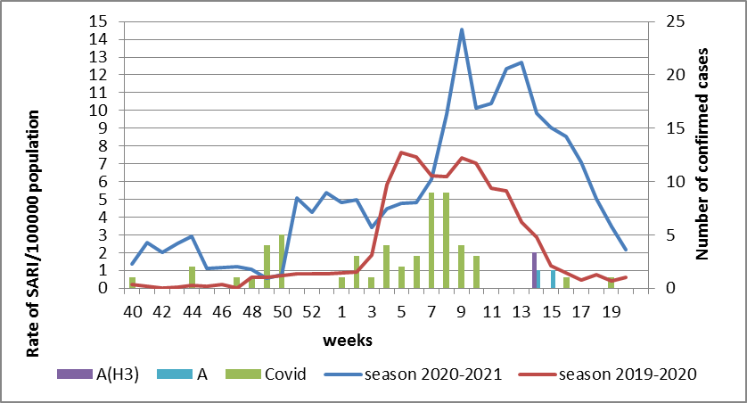

Fig.2 The dynamic of recorded SARI cases and the number of laboratory confirmed influenza and SARS-CoV-2 cases in season 2020 – 2021 in four sentinel centers of Ukraine.

From the 40th to the 20th week of 2020-2021 season there were investigated 170 samples from ILI and SARI patients by PCR method. There were laboratory confirmed 65 (38.2%) SARS-CoV-2 cases, 2 (1.1%) - influenza A cases (unsubtyped) and 1 influenza A(H3) (0.6%) virus (fig. 3).

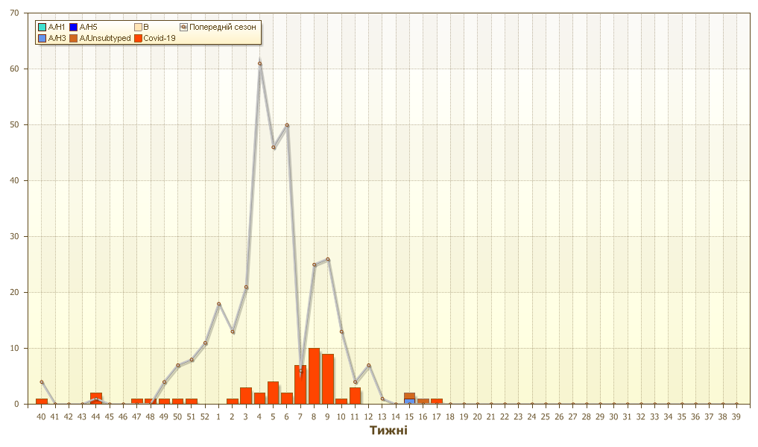
Fig. 3. Number of laboratory confirmed SARS-CoV-2 positive cases in sentinel centers of Ukraine in season 2020-2021.
Proportion of SARI from the total number of hospitalizations is 9.6% (fig. 4).
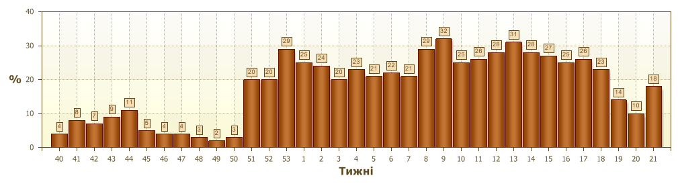
Fig. 4 Proportion of SARI from the total number of hospitalizations in the hospitals of sentinel centers.

So, the epidemic season is over. The recorded ILI and SARI cases, which were caused by other respiratory infections, in particular SARS-CoV-2 significantly decreased, but the morbidity indexes were twice higher than the previous year one.
In Ukraine and European counties the epidemic influenza season 2020-2021 significantly differs from previous seasons, the influenza morbidity level didn’t reach the threshold values and the intensity of influenza epidemic process was at the off-season levels during the whole season. Anti-epidemic measures which were taken to prevent the spreading of SARS-CoV-2 significantly affected epidemic process of influenza in the world.
According to data of influenza surveillance system there were laboratory confirmed 2 influenza A cases (unsubtyped) and 1 A(H3) influenza case in Odessa.
According to weekly ECDC-WHO intensity of epidemic process in European countries from the beginning of the season there were investigated 889 284 samples from patients by PCR method. Among them there were laboratory confirmed 909 (0.1%) influenza viruses. Among them influenza A – 468 (51.5%): 41 (8.8%) – influenza A(H1)pdm, 60 (12.8%) – influenza A(H3) and 367 (78.4%) – influenza A unsubtyped. There were also detected 441 (48.5%) influenza B cases, among them there were 13 (2.9%) – B/Victoria, 3 (0.7%) – B/Yamagata and 425 (96.4%) – influenza B (lineage is not detected).
За даними щотижневого бюлетеня ECDC-ВООЗ, з початку сезону в країнах Європи методом ПЛР обстежено 889 284 зразки від хворих, лабораторно підтверджено 909 (0,1%) випадків вірусів грипу. З них: грип А – 468 (51,5 %): 41 (8,7 %) - грип А(Н1)pdm, 60 (12,8 %) – грип А(Н3) та 367 (78,4 %) - грип А (не субтипований). Також виявлено 441 (48,5 %) вірусів грипу В, з них 13 (2,9%) – В/Vіctoria, 3 (0,7 %) – В/Yamagata та 425 (96,4 %) – грип В (лінія не визначена).

Performed by:
Alla Mironenko, MD, DSc
Olga Holubka, PhD

