L.V. Gromashevsky Institute of Epidemiology and Infectious Diseases National Academy of Medical Science of Ukraine

Scientific Influenza and ARI Center

Weekly Bulletin for Influenza Epidemic Situation in Ukraine by 4 Sentinel Centers
(Кyiv, Dnipro, Odessa, Khmelnitsky)
Weeks 20, 2019

Loaded on website www.ukrinfluenza.com.ua

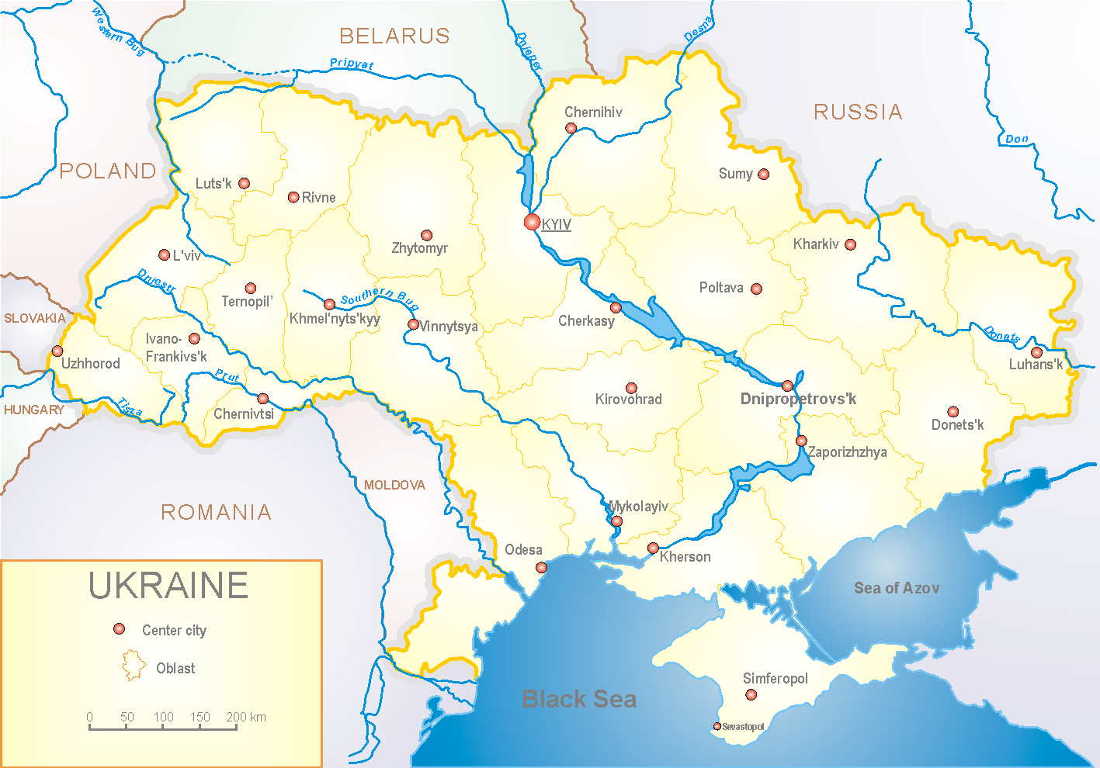
Since 2008 the system of ILI and SARI sentinel surveillance has been functioning in Ukraine. The sentinel centers are located in different geographical areas of the country: in Kyiv, Dnipro, Odessa and Khmelnytsky, which include 18 sentinel stations: 10 hospitals and 8 polyclinics.

According to data of influenza sentinel surveillance system in Ukraine in 8 policlinics of 4 sentinel centers the quantity of outpatients, which meet the definition of ILI during the 20th week (13.05.19 – 19.05.19) was 63 cases (30.4 per 100 thousand). The increase of morbidity level was 3.3% (fig. 1).
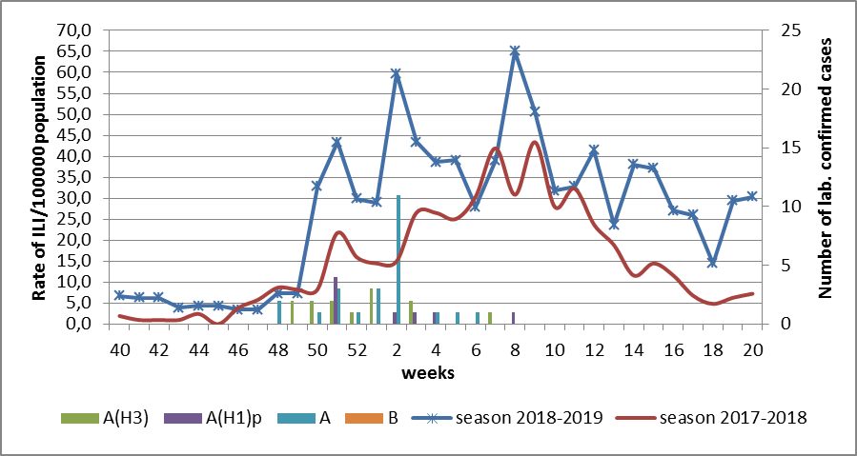

Fig.1. The dynamic of recorded ILI cases and number of laboratory confirmed influenza cases in 4 sentinel centers of Ukraine in the 2018 – 2019 season.

During the 20th week in 10 hospitals of 4 sentinel centers there were hospitalized 1081 patients, this is 4.4% more than during the previous week. The quantity of SARI patients (patients which meet the definition SARI) was 7 cases (0.24 per 100 thousand). The decrease of morbidity level was 36.4% (fig. 2).
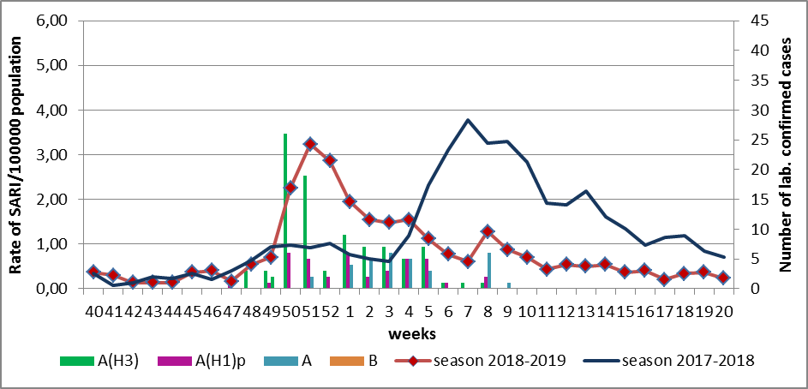
Fig.2 The dynamic of recorded SARI cases and the number of laboratory confirmed influenza in season 2018 – 2019 in four sentinel centers of Ukraine.
The percentage of SARI from all hospitalized was 0.6%.
From the beginning of the season 2018-2019 there were investigated 712 samples from ILI and SARI patients by PCR method. Laboratory confirmed 359 (50.4%) influenza positive cases: 131 (36.5%) - A(H3), 83 (23.1%) – influenza A(H1)pdm viruses and 145 (40.4%) – influenza A (unsubtyped). There were isolated 94 influenza viruses on MDCK cell culture (fig. 3).
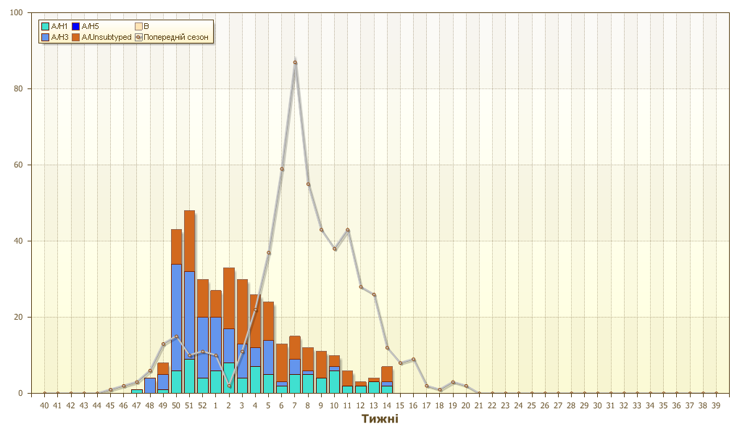
Рис. 3. Кількість підтверджених випадків грипу в ДЦ України.

Виконавці:
д.мед.н. Міроненко А.П.
к.мед.н. Голубка О.С.

