L.V. Gromashevsky Institute of Epidemiology and Infectious Diseases National Academy of Medical Science of Ukraine
National Influenza Center

Weekly Bulletin for Influenza Epidemic Situation in Ukraine by 4 Sentinel Centers
(Кyiv, Dnipropetrovsk, Odessa, Khmelnitsky)
Week 3, 2016

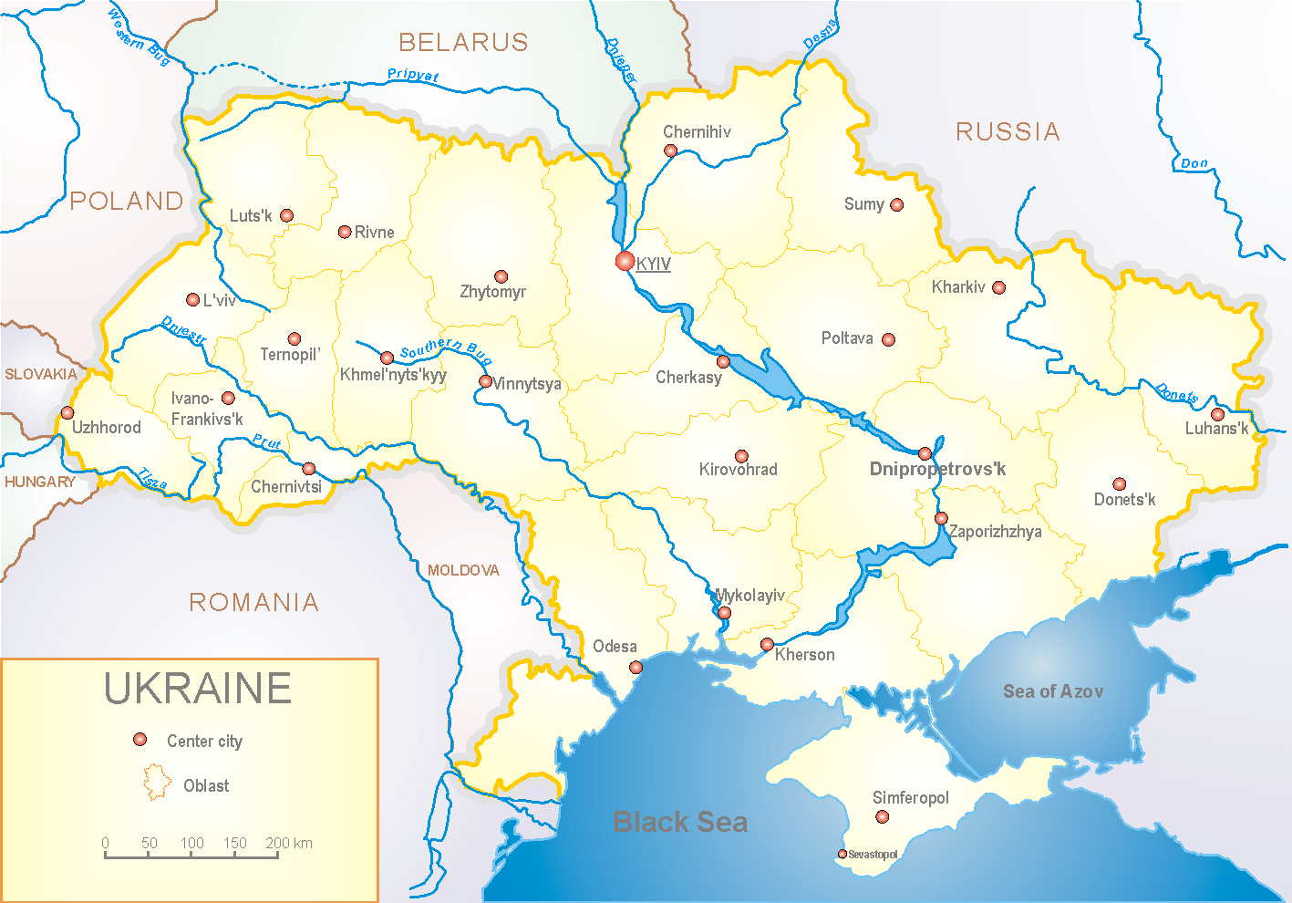
Since 2008 the system of ILI and SARI sentinel surveillance has been functioning in Ukraine. The sentinel centers are located in different geographical areas of the country: in Kyiv, Dnipropetrovsk, Odessa and Khmelnytskyi, which include 18 sentinel stations: 10 hospitals and 8 polyclinics.

According to data of sentinel surveillance system in 8 policlinics of 4 sentinel cities of Ukraine the quantity of outpatient, which meet the definition of ILI during the 3rd week (18.01 - 24.01.16) was 309 cases (148.9 per 100 thousand) corresponding population. In comparison with previous week the growth rate of morbidity was 46.4% (fig. 1).

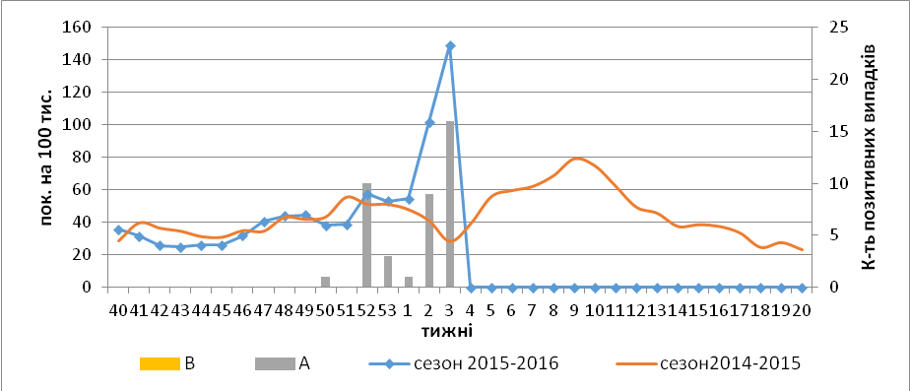

Fig.1. Dynamic of ILI cases and number of laboratory confirmed influenza cases in 4 sentinel cities of Ukraine in the 2015 – 2016 season.

During the 3rd week in 10 hospitals of 4 sentinel cities there were hospitalized 1539 patients, this is 9.4% less than during the previous week. The quantity of SARI patients (patients which meet the definition SARI) was 437 cases (14.7 per 100 thousand); the increase of morbidity level was 4.8% in comparison with the previous week (fig. 2 – 4).

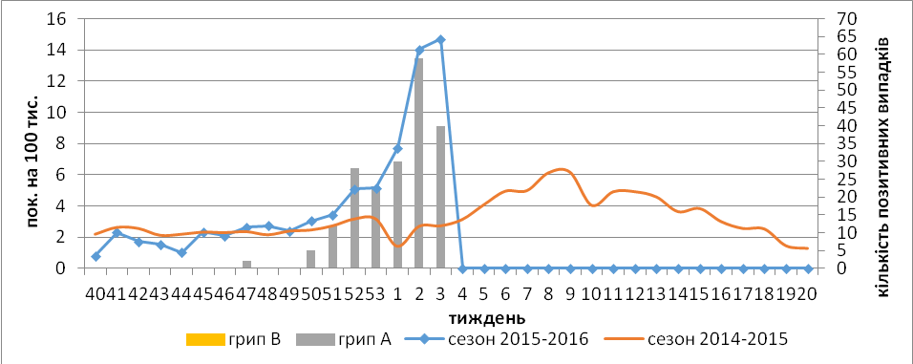

Fig.2. The dynamic of SARI cases and the number of laboratory confirmed influenza in season 2015 – 2016 in four sentinel cities of Ukraine.

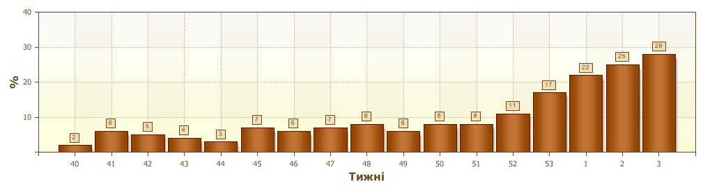
Fig.3. Proportion of SARI from the total number of hospitalizations in 4 sentinel cities of Ukraine in 2015 – 2016 season

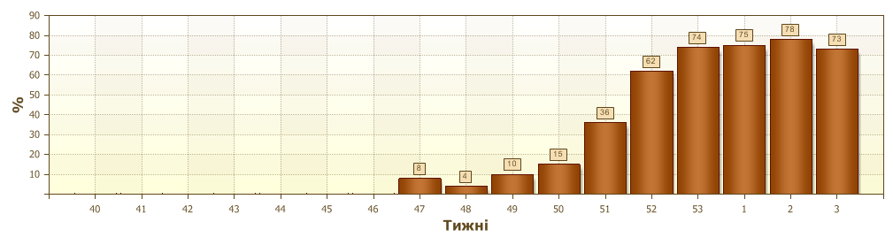
Fig.4. Proportion of laboratory confirmed influenza from all SARI examined in hospitals of 4 sentinel cities of Ukraine in 2015 – 2016 season.

From 40th to 3rd week of 2015 – 2016 there were investigated 730 samples from ILI and SARI patients by PCR method. There were detected 239 (32.7%) positive influenza samples: 162 – influenza viruses A(H1)pdm, 72 - influenza A (unsubtyped) and 5 – A(H3).
From the beginning of epidemiological season there were isolated 63 influenza viruses on MDCK cell culture.
Virological sentinel influenza surveillance data are presented weekly on WHO site http://www.who.int/influenza/gisrs_laboratory/flunet/en/ (fig. 5). The above-mentioned is done to make Ukraine participate in the global influenza surveillance system.

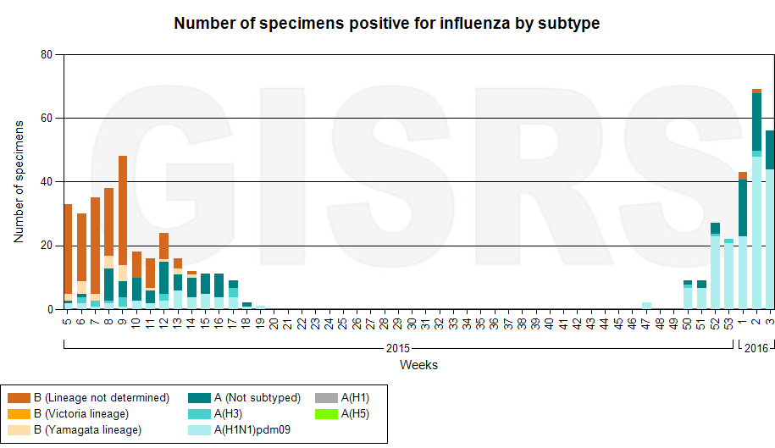

Fig.5. The quantity of laboratory confirmed influenza cases among patients with ILI and SARI diagnosis in season 2015 – 2016 in the sentinel cities of Ukraine.

Performed by:
Alla Mironenko, MD, DSc
Olga Holubka, PhD

