L.V. Gromashevsky Institute of Epidemiology and Infectious Diseases National Academy of Medical Science of Ukraine

Scientific Influenza and ARI Center

Weekly Bulletin for Influenza Epidemic Situation in Ukraine by 4 Sentinel Centers
(Кyiv, Dnipro, Odessa, Khmelnitsky)
Week 3, 2020

Loaded on website www.ukrinfluenza.com.ua

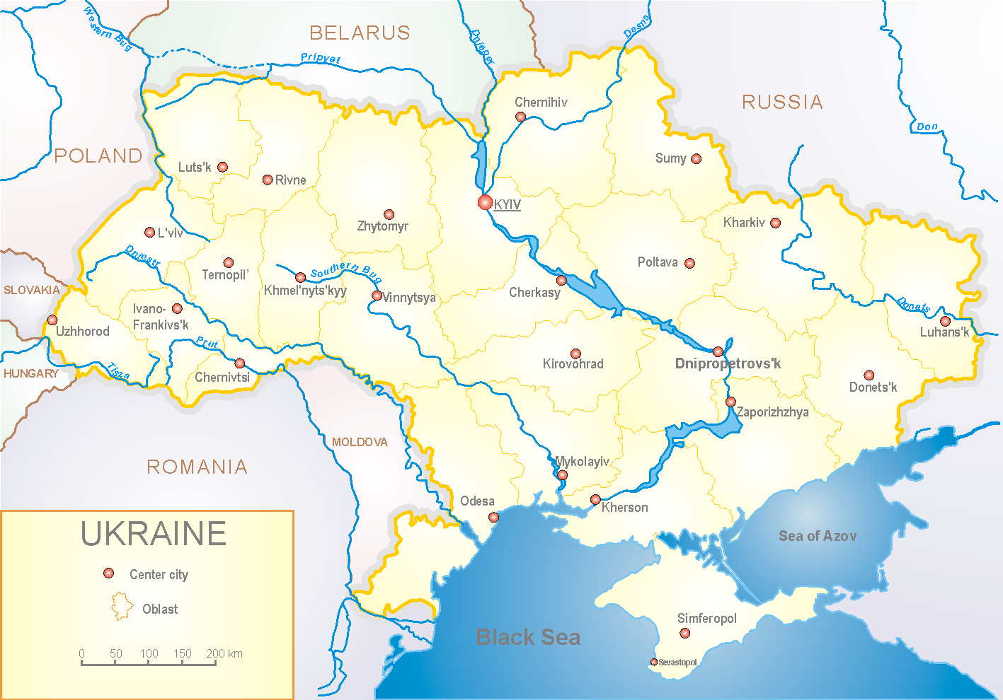
Since 2008 the system of ILI and SARI sentinel surveillance has been functioning in Ukraine. The sentinel centers are located in different geographical areas of the country: in Kyiv, Dnipro, Odessa and Khmelnytsky, which include 18 sentinel stations: 10 hospitals and 8 polyclinics.

According to data of influenza sentinel surveillance system in Ukraine in 8 policlinics of 4 sentinel cities of Ukraine the quantity of outpatient, which meet the definition of ILI during the 3rd week (13.01. –19.01.2020) was 86 cases (8.1 per 100 thousand), this is 3 times more than the rate of morbidity of previous year (fig. 1).

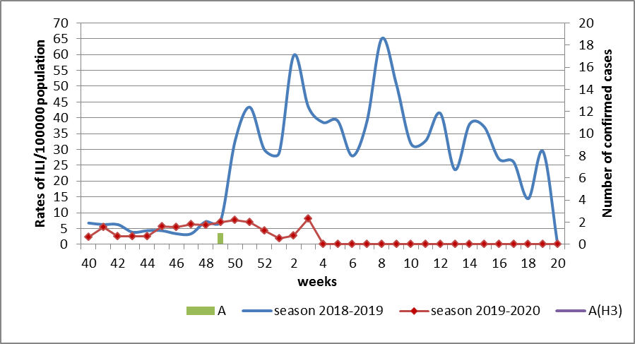
Fig.1. The dynamic of recorded ILI cases and number of laboratory confirmed influenza cases in 4 sentinel centers of Ukraine in the 2019 – 2020 season.

During the 3rd week in 10 hospitals of 4 sentinel centers there were hospitalized 1185 patients. This is 25.6% more than during the previous week. The quantity of SARI patients (patients which meet the definition SARI) was 48 cases (1.88 per 100 thousand), this is 2.1 times more than the rate of previous week (fig. 2).

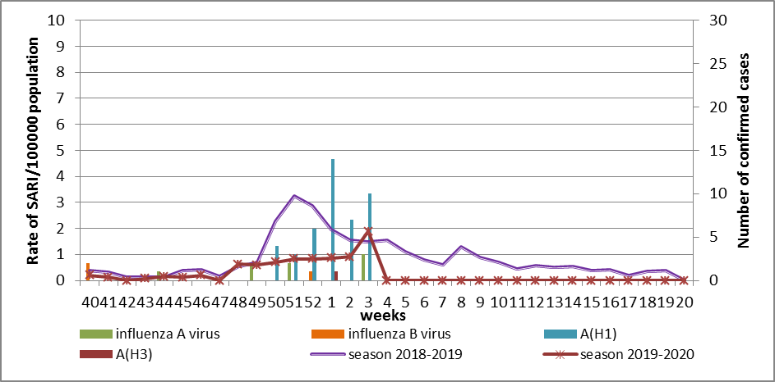
Fig.2 The dynamic of recorded SARI cases and the number of laboratory confirmed influenza in season 2019 – 2020 in four sentinel centers of Ukraine.

From the 40th to the 3rd week of 2019-2020 season there were investigated 134 samples from ILI and SARI patients by PCR method. There were laboratory confirmed 61 (45.5%) influenza viruses: 12 (19.7%) – influenza A (unsubtyped), 45 (73.8%) – influenza A(H1)pdm, 1 (1.6%) – influenza A(H3), 3 (4.9%) – influenza B (2 – influenza B/Victoria) (fig. 3).
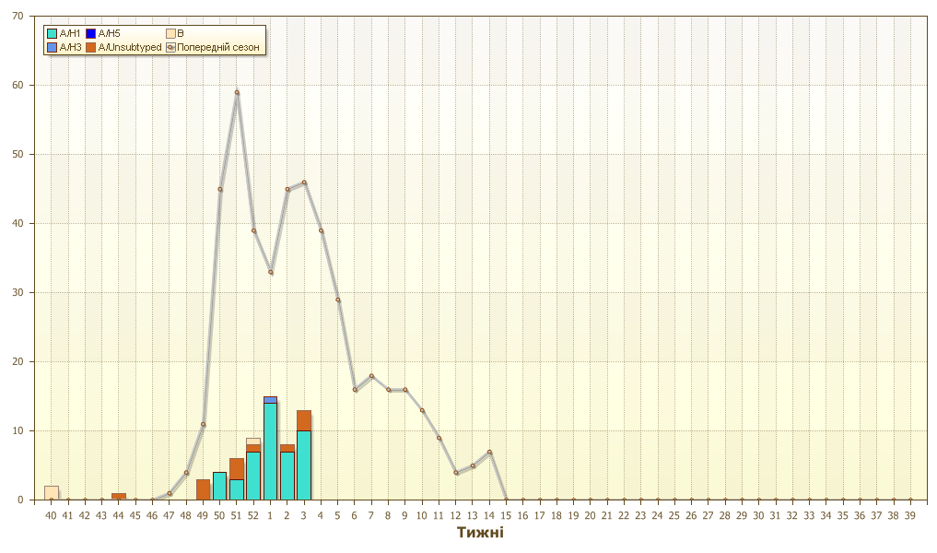
Fig.3. Number of laboratory confirmed influenza positive cases in sentinel centers of Ukraine.

So, the activity of flu increases, the levels of ILI and SARI morbidity are in 3 times more than rates of previous week. Influenza A(H1)pdm (73.8%) predominates among the circulating viruses.
According to data of ECDC-WHO weekly bulletin rates of influenza morbidity are increasing in European countries but influenza A(H3) virus and influenza B/Victoria predominate there.

Performed by:
Alla Mironenko, MD, DSc
Olga Holubka, PhD

