L.V. Gromashevsky Institute of Epidemiology and Infectious Diseases National Academy of Medical Science of Ukraine

Scientific Influenza and ARI Center

Weekly Bulletin for Influenza Epidemic Situation in Ukraine by 4 Sentinel Centers
(Кyiv, Dnipropetrovsk, Odesa, Khmelnitsky)
Weeks 40 - 47, 2016

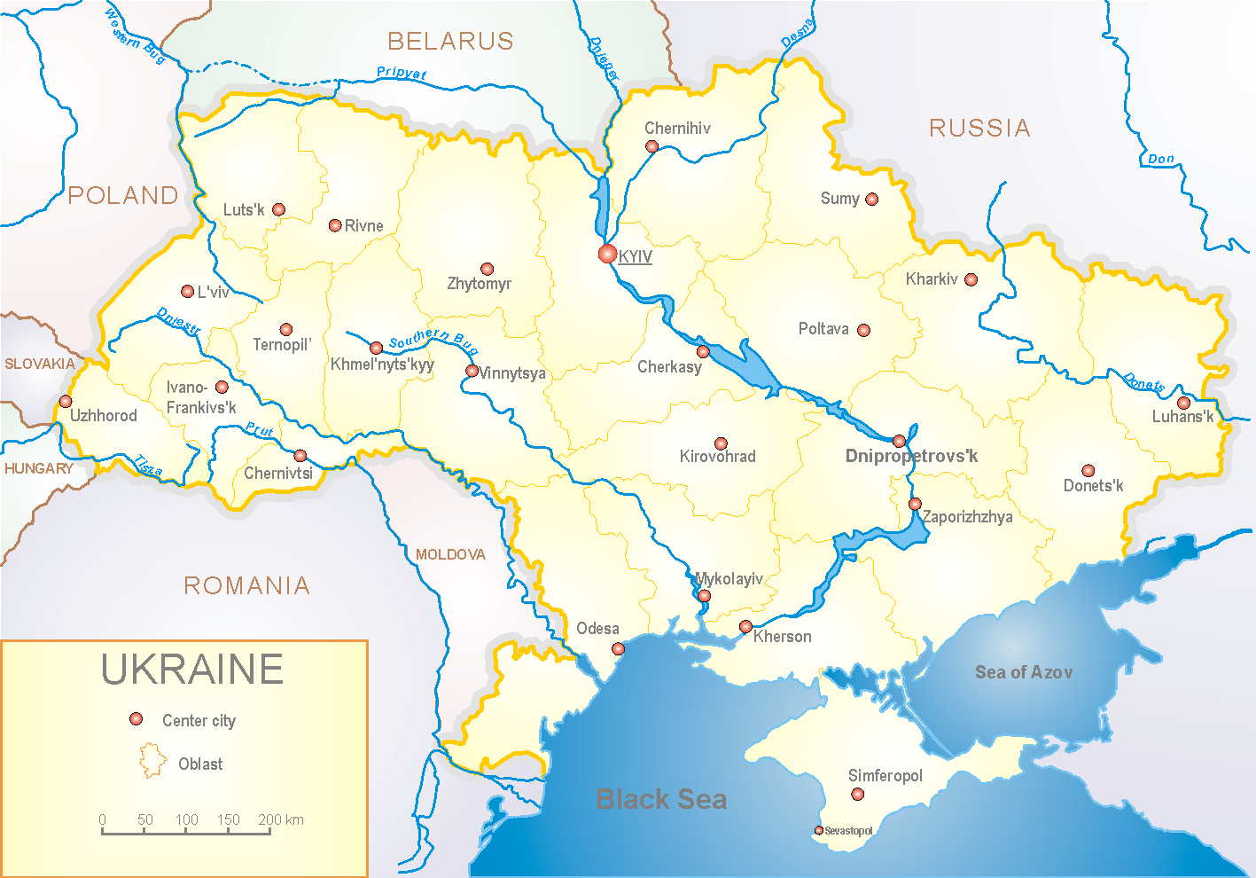
Since 2008 the system of ILI and SARI sentinel surveillance has been functioning in Ukraine. The sentinel centers are located in different geographical areas of the country: in Kyiv, Dnipropetrovsk, Odessa and Khmelnytskyi, which include 18 sentinel stations: 10 hospitals and 8 polyclinics.

According to data of influenza sentinel surveillance system in Ukraine during the 40th – 47th weeks of season 2016 – 2017 there were registered the following levels of influenza morbidity among the population. Abovementioned data met seasonal levels, but beginning from the 43rd week there were registered the sporadic cases.
In 8 policlinics of 4 sentinel cities of Ukraine the quantity of outpatient, which meet the definition of ILI during the 47th week (21.11 – 27.11.16) was 85 cases (41.0 per 100 thousand) corresponding population. In comparison with the previous week there was the increase of morbidity level – 13.3% and there was 1 laboratory confirmed influenza case A(H1) (fig. 1).

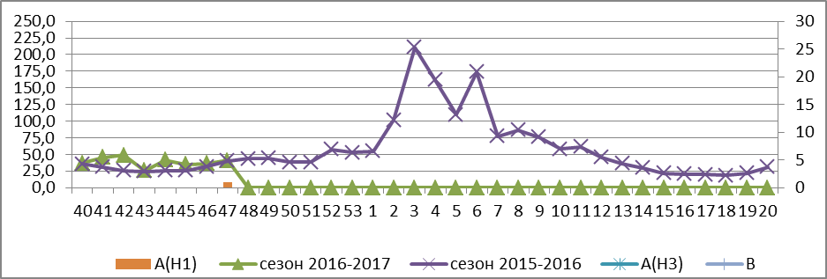

Fig.1. The dynamic of ILI cases and number of laboratory confirmed influenza cases in 4 sentinel cities of Ukraine in the 2016 – 2017 season.

During the 47th week in 10 hospitals of 4 sentinel centers there were hospitalized 1189 patients, this is 7.2% more than during the previous week. The quantity of SARI patients (patients which meet the definition SARI) was 53 cases (1.78 per 100 thousand) the increase of morbidity level was 23.3% in comparison with the previous week (fig. 2).

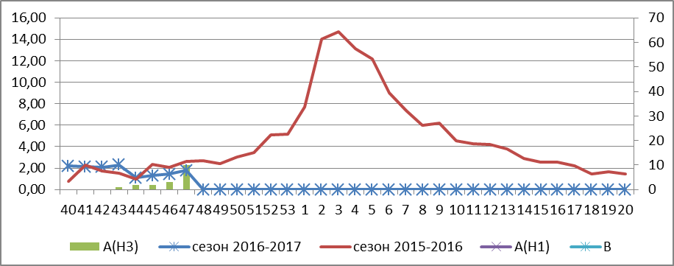

Fig.2 The dynamic of SARI cases and the number of laboratory confirmed influenza in season 2016 – 2017 in four sentinel centers of Ukraine.

From 40th to 47th week there were investigated 85 samples from ILI and SARI patients by PCR method. There were detected 20 positive influenza samples: 1 – influenza virus A(H1) and 19 – influenza viruses A(H3).

Therefore, the flu season is beginning in Ukraine.

Performed by:
Alla Mironenko, MD, DSc
Olga Holubka, PhD

