L.V. Gromashevsky Institute of Epidemiology and Infectious Diseases National Academy of Medical Science of Ukraine

Scientific Influenza and ARI Center

Weekly Bulletin for Influenza Epidemic Situation in Ukraine by 4 Sentinel Centers
(Кyiv, Dnipro, Odessa, Khmelnitsky)
Weeks 40, 2018

Loaded on website www.ukrinfluenza.com.ua
Since 2008 the system of ILI and SARI sentinel surveillance has been functioning in Ukraine. The sentinel centers are located in different geographical areas of the country: in Kyiv, Dnipro, Odessa and Khmelnytsky, which include 18 sentinel stations: 10 hospitals and 8 polyclinics.
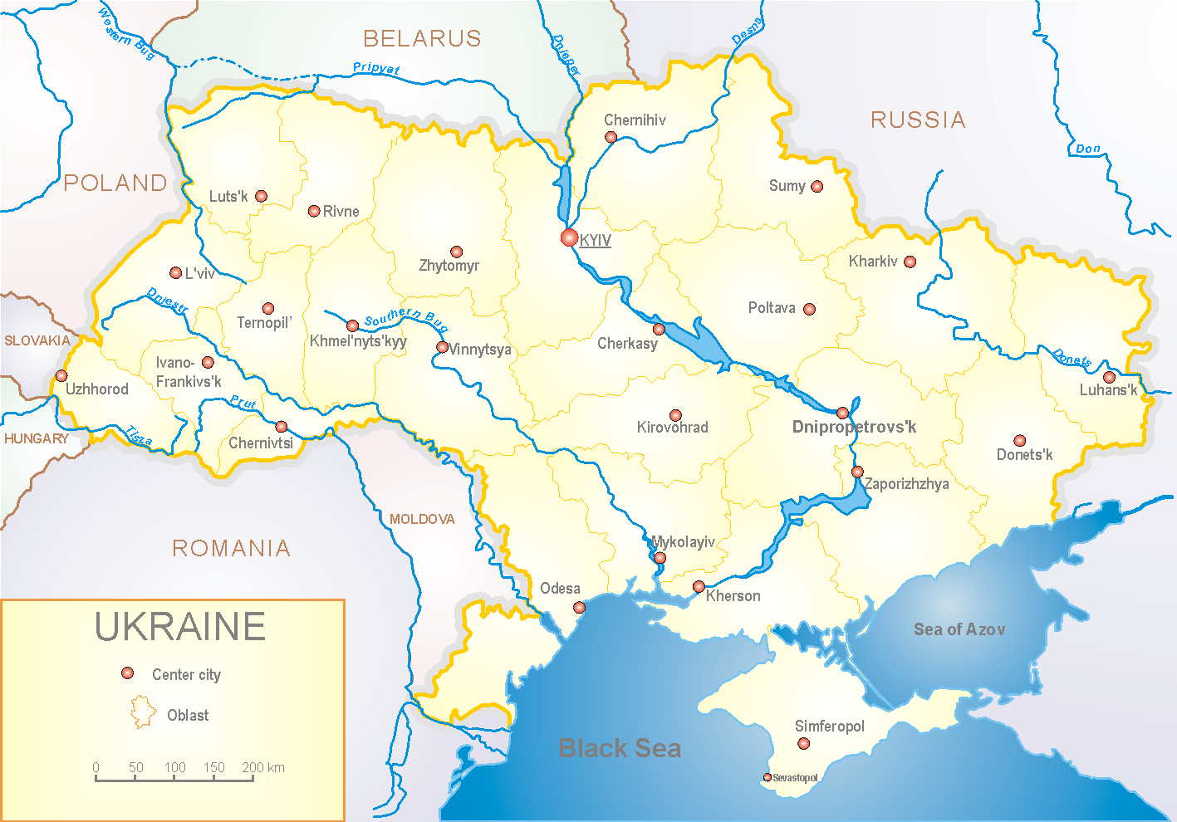
According to data of influenza sentinel surveillance system in Ukraine there were recorded ILI and SARI cases among population which met the seasonal levels.
In 8 policlinics of 4 sentinel cities of Ukraine the quantity of outpatient, which meet the definition of ILI during the 40th week (01.10 – 07.10.18) was 14 cases (6.7 per 100 thousand) corresponding population (fig. 1).

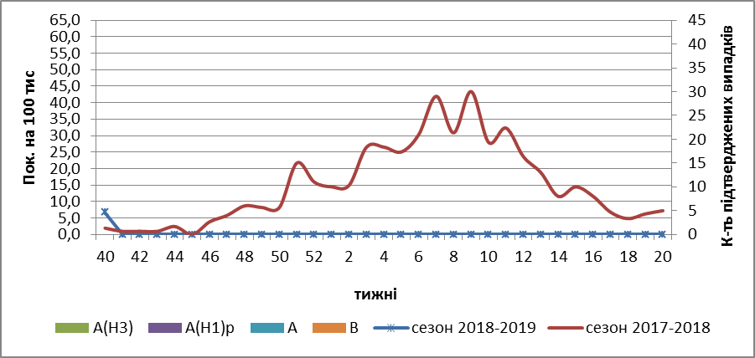

Fig.1. The dynamic of recorded ILI cases and number of laboratory confirmed influenza cases in 4 sentinel centers of Ukraine in the 2018 – 2019 season.

During the 40th week in 10 hospitals of 4 sentinel centers there were hospitalized 1110 patients. The quantity of SARI patients (patients which meet the definition SARI) was 11 cases (0.37 per 100 thousand) (fig. 2).

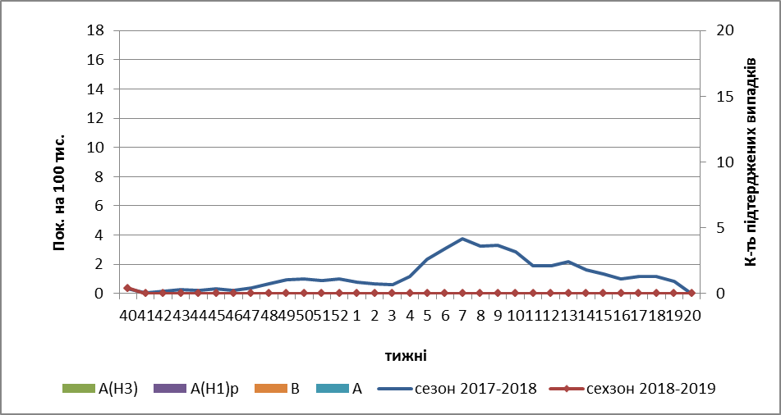
Fig.2 The dynamic of recorded SARI cases and the number of laboratory confirmed influenza in season 2018 – 2019 in four sentinel centers of Ukraine

From the beginning of the season 2018-2019 there were investigated 14 samples from ILI and SARI patients by PCR method. There weren’t detected any positive influenza samples.

So the flu season is beginning in Ukraine.

Performed by:
Alla Mironenko, MD, DSc
Olga Holubka, PhD

