L.V. Gromashevsky Institute of Epidemiology and Infectious Diseases National Academy of Medical Science of Ukraine

Scientific Influenza and ARI Center

Weekly Bulletin for Influenza Epidemic Situation in Ukraine by 4 Sentinel Centers
(Кyiv, Dnipro, Odessa, Khmelnitsky)
Weeks 43, 2018

Loaded on website www.ukrinfluenza.com.ua

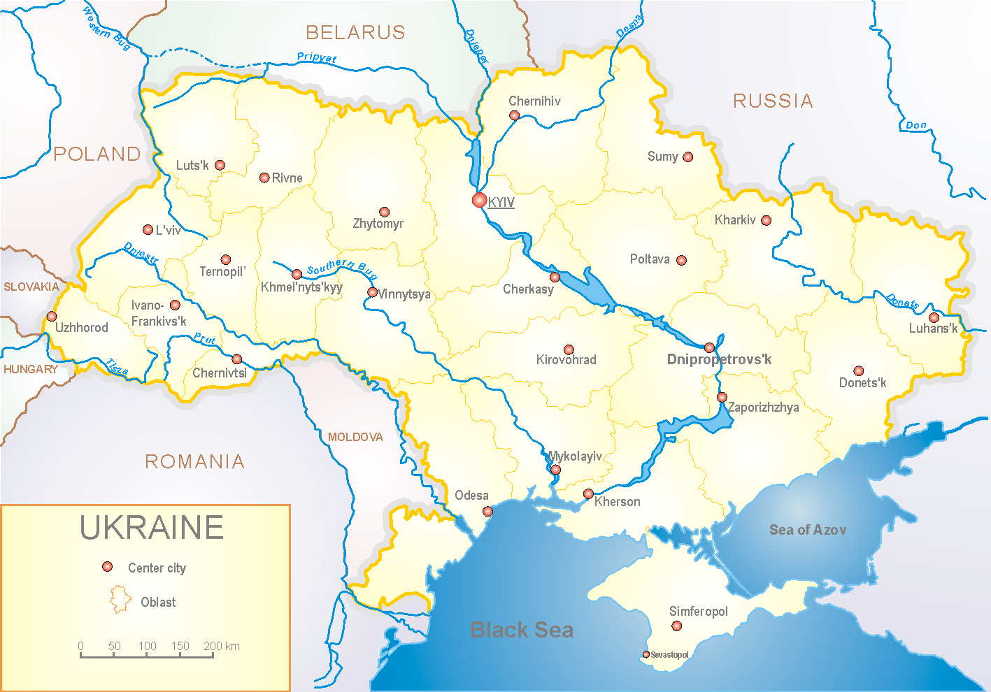
Since 2008 the system of ILI and SARI sentinel surveillance has been functioning in Ukraine. The sentinel centers are located in different geographical areas of the country: in Kyiv, Dnipro, Odessa and Khmelnytsky, which include 18 sentinel stations: 10 hospitals and 8 polyclinics.

According to data of influenza sentinel surveillance system in Ukraine in 8 policlinics of 4 sentinel centers the quantity of outpatients, which meet the definition of ILI during the 43rd week (22.10 – 28.10.18) was 8 cases (3.9 per 100 thousand) of corresponding population. In comparison with the previous week the decrease of morbidity levels was 38.5% (fig. 1).

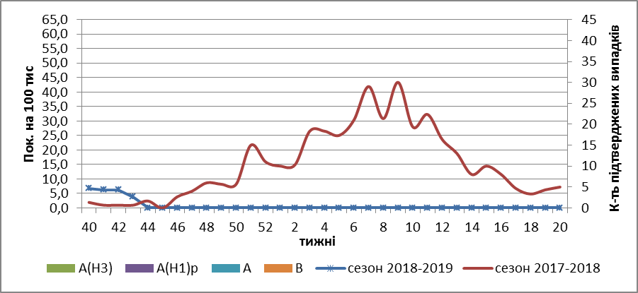

Fig.1. The dynamic of recorded ILI cases and number of laboratory confirmed influenza cases in 4 sentinel centers of Ukraine in the 2018 – 2019 season.

During the 43rd week in 10 hospitals of 4 sentinel centers there were hospitalized 1226 patients, this is 10.7% more than during the previous week. The quantity of SARI patients (patients which meet the definition SARI) was 4 cases (0.13 per 100 thousand). In comparison with the previous week the morbidity rate has not changed (fig. 2).

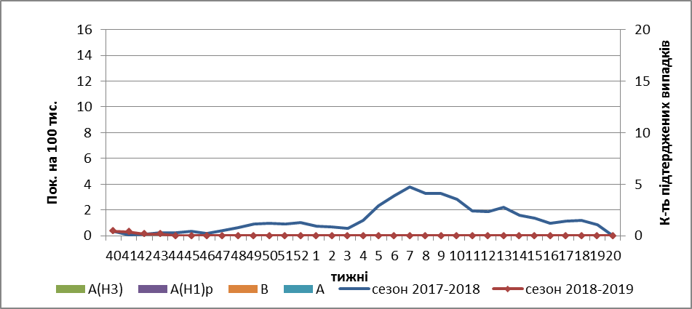
Fig.2 The dynamic of recorded SARI cases and the number of laboratory confirmed influenza in season 2018 – 2019 in four sentinel centers of Ukraine.

From the beginning of the season 2018-2019 there were investigated 32 samples from ILI and SARI patients by PCR method. There weren’t detected any positive influenza samples.
So, statistically the flu season is beginning in Ukraine, although the circulation of influenza viruses is not confirmed by laboratory methods.

Performed by:
Alla Mironenko, MD, DSc
Olga Holubka, PhD

