L.V. Gromashevsky Institute of Epidemiology and Infectious Diseases National Academy of Medical Science of Ukraine

Scientific Influenza and ARI Center

Weekly Bulletin for Influenza Epidemic Situation in Ukraine by 4 Sentinel Centers
(Кyiv, Dnipropetrovsk, Odesa, Khmelnitsky)
Week 48, 2016

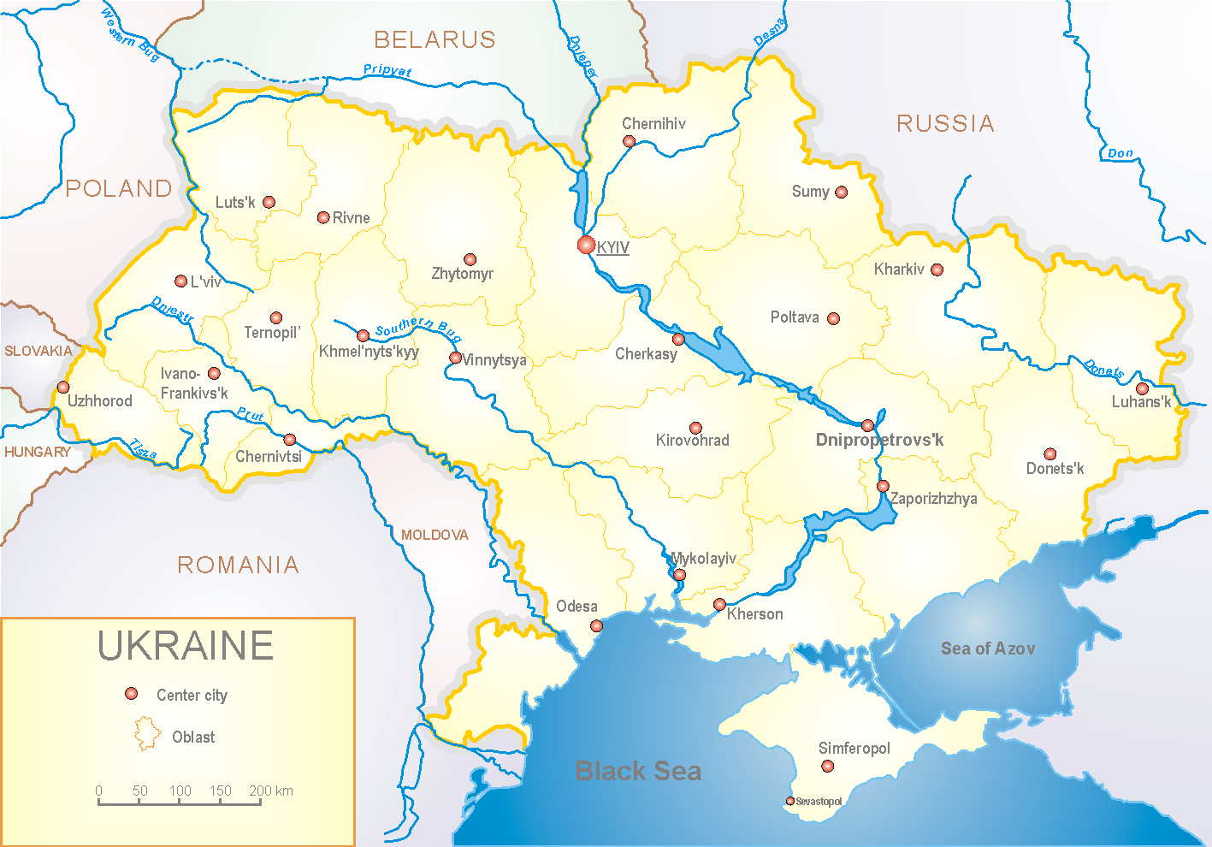
Since 2008 the system of ILI and SARI sentinel surveillance has been functioning in Ukraine. The sentinel centers are located in different geographical areas of the country: in Kyiv, Dnipropetrovsk, Odessa and Khmelnytskyi, which include 18 sentinel stations: 10 hospitals and 8 polyclinics.

According to data of influenza sentinel surveillance system in Ukraine in 8 policlinics of 4 sentinel centers the quantity of outpatient, which meet the definition of ILI during the 48th week (28.11 – 04.12.16) was 89 cases (42.9 per 100 thousand) corresponding population. In comparison with the previous week there was the increase of morbidity level – 4.7%. There were 10 laboratory confirmed influenza cases A(H3) and 3 – influenza A (unsubtyped) (fig. 1).

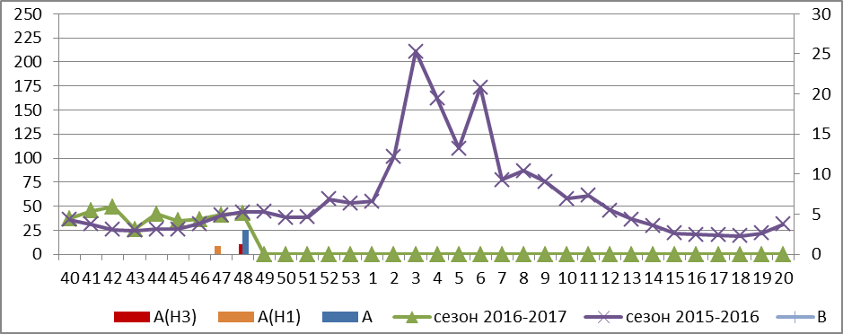
Fig.1. The dynamic of ILI cases and number of laboratory confirmed influenza cases in 4 sentinel cities of Ukraine in the 2016 – 2017 season.

During the 48th week in 10 hospitals of 4 sentinel centers there were hospitalized 1381 patients, this is16.1% more than during the previous week. The quantity of SARI patients (patients which meet the definition SARI) was 67 cases (2.26 per 100 thousand) the increase of morbidity level was 26.4% in comparison with the previous week (fig. 2).

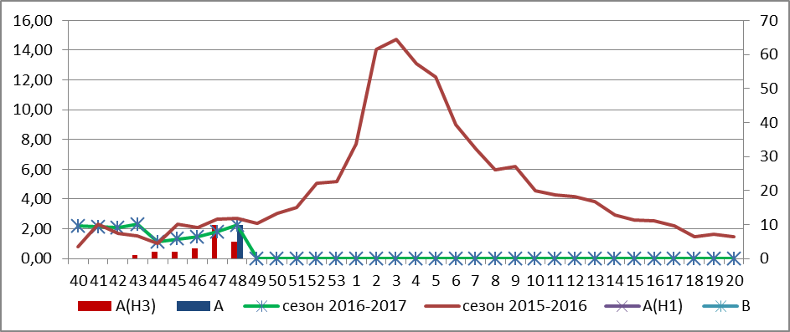
Fig.2 The dynamic of SARI cases and the number of laboratory confirmed influenza in season 2016 – 2017 in four sentinel centers of Ukraine.

From 40th to 48th week there were investigated 105 samples from ILI and SARI patients by PCR method. There were detected 56 positive influenza samples: 13 – influenza viruses A(unsubtyped), 1 – influenza virus A(H1) and 42 – influenza viruses A(H3).

Performed by:
Alla Mironenko, MD, DSc
Olga Holubka, PhD

