L.V. Gromashevsky Institute of Epidemiology and Infectious Diseases National Academy of Medical Science of Ukraine

Scientific Influenza and ARI Center

Weekly Bulletin for Influenza Epidemic Situation in Ukraine by 4 Sentinel Centers
(Кyiv, Dnipro, Odessa, Khmelnitsky)
Week 48, 2019

Loaded on website www.ukrinfluenza.com.ua

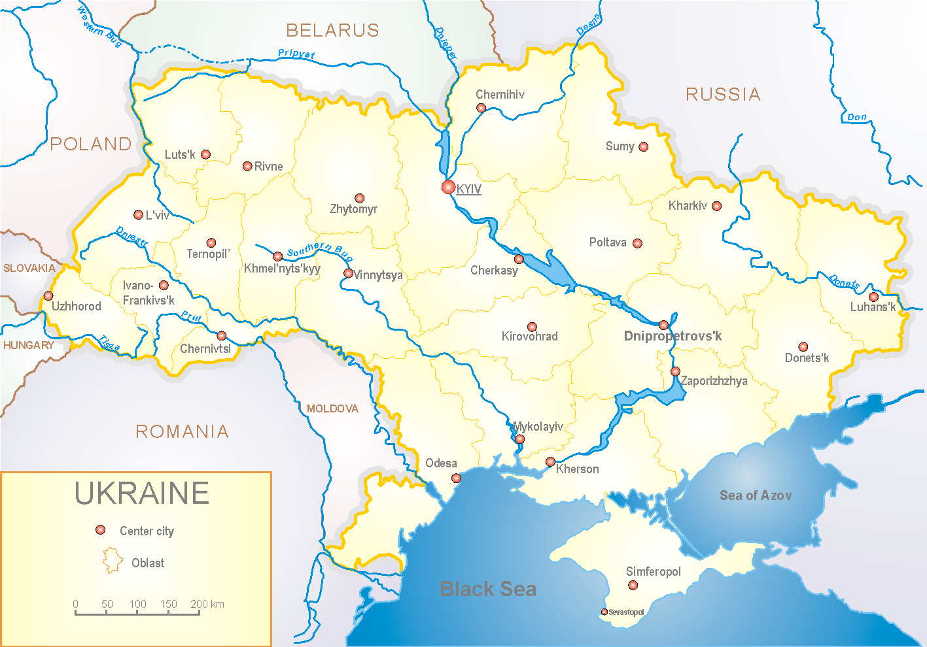
Since 2008 the system of ILI and SARI sentinel surveillance has been functioning in Ukraine. The sentinel centers are located in different geographical areas of the country: in Kyiv, Dnipro, Odessa and Khmelnytsky, which include 18 sentinel stations: 10 hospitals and 8 polyclinics.

According to data of influenza sentinel surveillance system in Ukraine in 8 policlinics of 4 sentinel cities of Ukraine the quantity of outpatient, which meet the definition of ILI during the 48th week (25.11 – 01.12.19) was 70 cases (6.6 per 100 thousand). The increase of morbidity level was 2.9% (fig. 1).

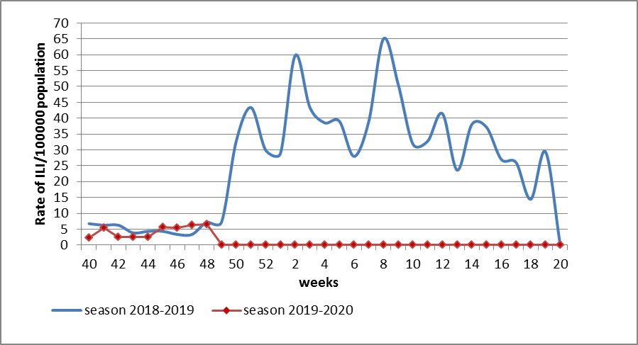

Fig.1. The dynamic of recorded ILI cases and number of laboratory confirmed influenza cases in 4 sentinel centers of Ukraine in the 2019 – 2020 season.

During the 48th week in 10 hospitals of 4 sentinel centers there were hospitalized 990 patients. This is 4.5% more than during the previous week. The quantity of SARI patients (patients which meet the definition SARI) was 16 cases (0.63 per 100 thousand) (fig. 2).
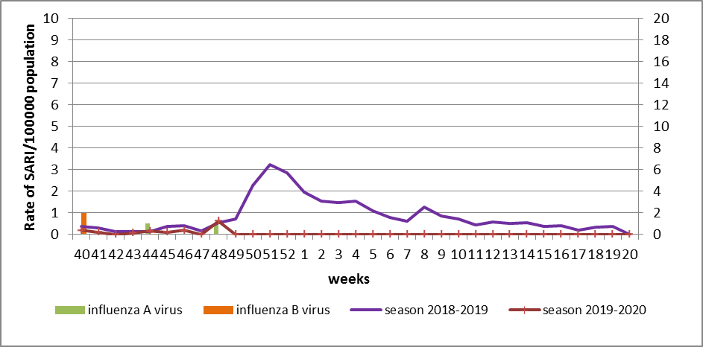

Fig.2 The dynamic of recorded SARI cases and the number of laboratory confirmed influenza in season 2019 – 2020 in four sentinel centers of Ukraine.

During the 48th week of 2019-2020 season there were investigated 56 samples from ILI and SARI patients by PCR method. There were laboratory confirmed 4 influenza viruses: 2 – influenza A (unsubtyped), 2 – influenza B (1 – influenza B/Victoria) (fig. 3).

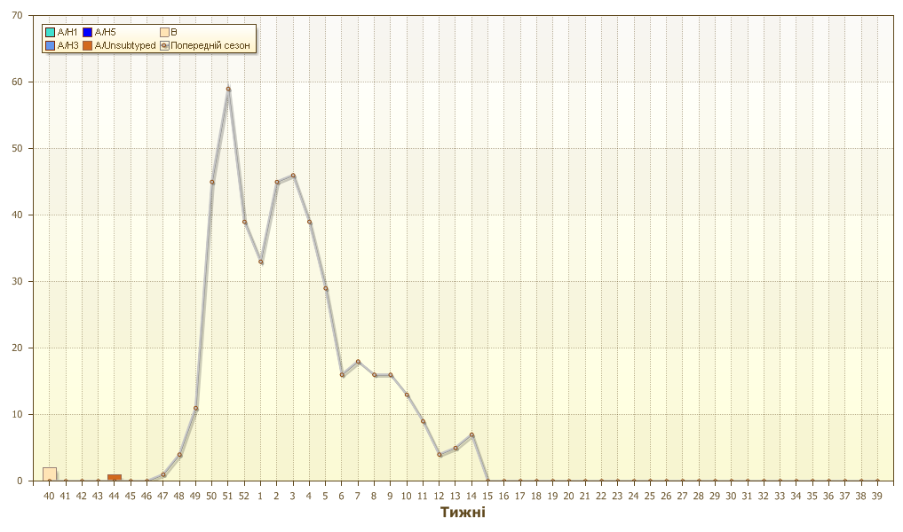
Fig. 3. Number of laboratory confirmed influenza positive cases in sentinel centers of Ukraine.

Performed by:
Alla Mironenko, MD, DSc
Olga Holubka, PhD

