L.V. Gromashevsky Institute of Epidemiology and Infectious Diseases National Academy of Medical Science of Ukraine

Scientific Influenza and ARI Center

Weekly Bulletin for Influenza Epidemic Situation in Ukraine by 4 Sentinel Centers
(Кyiv, Dnipro, Odessa, Khmelnitsky)
Weeks 48, 2018

Loaded on website www.ukrinfluenza.com.ua
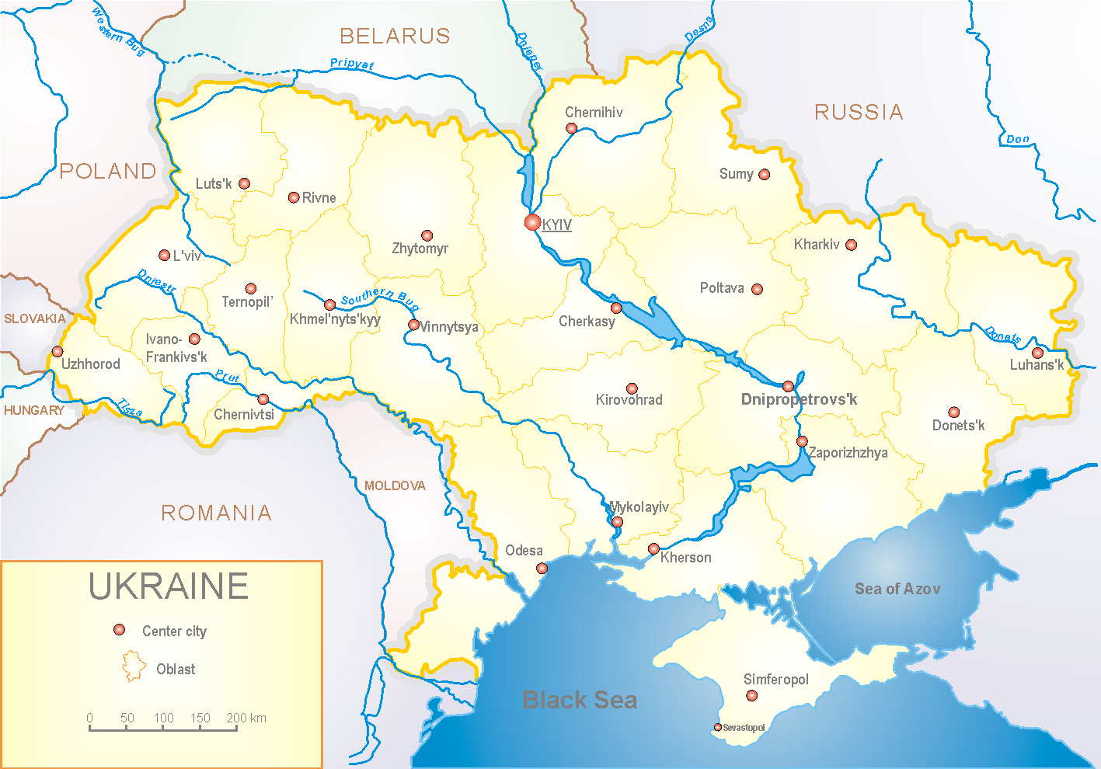
Since 2008 the system of ILI and SARI sentinel surveillance has been functioning in Ukraine. The sentinel centers are located in different geographical areas of the country: in Kyiv, Dnipro, Odessa and Khmelnytsky, which include 18 sentinel stations: 10 hospitals and 8 polyclinics.

According to data of influenza sentinel surveillance system in Ukraine in 8 policlinics of 4 sentinel centers the quantity of outpatients, which meet the definition of ILI during the 48th week (26.11 – 02.12.18) was 15 cases (7.2 per 100 thousand), this is twice more than the rate of morbidity of the previous week. The increase of morbidity level is caused by the beginning of influenza viruses type A circulation on the territory of the country. This was laboratory confirmed (fig. 1).

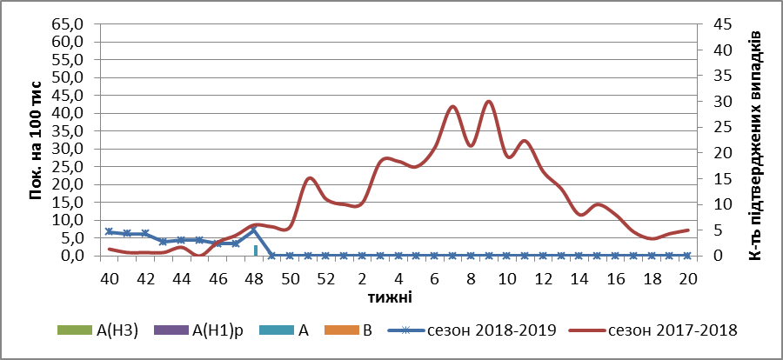
Fig.1. The dynamic of recorded ILI cases and number of laboratory confirmed influenza cases in 4 sentinel centers of Ukraine in the 2018 – 2019 season.

During the 48th week in 10 hospitals of 4 sentinel centers there were hospitalized 1223 patients, this is 13.0 % more than during the previous week. The quantity of SARI patients (patients which meet the definition SARI) was 16 cases (0.54 per 100 thousand). The morbidity level increased in 3.2 times in comparison with the previous week. The percentage of SARI from all hospitalized was 1.3%. During the 48th week 1 influenza type A virus was laboratory confirmed (fig. 2).

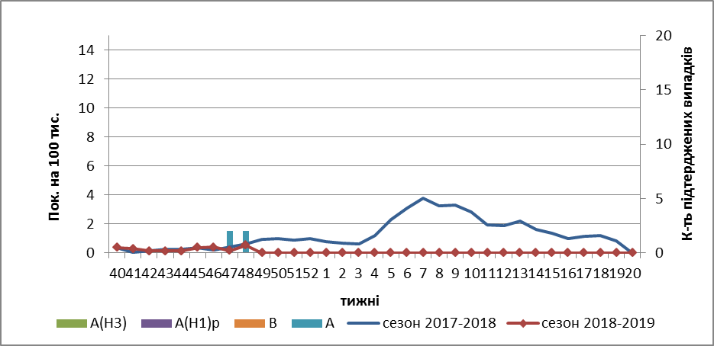

Fig.2 The dynamic of recorded SARI cases and the number of laboratory confirmed influenza in season 2018 – 2019 in four sentinel centers of Ukraine.

From the beginning of the season 2018-2019 there were investigated 91 samples from ILI and SARI patients by PCR method. Laboratory confirmed 3 cases of influenza A.
So, the influenza season has started in Ukraine. ILI and SARI indexes of morbidity don’t exceed seasonal value. But there are registered sporadic influenza cases in the country, which has been confirmed by laboratory methods.

Performed by:
Alla Mironenko, MD, DSc
Olga Holubka, PhD

