L.V. Gromashevsky Institute of Epidemiology and Infectious Diseases National Academy of Medical Science of Ukraine

Scientific Influenza and ARI Center

Weekly Bulletin for Influenza Epidemic Situation in Ukraine by 4 Sentinel Centers
(Кyiv, Dnipro, Odessa, Khmelnitsky)
Week 5, 2021

Loaded on website www.ukrinfluenza.com.ua
Since 2008 the system of ILI and SARI sentinel surveillance has been functioning in Ukraine. The sentinel centers are located in different geographical areas of the country: in Kyiv, Dnipro, Odessa and Khmelnytsky, which include 17 sentinel stations: 9 hospitals and 8 polyclinics.
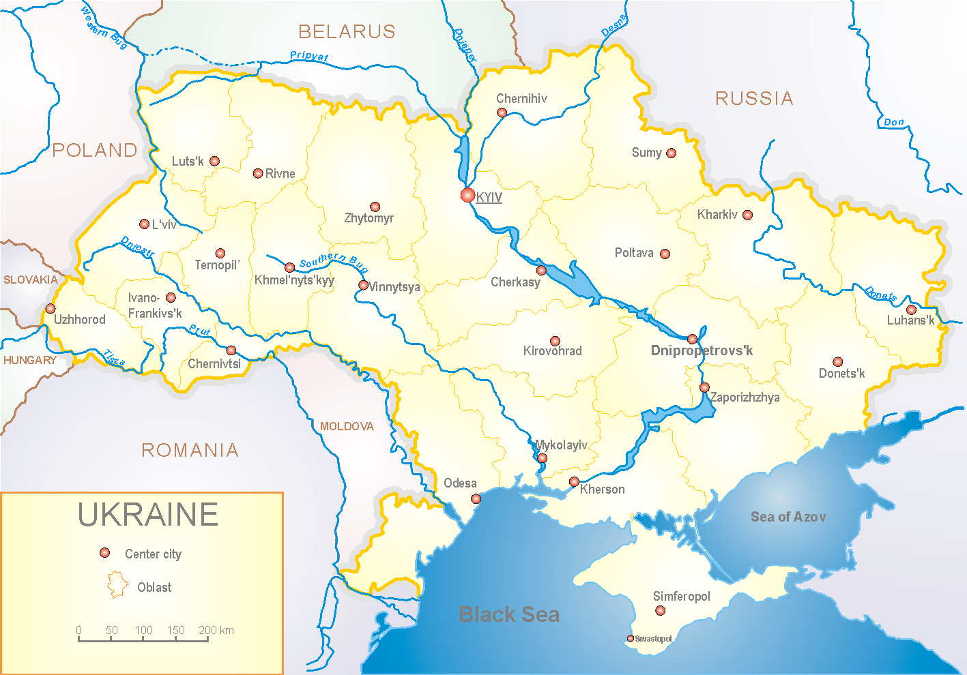
Influenza epidemic season 2020-2021 take place on the background of SARS-CoV-2 pandemic both in Ukraine and in the world.
According to data of influenza sentinel surveillance system in Ukraine in 8 policlinics of 4 sentinel cities of Ukraine the quantity of outpatient, which meet the definition of ILI during the 5th week (01.02.2021 – 07.02.2021) was 87 cases (8.2 per 100 thousand). The increase of morbidity level was 24.3% in comparison with the previous week but 2.2 times less than in previous year (index 18.4 per 100 thousand – 2020) (fig. 1).

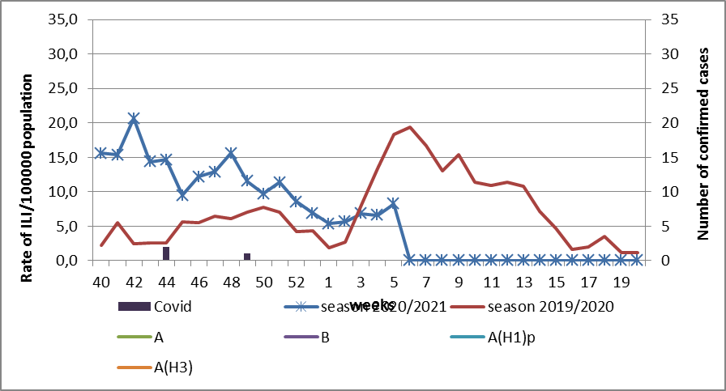

Fig.1. The dynamic of recorded ILI cases and number of laboratory confirmed influenza cases in 4 sentinel centers of Ukraine in the 2020 – 2021 season.

During the 5th week in 9 hospitals of 4 sentinel centers there were hospitalized 533 patients. This is 3.9% more than during the previous week. The quantity of SARI patients (patients which meet the definition SARI) was 121 cases (4.75 per 100 thousand). The increase of morbidity level was 6.1% in comparison with the previous week and in 1.5 times lower than the indexes of pervious year (index 7.7 per 100 thousand in 2020). There was the highest morbidity level of influenza during the 5th week of pervious year (fig. 2).

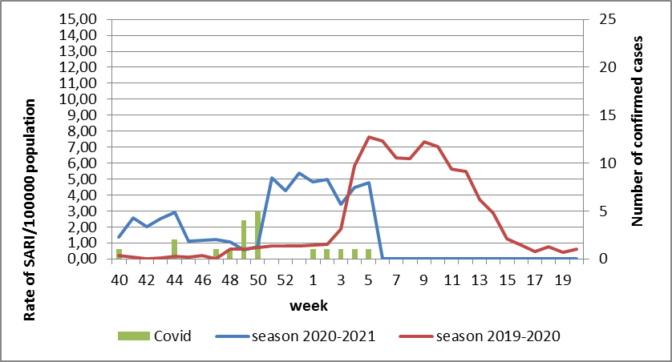
Fig.2 The dynamic of recorded SARI cases and the number of laboratory confirmed influenza in season 2020 – 2021 in four sentinel centers of Ukraine.

From the 40th to the 5th week of 2020-2021 season there were investigated 35 samples from ILI and SARI patients by PCR method. There were laboratory confirmed 24 COVID cases (fig. 3).

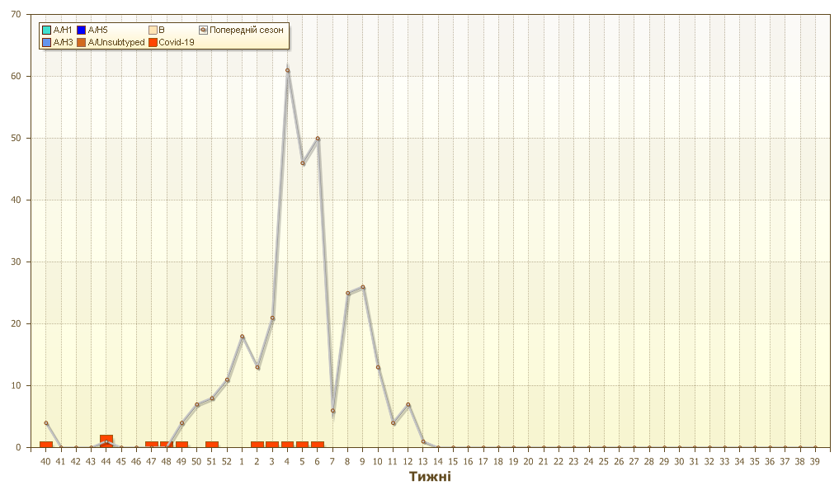
Fig. 3. Number of laboratory confirmed SARS-CoV-2 positive cases in sentinel centers of Ukraine in season 2020-2021.
So, according to sentinel surveillance the SARI and ILI morbidity indexes are on the background levels. There were not any confirmed influenza cases.
According to weekly ECDC-WHO influenza activity in European countries is at the off-season levels.
Anti-epidemic measures which were taken to prevent the spreading of SARS-CoV-2 significantly affected epidemic process of influenza in the world.
From the beginning of the season in European countries there were investigated 336140 samples from ILI and SARI patients by PCR method. Among them there were laboratory confirmed 302 influenza A viruses: 26 (8.6%) – influenza A(H1)pdm, 33 (10.9%) – influenza A(H3) and 243 (80.5%) – influenza A unsubtyped. There were also detected 303 influenza B cases, among them there were 5 (1.7%) – B/Victoria, 1 (0.3%) – B/Yamagata and 297 (98%) – influenza B.
The genetic characteristic of 4 influenza viruses have been examined for the current season: influenza A(H3) virus belongs to the strain А/Slovenia/1637/2020, the other one belongs to the strain A/Denmark/3264/2019. Influenza A(H1) virus is represented by the strain А/Guangdond-Maonan/SWL1536/2019. Influenza B virus type Victoria belongs to the strain В/Washington/02/2019.

Performed by:
Alla Mironenko, MD, DSc
Olga Holubka, PhD

