L.V. Gromashevsky Institute of Epidemiology and Infectious Diseases National Academy of Medical Science of Ukraine
National Influenza Center

Weekly Bulletin for Influenza Epidemic Situation in Ukraine by 4 Sentinel Centers
(Кyiv, Dnipropetrovsk, Odesa, Khmelnitsky)
Week 50, 2015

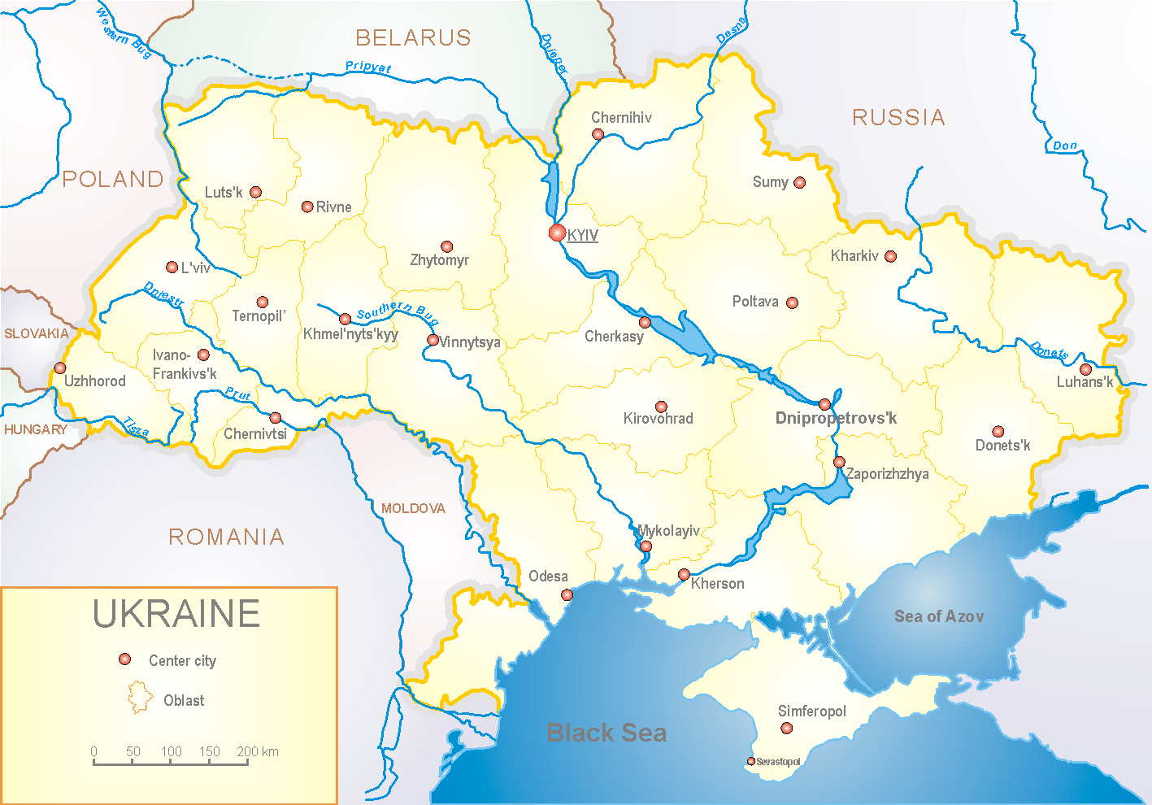
Since 2008 the system of ILI and SARI sentinel surveillance has been functioning in Ukraine. The sentinel centers are located in different geographical areas of the country: in Kyiv, Dnipropetrovsk, Odessa and Khmelnytskyi, which include 18 sentinel stations: 10 hospitals and 8 polyclinics.
According to data of sentinel surveillance system in 8 policlinics of 4 sentinel cities of Ukraine the quantity of outpatient, which meet the definition of ILI during the 50th week (07.12 - 13.12.15) was 29 cases (14.0 per 100 thousand) corresponding population. In comparison with previous week there was the decrease of morbidity level – 27.5% (fig. 1).

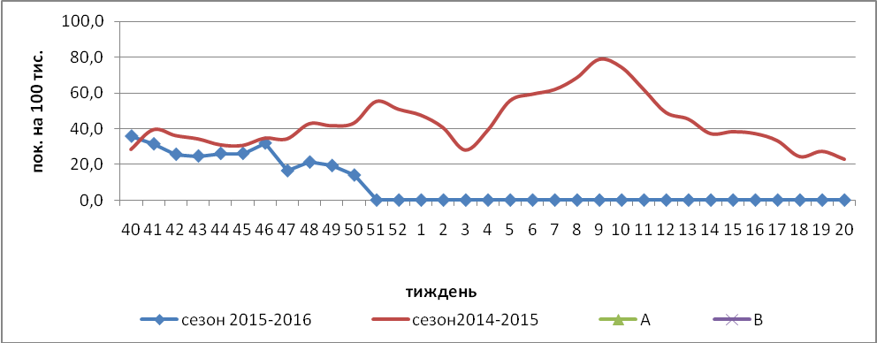

Fig.1. The dynamic of ILI cases and number of laboratory confirmed influenza cases in 4 sentinel cities of Ukraine in the 2015 – 2016 season.

The percentage of appeals to policlinics with ILI diagnosis during the 50th week was low and remained at the level of previous week among all age groups (fig.2).

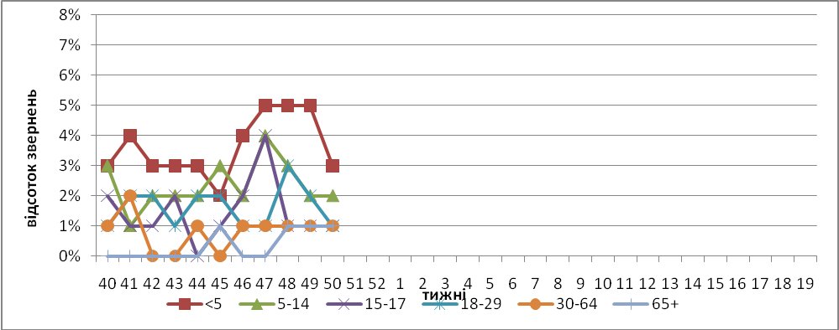

Fig. 2. The percentage of appeals to policlinics with ILI diagnosis among different age groups in season 2015 – 2016 in four sentinel cities of Ukraine.

During the 50th week in 10 hospitals of 4 sentinel cities there were hospitalized 813 patients, in comparison with the previous week there was the decrease of hospitalization level by 26.0%. The quantity of SARI patients (patients which meet the definition SARI) was 87 cases (2.93 per 100 thousand); the increase of morbidity level was 24.3% in comparison with the previous week (fig. 3).

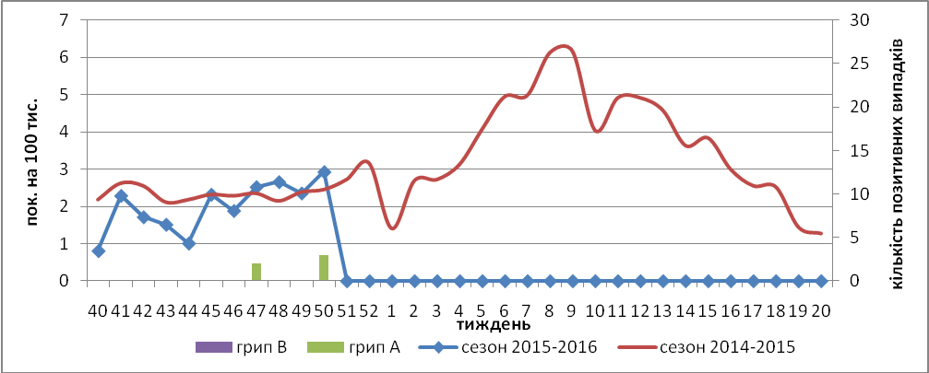

Fig.3 The dynamic of SARI cases and the number of laboratory confirmed influenza in season 2015 – 2016 in four sentinel cities of Ukraine.

From 40th to 50th week there were investigated 229 samples from ILI and SARI patients by PCR method. There were detected 3 influenza viruses A(H1)pdm from SARI patients, who are treated in Kyiv hospitals.
Virological sentinel influenza surveillance data are presented weekly on WHO site http://www.who.int/influenza/gisrs_laboratory/flunet/en/ (fig. 4). The above-mentioned is done to make Ukraine participate in the global influenza surveillance system.

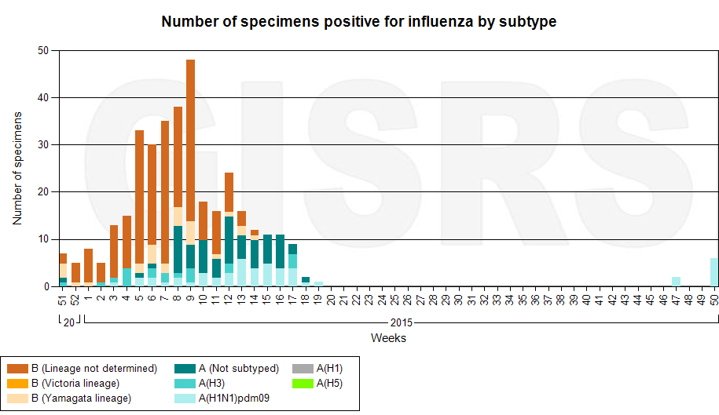

Fig. 4. The quantity of laboratory confirmed influenza cases among patients with ILI and SARI diagnosis in season 2015 – 2016 in the sentinel cities of Ukraine.

Thus, considering the above data of sentinel surveillance, we can conclude, that the stable circulation of influenza viruses is beginning.

Performed by:
Alla Mironenko, MD, DSc
Olga Holubka, PhD

