L.V. Gromashevsky Institute of Epidemiology and Infectious Diseases National Academy of Medical Science of Ukraine

Scientific Influenza and ARI Center

Weekly Bulletin for Influenza Epidemic Situation in Ukraine by 4 Sentinel Centers
(Кyiv, Dnipro, Odessa, Khmelnitsky)
Week 50, 2017

Loaded on website www.ukrinfluenza.com.ua
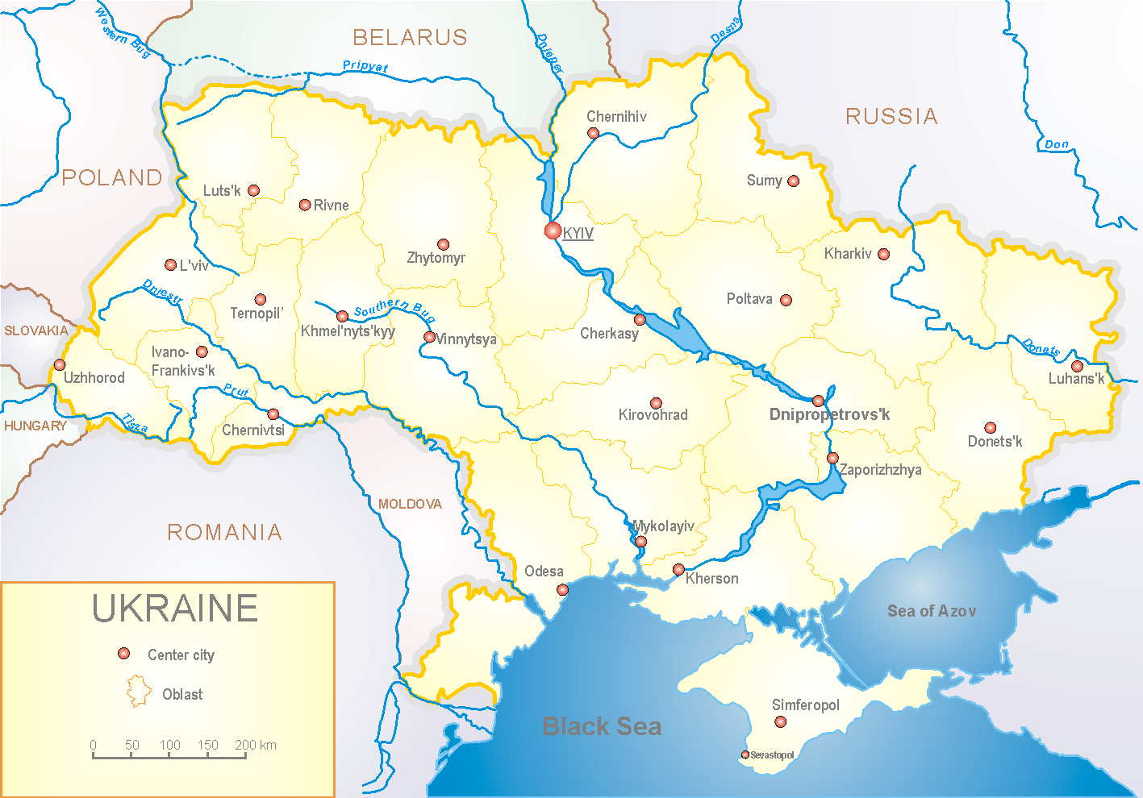
Since 2008 the system of ILI and SARI sentinel surveillance has been functioning in Ukraine. The sentinel centers are located in different geographical areas of the country: in Kyiv, Dnipro, Odessa and Khmelnytsky, which include 18 sentinel stations: 10 hospitals and 8 polyclinics.

In 8 policlinics of 4 sentinel cities of Ukraine the quantity of outpatient, which meet the definition of ILI during the 50th week (11.12 – 17.12.17) was 9 cases (4.3 per 100 thousand) corresponding population. In comparison with the previous week the morbidity level didn’t change (fig. 1).

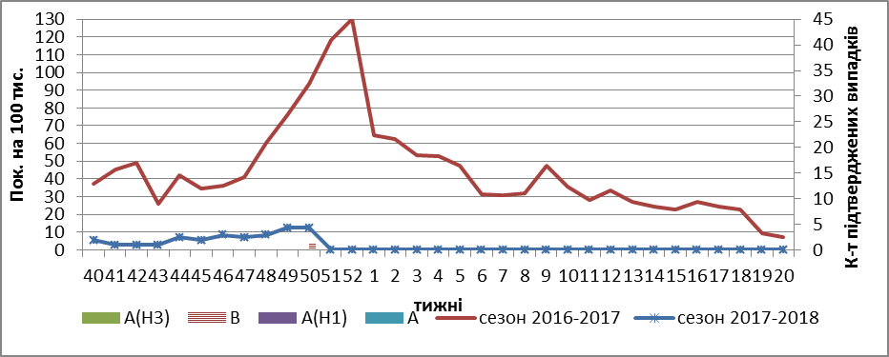

Fig.1. The dynamic of ILI cases and number of laboratory confirmed influenza cases in 4 sentinel centers of Ukraine in the 2017 – 2018 season.

During the 50th week in 10 hospitals of 4 sentinel centers there were hospitalized 1260 patients, this is 0.08% more than during the previous week. The quantity of SARI patients (patients which meet the definition SARI) was 29 cases (0.98 per 100 thousand); the growth rate of morbidity levels was 3.6% in comparison with the previous week (fig. 2).

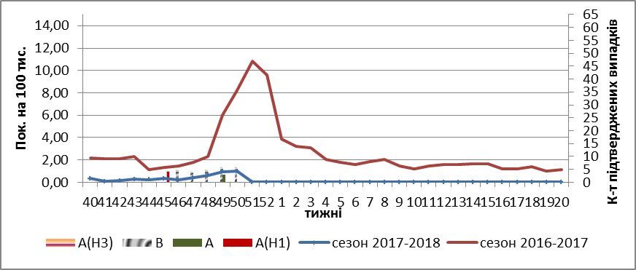

Fig.2 The dynamic of SARI cases and the number of laboratory confirmed influenza in season 2017 – 2018 in four sentinel centers of Ukraine.

From 40th to 50th week 2017-2018 there were investigated 76 samples from ILI and SARI patients by PCR method. From the beginning of season there were laboratory confirmed: 16 – influenza viruses B, 1 - influenza virus A (unsubtyped) and 1 – influenza virus A(H1).

At 43rd and 49th weeks there were registered 2 fatal cases in the age group 30 – 64 in the hospitals of sentinel centers and at 50th week there was registered 1 fatal case in the age group 0 – 5 years old, but they were not laboratory confirmed.

So ILI and SARI indexes of morbidity in 4 sentinel centers match seasonal levels. There is the circulation of influenza virus B.

Performed by:
Alla Mironenko, MD, DSc
Olga Holubka, PhD

