L.V. Gromashevsky Institute of Epidemiology and Infectious Diseases National Academy of Medical Science of Ukraine

Scientific Influenza and ARI Center

Weekly Bulletin for Influenza Epidemic Situation in Ukraine by 4 Sentinel Centers
(Кyiv, Dnipro, Odessa, Khmelnitsky)
Weeks 50, 2018

Loaded on website www.ukrinfluenza.com.ua

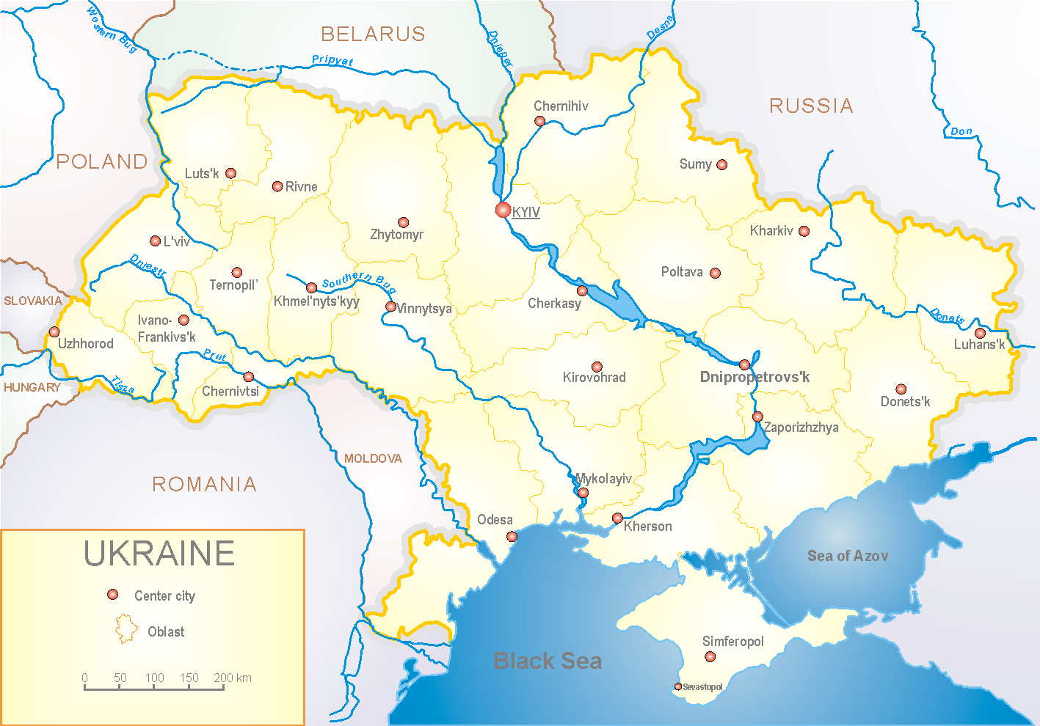
Since 2008 the system of ILI and SARI sentinel surveillance has been functioning in Ukraine. The sentinel centers are located in different geographical areas of the country: in Kyiv, Dnipro, Odessa and Khmelnytsky, which include 18 sentinel stations: 10 hospitals and 8 polyclinics.

According to data of influenza sentinel surveillance system in Ukraine in 8 policlinics of 4 sentinel centers the quantity of outpatients, which meet the definition of ILI during the 50th week (10.12 – 16.12.18) was 68 cases (32.8 per 100 thousand). In comparison with the previous week the level of morbidity increased in 4.5 times and it was in 4 times more than the previous year index (fig 1). 2 influenza A(H3) viruses and 1 influenza A unsubtyped were laboratory confirmed.

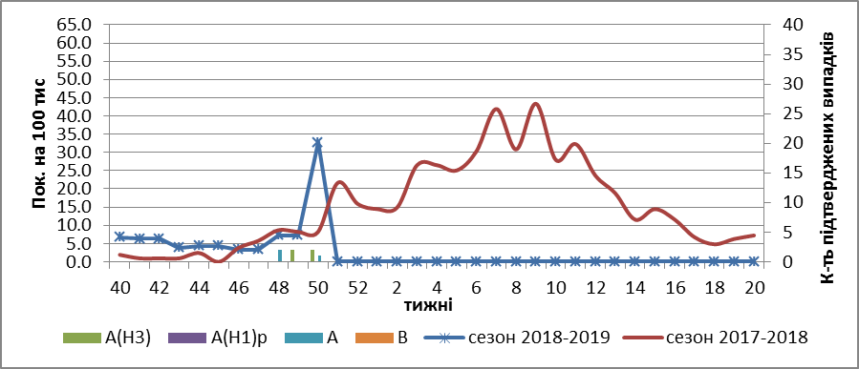

Fig.1. The dynamic of recorded ILI cases and number of laboratory confirmed influenza cases in 4 sentinel centers of Ukraine in the 2018 – 2019 season.

During the 50th week in 10 hospitals of 4 sentinel centers there were hospitalized 1347 patients, this is 11.0 % more than during the previous week. The quantity of SARI patients (patients which meet the definition SARI) was 67 cases (2.26 per 100 thousand). The morbidity level increased in 3 times in comparison with the previous week. The percentage of SARI from all hospitalized was 4.6%. During the 50th week 4 influenza type A(H1)pdm viruses and 12 – A(H3) viruses were laboratory confirmed (fig. 2).
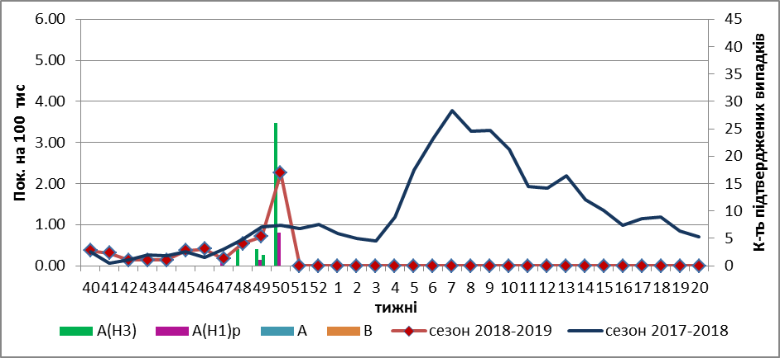
Fig.2 The dynamic of recorded SARI cases and the number of laboratory confirmed influenza in season 2018 – 2019 in four sentinel centers of Ukraine.

From the beginning of the season 2018-2019 there were investigated 152 samples from ILI and SARI patients by PCR method. Laboratory confirmed 55 influenza positive cases: 37 cases of influenza A(H3), 10 – influenza A(H1)pdm viruses and 8 – influenza A (unsubtyped).
So, we can observe the active circulation of influenza A viruses on the territory of the country. The highest quantity of confirmed influenza cases is recorded among the children under 5 years old and in the age group 18-29 years old.

Performed by:
Alla Mironenko, MD, DSc
Olga Holubka, PhD

