L.V. Gromashevsky Institute of Epidemiology and Infectious Diseases National Academy of Medical Science of Ukraine
National Influenza Center

Weekly Bulletin for Influenza Epidemic Situation in Ukraine by 4 Sentinel Centers
(Кyiv, Dnipropetrovsk, Odesa, Khmelnitsky)
Week 52, 2015

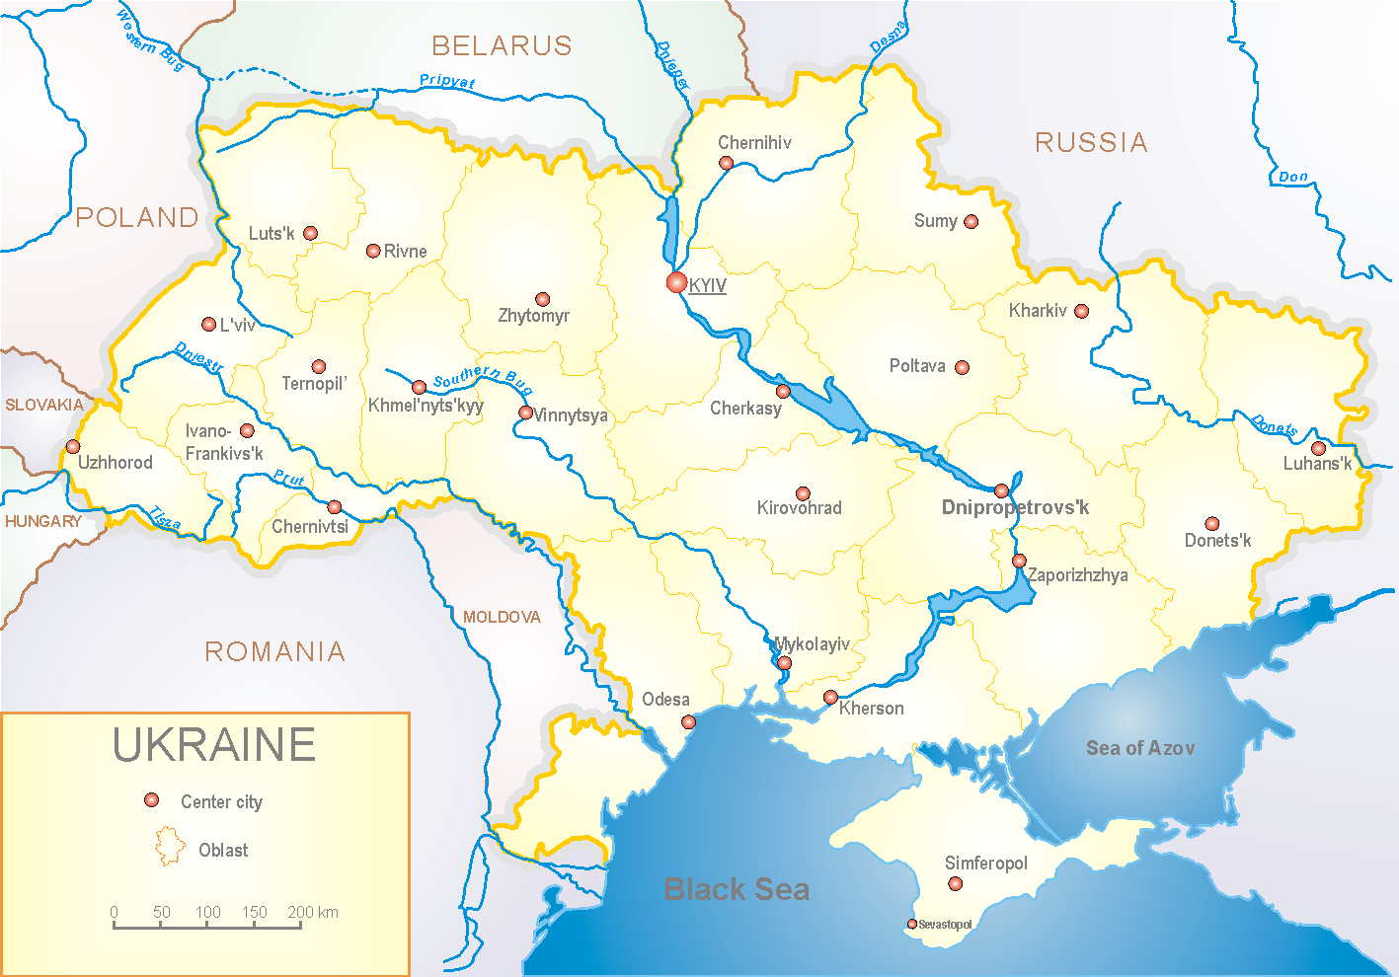
Since 2008 the system of ILI and SARI sentinel surveillance has been functioning in Ukraine. The sentinel centers are located in different geographical areas of the country: in Kyiv, Dnipropetrovsk, Odessa and Khmelnytskyi, which include 18 sentinel stations: 10 hospitals and 8 polyclinics.

According to data of sentinel surveillance system in 8 policlinics of 4 sentinel cities of Ukraine the quantity of outpatient, which meet the definition of ILI during the 52th week (21.12 - 27.12.15) was 66 cases (31.8 per 100 thousand) corresponding population. In comparison with previous week there was the increase of morbidity level – 78.4% (fig. 1).

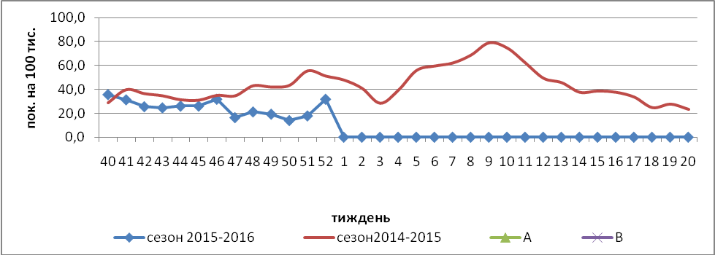

Fig.1. The dynamic of ILI cases and number of laboratory confirmed influenza cases in 4 sentinel cities of Ukraine in the 2015 – 2016 season.

The percentage of appeals to policlinics with ILI diagnosis during the 52th week increased among population of age groups <5 and 30 – 64 in comparison with the previous week (fig.2).

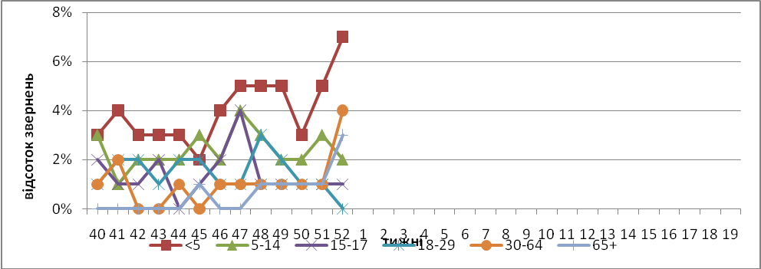

Fig. 2. The percentage of appeals to policlinics with ILI diagnosis among different age groups in season 2015 – 2016 in four sentinel cities of Ukraine.

During the 52th week in 10 hospitals of 4 sentinel cities there were hospitalized 1320 patients, in comparison with the previous week there was the increase of hospitalization level by 6.2%. The quantity of SARI patients (patients which meet the definition SARI) was 114 cases (3.8 per 100 thousand); the increase of morbidity level was 12.9% in comparison with the previous week (fig. 3).

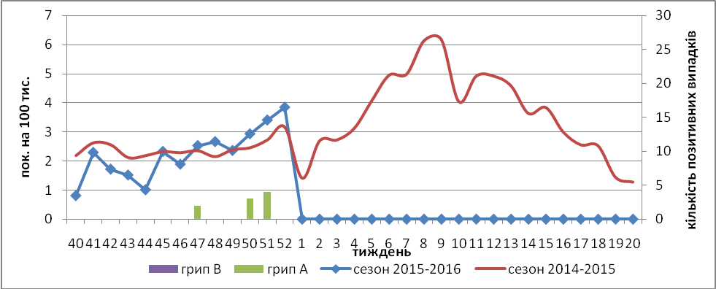

Fig.3. The dynamic of SARI cases and the number of laboratory confirmed influenza in season 2015 – 2016 in four sentinel cities of Ukraine.

From 40th to 52th week of 2015 – 2016 there were investigated 312 samples from ILI and SARI patients by PCR method. There were detected 10 (3.2%) positive influenza samples: 1 – influenza A () and 9 – influenza viruses A(H1)pdm. From the beginning of epidemiological season there were isolated 7 influenza viruses A(H1)pdm on MDCK cell culture.
Virological sentinel influenza surveillance data are presented weekly on WHO site http://www.who.int/influenza/gisrs_laboratory/flunet/en/ (fig. 4). The above-mentioned is done to make Ukraine participate in the global influenza surveillance system.

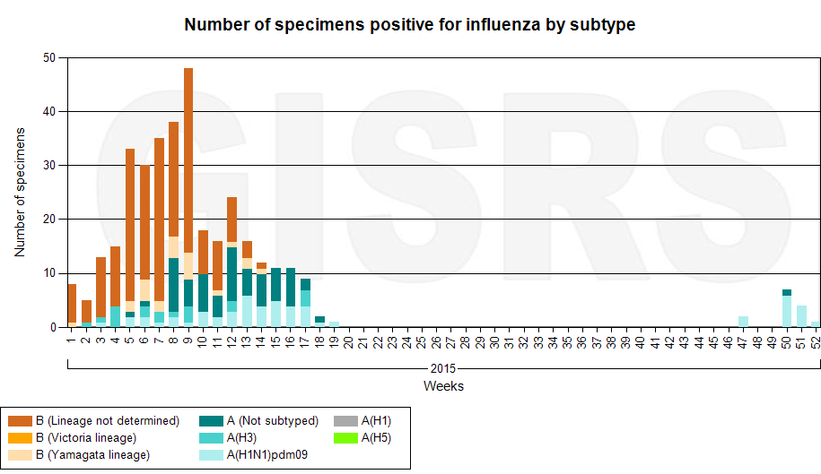

Fig. 4. The quantity of laboratory confirmed influenza cases among patients with ILI and SARI diagnosis in season 2015 – 2016 in the sentinel cities of Ukraine.

Thus, considering the above data of sentinel surveillance, we can conclude, that the stable circulation of influenza viruses continues.

Performed by:
Alla Mironenko, MD, DSc
Olga Holubka, PhD

