L.V. Gromashevsky Institute of Epidemiology and Infectious Diseases National Academy of Medical Science of Ukraine

Scientific Influenza and ARI Center

Weekly Bulletin for Influenza Epidemic Situation in Ukraine by 4 Sentinel Centers
(Кyiv, Dnipro, Odessa, Khmelnitsky)
Week 7, 2021

Loaded on website www.ukrinfluenza.com.ua
Since 2008 the system of ILI and SARI sentinel surveillance has been functioning in Ukraine. The sentinel centers are located in different geographical areas of the country: in Kyiv, Dnipro, Odessa and Khmelnytsky, which include 17 sentinel stations: 9 hospitals and 8 polyclinics.
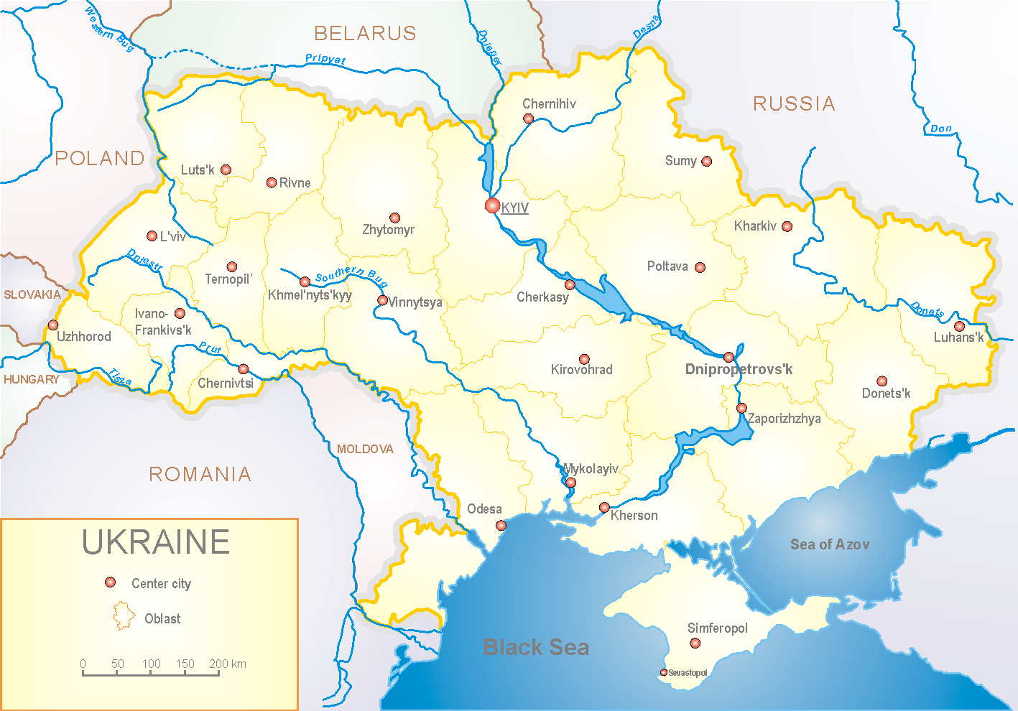

Influenza epidemic season 2020-2021 take place on the background of SARS-CoV-2 pandemic both in Ukraine and in the world.
According to data of influenza sentinel surveillance system in Ukraine in 8 policlinics of 4 sentinel cities of Ukraine the quantity of outpatient, which meet the definition of ILI during the 7th week (15.02.2021 – 21.02.2021) was 143 cases (13.5 per 100 thousand). The increase of morbidity level was 34.9% in comparison with the previous week but 23.7% lower than in the previous year (index 16.7 per 100 thousand – 2020) (fig. 1).

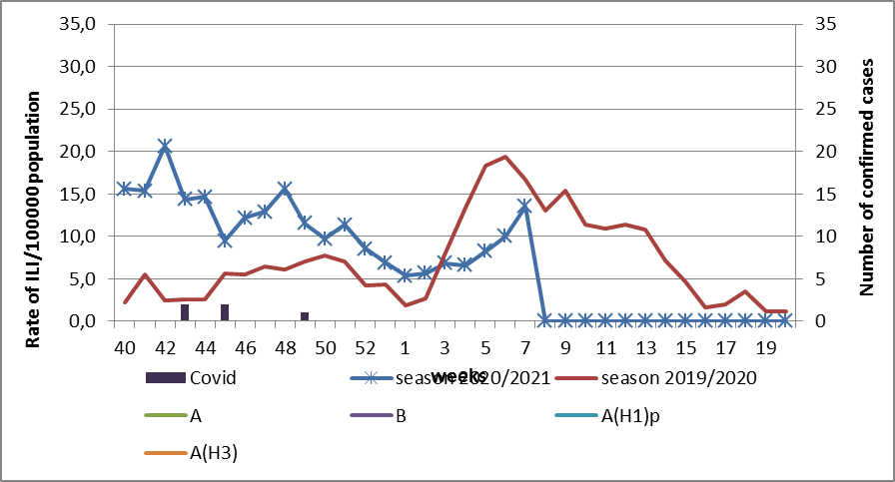

Fig.1. The dynamic of recorded ILI cases and number of laboratory confirmed influenza and SARS-CoV-2 cases in 4 sentinel centers of Ukraine in the 2020 – 2021 season.

During the 7th week in 9 hospitals of 4 sentinel centers there were hospitalized 764 patients. This is 64.6% more than during the previous week. The quantity of SARI patients (patients which meet the definition SARI) was 156 cases (6.12 per 100 thousand). The increase of morbidity level was 26.8% in comparison with the previous week (fig. 2).

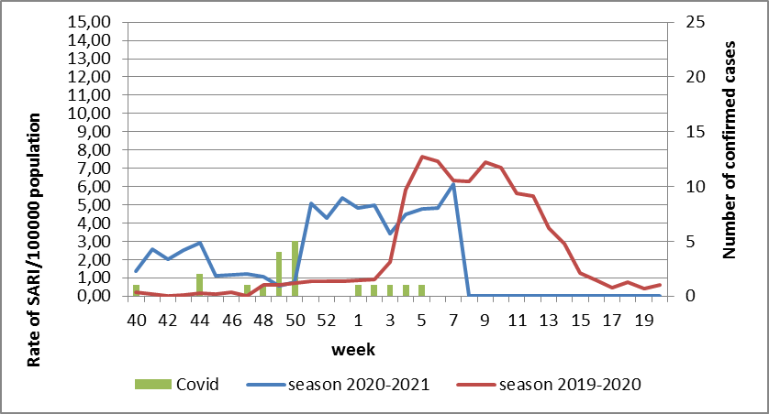

Fig.2 The dynamic of recorded SARI cases and the number of laboratory confirmed influenza and SARS-CoV-2 cases in season 2020 – 2021 in four sentinel centers of Ukraine.
From the 40th to the 7th week of 2020-2021 season there were investigated 55 samples from ILI and SARI patients by PCR method. There were laboratory confirmed 24 COVID cases (fig. 3).
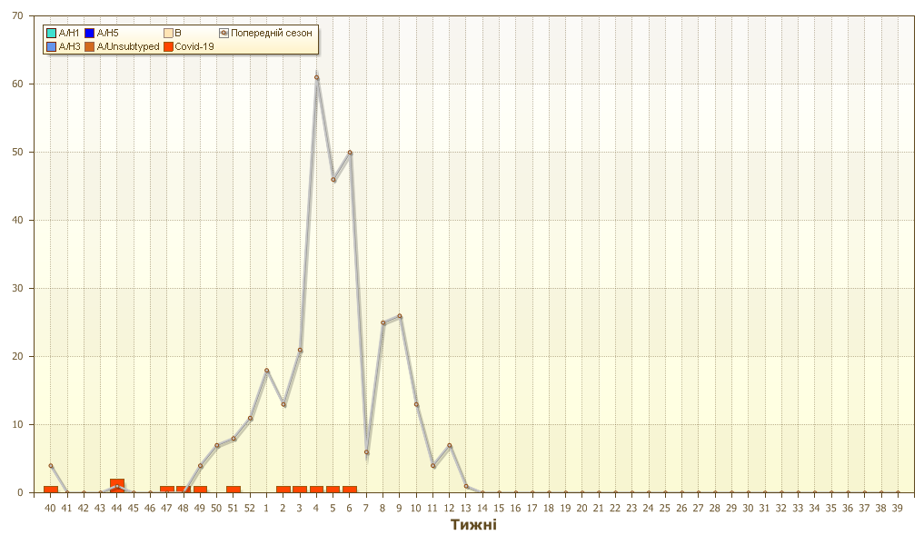
Fig. 3. Number of laboratory confirmed SARS-CoV-2 positive cases in sentinel centers of Ukraine in season 2020-2021.
.

So, according to sentinel surveillance the SARI and ILI morbidity indexes are on the background levels, but we can observe the increase of morbidity levels, it is due circulation of other respiratory viruses and SARS-CoV-2 virus. There were not any confirmed influenza cases.
According to weekly ECDC-WHO influenza activity in European countries is at the off-season levels.
Anti-epidemic measures which were taken to prevent the spreading of SARS-CoV-2 significantly affected epidemic process of influenza in the world.
From the beginning of the season in European countries there were investigated 360 836 samples from ILI and SARI patients by PCR method. Among them there were laboratory confirmed 644 influenza viruses. Among them influenza A – 326 (50.6%): 40 (12.2%) – influenza A(H1)pdm, 35 (10.7%) – influenza A(H3) and 251 (77.0%) – influenza A unsubtyped. There were also detected 318 (49.4%) influenza B cases, among them there were 8 (2.5%) – B/Victoria, 1 (0.3%) – B/Yamagata and 309 (97.2%) – influenza B (lineage is not detected).
The genetic characteristic of 4 influenza viruses have been examined for the current season: influenza A(H3) virus belongs to the strain А/Slovenia/1637/2020, the other one belongs to the strain A/Denmark/3264/2019. Influenza A(H1) virus is represented by the strain А/Guangdond-Maonan/SWL1536/2019. Influenza B virus type Victoria belongs to the strain В/Washington/02/2019.

Performed by:
Alla Mironenko, MD, DSc
Olga Holubka, PhD

